Naas Local Area Plan 2018-2024
Chief Executive’s Report on Submissions Received on Pre Draft Issues Paper
YOUR TOWN, YOUR PLACE, YOUR NAAS

Planning Department
Kildare County Council
February 2018

Contents
1. Introduction 1
2. Overview of Pre Draft Consultation Stage 1
3. Submissions Received and Chief Executive’s Responses 2
4. Next Steps 36

Appendix I
Summary of formal submissions received …………………………………………………………………………………………….37

Appendix II
Summary of informal submissions / comments received at the Public Consultation Day ……………………136

List of Tables

Table 1: Main themes of submissions received (% breakdown)
Table 2: List of Persons/Organisations who made submissions
Table 3: Residential land use zoning requests
Table 4: Employment land use zoning requests

Introduction

The purpose of this Report is to outline the outcome of the consultation process carried out prior to the preparation of the Naas Local Area Plan 2018 - 2024.

Section 2: Overview of pre draft consultation process
Section 3: Lists the persons who made written submissions
Section 3: Summary of submissions by category and the Chief Executive’s response to the issues raised
Section 4: Next Steps

Overview of Pre Draft Consultation Stage

Section 20 of the Planning and Development Act 2000 (as amended) states that;
“A planning authority shall take whatever steps it considers necessary to consult the minister and the public before preparing, amending or revoking a local area plan including consultations with any local residents, public sector agencies, non governmental agencies, local community groups and commercial and business interests within the area.”
A Pre Draft Strategic Issues Paper was prepared for the Naas Local Area Plan 2018-2024 identifying key issues. An advertisement was published in the Leinster Leader on 19th September 2017 notifying the public of the Council’s intention to make a local area plan for Naas and inviting submissions over a period of 6 weeks from 19th September 2017 to 24th October 2017. The Issues Paper was referred to the Prescribed Bodies as listed in the Planning and Development Regulations 2001 (as amended) and was available for viewing at the following locations:
- Public Counter, Planning Department, Kildare County Council, Áras Chill Dara, Devoy Park, Naas;
- Naas Public Library, Naas, Co. Kildare.

The Issues Paper was widely distributed throughout Naas to Naas General Hospital, the Vista Clinic, GPs, K Leisure, various community facilities, financial institutions, cafes, restaurants and many shops and retailers throughout the town centre. The Issues Paper was also published on the Council’s web-site to view and make submissions.
An informal Public Consultation Day was held on Tuesday the 3rd October 2017 between 12 noon and 7pm in Naas Town Hall. This event was attended by approximately 100 people. All comments and submissions made at this event were collated and are summarised in Appendix II.

Summary of Submissions and Chief Executive’s Responses

A total of 246 submissions raising multiple issues were received during the public consultation period. A breakdown of the main issues raised are set out in Table 1. A summary of each submission received and the Chief Executive’s Response and Recommendation are set out below under the following themes:
3.1 Vision and Core Strategy
3.2 Town Centre and Retail
3.3 Housing and Community
3.4 Economic Development and Tourism
3.5 Movement, Transportation and Infrastructure
  - Built Heritage and Archaeology
3.7 Natural Heritage, Green Infrastructure and Strategic Open Space
3.8 Urban Design and Key Development Areas

Table 1: Main themes of submissions received (% Breakdown)
Theme | No. of formal Submissions | No. of informal Submissions | Total no. of Submissions | Percentage of Total
Movement & Transportation | 87 | 8 | 95 | 26.4%
Housing & Community | 45 | 10 | 55 | 15.3%
Built Heritage  (incl. Culture & Gaeilge) | 36 | 17 | 53 | 14.8%
Specific Zoning Objectives | 36 |  | 36 | 10%
Town Centre & Retail | 28 | 6 | 34 | 9.5%
Natural Heritage, Open Space, Green Infrastructure | 20 | 14 | 34 | 9.5%
Urban Design & KDAs | 11 | 17 | 28 | 7.8%
Economic Development | 13 | 4 | 17 | 4.7%
Vision for Naas |  | 7 | 7 | 2%
TOTAL | 276 | 83 | 359 | 100%

Table 2: Persons/Organisations who made Submissions

1 | NTA
2 | Department of Education
3 | TII
4 | Dept of Culture, Heritage & the Gaeltacht
5 | Irish Water
6 | Inland Fisheries Ireland
7 | EPA
8 | Cllr. Seamie Moore
9 | County Kildare Chamber
10 | RGDATA
11 | Abbey Bridge & Canal Road Residents Group
12 | Naas Access & Disability Group
13 | Naas GAA
14 | Naas Neighbourhood Greenway
15 | Naas Regeneration Group
16 | Naas Rugby Football Club
17 | Naas Sports & Tourism Forum
18 | Urbact
19 | Woodlands Residents Assoc
20 | Anne & Larry Breen
21 | Aoife Egan
22 | Applegreen Service Areas Ltd
23 | Ballymore, Tetrarch Capital & Midwest Holding
24 | Barry, Catherine, Eoghan & Padraig Redmond.
25 | BKM Tapes ltd
26 | Brian O' Riordan
27 | Burke Family
28 | Cairn Homes Properties Ltd
29 | Castlekeel Ltd
30 | Chris Mc Loughlin
31 | Chris O'Neill.
32 | Christopher McDonald
33 | Clonmel Enterprises
34 | Colivet Family
35 | Con Horan
36 | Conor Furey
37 | Craddockstown Golf Club
38 | Crylock Developments Ltd
39 | David Lindopp
40 | David O'Rourke
41 | Dermot O'Rourke
42 | Dorothy Kinirons
43 | Eamonn Gilgunn
44 | Eileen Kiely
45 | Fergus Phelan
46 | Fiona Gilgunn
47 | Fiona Lennon
48 | Ger Dunne
49 | Glengolden Builders Ltd.
50 | Headfort Properties Ltd.
51 | Jim O'Sullivan
52 | Jimmy Kelly
53 | Joe, David & Robert Osborne
54 | John Kinchella
55 | John O'Reilly
56 | Joy Donohoe
57 | Kevin Maher
58 | Liam, Seamus & Paul O'Brien
59 | Mark Rogers
60 | Michael Dunphy
61 | Millennium Properties Ltd Partnership-Tetrarch Capital Ltd
62 | Naas Racecourse PLC
63 | Neil Austin.
64 | Niall Collins
65 | Niall Sargent
66 | Norman Farragher
67 | Origin Enterprises
68 | Paul Reid
69 | Pierce Moloney
70 | Queally Group
71 | Quinby Holdings Ltd.
72 | Quinby Holdings Ltd.
73 | Richard Godsil & Ward Frisby
74 | Robin Skelton
75 | Sandra Nelson
76 | Siobhan O'Carroll
77 | Springwood Ltd.
78 | Susanne Quinn
79 | Swans on the Green
80 | Thomas Maguire
81 | Westar Homes Ltd.
82 | Aldi Stores (Ireland) Ltd.
83 | Antoinette & Eugene Forde
84 | C & L Higgins
85 | Elsie Lloyd
86 | Frank O'Leary
87 | Helen O'Leary
88 | Helena Cahill
89 | Juanita Meany
90 | Liz & Frank Butler
91 | Maria & Bobby Lloyd
92 | Maura Fidgeon
93 | Thomas J Higgins.
94 | Anthony Boland
95 | Aoife Ni Ruairc
96 | Ciara Shortall.
97 | Colm Gordon.
98 | Dónall Ó'Riagáin
99 | Eoin O'Mordha
100 | Jackie Blake.
101 | Joseph Bergin
102 | Liam Grogan
103 | Mac Dara O'Maithiu
104 | Maebh Ni Chleirigh
105 | Mairead Finn
106 | Mick Moriarty
107 | Niamh Whittaker
108 | Padraic Grogan
109 | Paul Whittaker
110 | Roberta Keaney
111 | Ruth Leathlobhair
112 | Sarah Stewart
113 | Siobhan Evans
114 | Siobhan Grogan
115 | Sorcha Mulryan
116 | Susan Herbert
117 | Tom Davis.
118 | Willette Conroy
119 | Ailis Robinson
120 | Alan Duncan
121 | B. Egan
122 | Barry Brophy
123 | Barry Ward
124 | Bernadette O'Connor
125 | Cairan Gormley
126 | Cathal McLysaght
127 | Catherine McGrath
128 | Ciaran & Ruth O'Loughlin
129 | Ciaran O'Loughlin
130 | D. Mellon
131 | Darina Dunphy
132 | David O'Halloran
133 | Derek O'Connor
134 | Dorota Gebura
135 | Eileen Nelson
136 | Emily Ward
137 | Finbar Ward
138 | Frank Lawler
139 | Gail Coughlan
140 | Gary Stafford
141 | Geraldine Ward
142 | Jacqueline Howley
143 | James Foley
144 | John & Fiona Lennon
145 | John Aherne
146 | John Coyne
147 | Julie Ann & Andy Black
148 | Laurence Hogan
149 | Letitia Foley
150 | Liz Matthews
151 | Margaret Duncan
152 | Marianne Lawler
153 | Martin & Geraldine Hogan
154 | Mary Brophy
155 | Mary O'Halloran
156 | Michael & Ciara Wogerbauer
157 | Michael O' Halloran
158 | Michelle McElroy
159 | Michelle Williams
160 | Neil Austin
161 | Nicola Harney
162 | Ollie Collins
163 | Pat & Carol McCabe
164 | Paul Dunne
165 | Paula Dunphy (Moran)
166 | Ray O'Halloran
167 | Richard Lyons
168 | Roger & Petra Lahtinen
169 | Roger Parrow
170 | Ruth O'Loughlin.
171 | Ruth Teskey
172 | Sandra McIntyre
173 | Sean Brophy
174 | Sian Williams
175 | Siobhan Melia & Martin Cooney
176 | Stephen Ryan.
177 | Tricia Kelly
178 | William Quilter
179 | Aled Williams
180 | Aleksandra Kazmierczak
181 | Angela Haslam
182 | Ann Crowley
183 | Ann Marie Thompson
184 | Ben Doyle
185 | Bernie O'Connor
186 | Brian Dempsey.
187 | Brian Kavanagh
188 | Brian King.
189 | Catherine Domican
190 | Celine Maguire
191 | Clare Linehan
192 | David Burke
193 | Dee Hulse
194 | Deirdre Hogan
195 | Delphine Lelievre
196 | Doreen Ryan
197 | Fiona Gilgunn
198 | Geraldine Fitzpatrick
199 | Helen Cully
200 | Joseph Bergin
201 | Joy Donohoe
202 | Karen Cahill
203 | Karen McTague
204 | Keith Cully
205 | Kieran Rogers
206 | Leona Martin
207 | Mags Conroy
208 | Marie Daly
209 | Martin Murray
210 | Niall O'Reilly
211 | Orla Allen
212 | Owen Mc Clave
213 | Paul Domican
214 | Robert Burke
215 | Ross Allen
216 | Ruth Brennan
217 | Sheelagh Pentony
218 | William Gilligan
219 | Adrian Geissel
220 | Brendan Moran
221 | Catherine Corrigan
222 | Claire Prasad
223 | Claudia Stone
224 | Colette Cooney
225 | Deirdre Curtin
226 | Don Higgins
227 | Fiona Duigan
228 | Gail Collins
229 | Jim & Shirley King
230 | John Collins
231 | John Ward
232 | Justin Mac Antsaoi
233 | Kathleen Ward
234 | Kay Cregan
235 | Kieron Curtin
236 | Mae Leonard
237 | Maria Grogan
238 | Marian Ward
239 | Patrick J. Grogan
240 | Paul Murphy
241 | Paula Ward
242 | Rhonda Willoughby
243 | Roisin & Alan Stewart
244 | Steven Fadian
245 | Ted Murphy
246 | T R Smith

3.1 Vision and Core Strategy
A number of submissions stated that the economic strengths of the local area should provide the focus for the vision for Naas. The town should be the location of choice for existing and potential business enterprise in the county; develop a sustainable, educated, skilled, confident, and entrepreneurial community; to be a connected regional, national and international infrastructure enabling growth and; a town excelling on its quality of life and place.
A further submission referenced the economic location of Naas in relation to the equine sector and the potential opportunities that this could present to grow and enhance Naas’s profile as the county town of the “Thoroughbred County”.
Another submission considered the environmental component and issues around sustainability. One submission stated that Naas should aspire to being the most sustainable town in Ireland, with walking and cycling prioritised over the use of cars. The greenway should aim to connect key areas of green and open space and that key areas and zones within the town centre should be pedestrianised.
Another theme mentioned was the heritage and historic character of Naas. One submission mentioned that Naas needs to be developed as an historic, contemporary and premium Market Town. Nas na Riogh means the meeting place of Kings – which could be used as a potential tag line for Naas should reflect the theme of ‘meeting place’.
Chief Executive’s Response
The comments received regarding the future vision for the town centre are welcome. The draft LAP will seek to define the vision for Naas and use this to help guide and focus future development and regeneration projects to target the vitality and viability of the town centre.
Chief Executive’s Recommendation
The emerging vision for Naas will seek to embrace the points raised in the submissions and will be used to help direct the future development and revitalisation of the town.

3.2 Town Centre & Retail
A number of submissions made reference to the town centre and the decline experienced over the past number of years with pressure from the peripheral out of town shopping centres at Monread to the north and the Naas Retail Park to the south of the town. It was mentioned that adequate and suitable provision be made to meet the needs of the growing and changing population, both overall and locally in order to provide for a vibrant retail mix, healthy competition and consumer choice.
It was suggested that in order to ensure sustainable retail development and promote the vibrancy and vitality of Naas Town Centre in the LAP, no new retail developments should be approved until the Town Centre Health Check is undertaken and the Plan is agreed. It was further suggested that the Health Check should be used to identify key data about the town and assist the Council in answering a number of high level and strategic questions:

- what new development is required?
- what is in the best interest of promoting a good retail mix?
- what will best service the population of the town?
- what will draw more footfall into the town centre, ensure vibrancy and vitality and provide sustainable development?
One submission outlines how Naas is a great place to live and raise a family; however concern was expressed that while the town centre should be supported through this new LAP it should not be at the expense of the character of the town. Businesses in Naas have suffered as there has been a focus on developing the nightlife of the town and promoting shopping centres outside the town centre. This trend has led to the deterioration of the town centre.

A number of submissions stated that it is important to make Naas a better place to live for its residents, make it more attractive for visitors to come and see and spend time in and improve the business and retail economy in the town centre. Most importantly it was felt and repeated that Naas needs the LAP to encourage an increase in footfall within the town, to re-energise retail businesses and to help attract leading brands back to the town. Concerns were raised in relation to the small size of the town centre and that the existing retail area was constrained, being focused along Main Street. It was suggested that there is an opportunity to increase the size of the town centre in order to provide a larger shopping area, more in keeping with a county town. Development of new retail facilities within Naas should be focused within the town in order to ensure that there is no overdevelopment of local, or neighbourhood centres, edge of town or out of town sites drawing more business away from the town centre.
Several submissions referenced the look and feel of the town centre. It was mentioned that the town looks dirty and unkempt and that a cleanup of the buildings (public and private), the pavements and street furniture would have a quick and immediate benefit. Several submissions referenced the number of vacant buildings and plots within the town and that these should be properly screened off (especially the former Cemex Site and the Shopping centre). Plans and options need to be explored for the key sites within the town centre such as the site at the Canal Harbour, the former Superquinn site and the half completed shopping centre along Corban’s Lane. In terms of development options it was suggested that the new LAP should help to facilitate development of higher buildings and densities in areas such as Poplar Square. These core development sites need to be completed and finished off in order to revitalise the town.
A Public Realm Strategy for the entire town was required and this should consider dedicating specific areas for enhanced and improved public amenity. The strategy should consider the materials and develop a standard palette for paving design, street furniture (seating, lighting etc.) and to require the underground routing of cables and power lines as well as the de-cluttering of signage. It should seek to identify key public areas, the connection between places and zones and that the strategy should support the implementation of free Public Wi-Fi within the town.
Numerous submissions referenced the opportunity to reduce traffic within the town, to introduce a ban of HGV vehicles from driving through the town centre, and to make the centre more pedestrian friendly, reducing the speed of traffic and if possible to fully pedestrianise areas.
A submission made reference to the importance of the Tourism section and it was mentioned that the Town could benefit from a Tourism Office located within the refurbished Town Hall; this could provide an opportunity for a local museum as well as a focal point for the town. This would encourage the extended use of assets within the town and could also generate an increase in footfall locally.
Naas needs to implement a Purple Flag programme within the town centre. It was suggested that this could help to raise the profile of the town as a destination location and to identify some of the key issues for developing an Evening and Night Time Economy strategy.
Chief Executive’s Response
The comments received regarding the town centre are welcomed. The draft LAP will seek to revitalise and regenerate the town centre and the policies and objectives of the plan will improve the vitality and viability of the town centre. Furthermore the Draft LAP will have regard to the findings of the Naas Town Health Check, 2017 and the outcomes of various public consultation events held in recent months and reports prepared relating to Naas such as URBACT (Naas Town Team), Space Engagers, 2017, and Naas Town Marketing Action Plan, 2013.
The plan will assess the size of the town centre area and the council will review the defined town centre boundary in order to extend it into appropriate areas. The Core Retail Area will be promoted and it shall remain the focus for new retail development.
In response to concerns about how the plan will encourage new retail and business activity, it is not within the remit of this plan to provide fiscal incentives. However, the plan will support the re-use of existing buildings and sites for appropriate uses should such proposals emerge.
In response to the issues about public realm the plan will confirm the importance of public realm for the attractiveness and viability of the town centre. The preparation of a public realm enhancement plan for the town centre will be considered as part of the LAP. The plan will seek to identify and promote future opportunities to enhance the streetscape, street furniture, building fabric and connectivity.
In response to the issue regarding tourism and the establishment of a new tourist office and museum within the Town Hall this matter will be addressed in the Economic Development & Tourism section of this report.
Chief Executive’s Recommendation
It is recommended that the Draft Naas LAP will review and incorporate policies and objectives as appropriate relating to the overall improvement of the town centre and the promotion of the retail offer.
3.3 Housing & Community
45 no. submissions received related to housing and community issues in Naas. This accounts for 18% of the overall submissions received. In addition a further 98 no. submissions raised concerns regarding the development of a KCC owned site on the Caragh Road for the provision of housing.

A number of submissions referenced specific sites and made proposals for the zoning of land for residential purposes. These sites are identified on Map 1 and the locations and details of the sites described in Table 3.

One submission referenced that Naas has fallen behind some of the smaller urban centres in the County such as Maynooth, Celbridge and Leixlip in terms of population growth. The 2016 Census confirms that Newbridge and Kildare’s population has exceeded Naas. It was mentioned that Naas is identified as the County Town and therefore it should grow and develop proportionately. Naas has in place the infrastructure i.e. roads, water, wastewater treatment, electricity, gas and broadband to facilitate and enable the growth. 40% of the employment profile of Kildare is employed outside of the County within the Greater Dublin Area.

The infrastructure within Naas has recently been upgraded and there are plans to undertake further investment in the roads and other transportation modes in order to facilitate further growth and development.

It is suggested that the draft LAP zones suitable amounts of land at sustainable locations that can be released and developed during the lifetime of the Plan. Lands zoned for development should be located so that that they are accessible to employment opportunities and transport nodes. It was mentioned that strategically located land banks can make a positive contribution to the future growth and development of Naas. Several of the submissions referenced the top heavy feel of the town with relatively high concentrations of housing stock and developed sites in the northern zone of Naas. Future housing and residential development should look to the southern and western sectors where lands are available to help re-balance the town and also to seek to infill and secure the consolidation of the town centre first before extending the town further.

The Council should build more social housing with the rents received being recycled back into the community and the local area. However, it was suggested that the location and the design of social housing developments should be carefully designed and planned to avoid the clustering and concentration of certain types of development.

It was recommended that the developers of new housing areas in excess of 200 housing units, should be required to prepare a detailed Masterplan for the local area. Housing densities should be increased within and close to the town centre, with higher rise properties and 3 storey properties instead of the usual 2 storey type development.

Further evaluation and surveys should be undertaken to identify where there is a need for new childcare facilities and that these should be designed and incorporated into new development projects

Chief Executive’s Response
The Naas LAP will seek to re-establish Naas as the County Town of Naas and the main growth town in the county. The proposed and projected population growth and extended town boundary will seek to ensure that a sufficient quantum of lands is zoned in order to achieve a sufficient increase in population of Naas during the plan period (2018-2024).

It shall be an objective of the Draft LAP to seek to redress the imbalance of people commuting out of the local area for work. It is envisaged that the Plan will facilitate a move towards greater local employment opportunities and an improved quality of life.

The LAP will seek to ensure that residential developments deliver a balanced supply of housing types offering choice and variety to meet the needs of the likely future population, and where appropriate the council will seek to require developers to produce a detailed Masterplan for the local area along with the provision of appropriate community facilities and social infrastructure.

Chief Executive’s Recommendation
The LAP will zone sufficient lands to accommodate the projected increase in population in accordance with the Core Strategy set out in the Kildare County Development Plan 2017-2024 and having regard to its role as a county town and a Large Growth Town I in the Greater Dublin Area.

The Plan will seek to ensure that a balanced supply of housing types, offering choice and variety is provided in the town. The Plan will also seek to ensure that appropriately located and sufficient open space and childcare crèche facilities are provided within all new housing developments.

Design Issues
It is submitted that the sequential infilling of sites should be around and alongside existing residential developments and within the town centre be used and developed first. New developments need to encourage and facilitate the use of alternative modes of transport and include connections for public transport and other means such as walking and cycling.

Several submissions referenced that within the town centre there are a number of vacant units and space above retail shops that could be re-used and developed. It was suggested that these spaces need to be brought back into active uses and that they could help to revitalise and refresh the town centre. It was suggested that the Council could look to invest in the purchase of vacant property and convert these units into houses or apartments. This action could help to improve the town centre and increase the use of the town and improve the natural surveillance of the local area.

Two submissions identified the opportunity to consider the development of ‘Tiny Houses’, it was suggested that a new style of home could help to alleviate the issues of affordability and availability and homelessness. The use of smaller homes could help to provide alternative forms of housing for students, recent graduates and retirees in campus style accommodation areas. One of these submissions referencing this new style suggested that the Government should prepare national guidelines for a minimum dwelling size and identify neighbourhoods and locations for these communities. However one submission expressed concern about this smaller style of home, suggesting that it could introduce sub-standard forms of development.

Chief Executive’s Response
The LAP will seek to ensure that sustainable neighbourhoods are designed and created with an efficient use of land, high quality urban design and the effective integration in the provision of physical and social infrastructure in order to create places where people want to live and reside. The Plan will seek to promote high quality design and construction standards that result in visually and functionally pleasing environments in accordance with Chapter 17, Development Management Guidelines, Kildare County Development Plan 2017-2024 and the Sustainable Residential Development in Urban Areas Guidelines (and accompanying Urban Design Manual), DEHLG, 2008. New residential development will seek to achieve a good quality of life for new residents while having regard to the amenities of existing residential areas in the town.

Chief Executive’s Recommendation
The Plan will set out a framework to ensure that new and infill sustainable neighbourhoods are designed and created in Naas, including high quality design and construction standards and the appropriate provision of well located community facilities.

Housing for the Elderly
Numerous submissions identified the ageing population of Naas and the need to consider and plan for an increasing elderly population. It was considered that the design of residential developments should include more two and one bedroom housing units for the elderly population. It is suggested that residential estates need to be more elderly friendly, with ease of access, special needs adaptability and the units located in appropriate areas in order to enable communities and populations to walk and therefore connect with local services. Residential developments need to be designed and planned in order to maintain the integrity of the living space and to ensure the quality of life for residents.

Naas has achieved Age Friendly Town Status, this should be promoted and the town encouraged to offer guidance and assistance to other towns in County Kildare. The traditional approach of housing and providing for the needs of the elderly is considered to be not now appropriate. A broader range of options is required including retirement villages with dedicated and specific facilities. The new LAP should endorse the need for new development for the elderly and to consider the opportunity to identify retirement villages as a distinct land-use category in the new and emerging LAP.

Chief Executive’s Response
The Council acknowledges the shifting population demographic and the rise in the numbers of persons aged 65 years and over as is evident in the 2016 Census. While the Council is not a direct provider of residential care and nursing homes it does have a responsibility for regulating development and seeking to provide the appropriate level and type of accommodation to cater for specific housing needs. The Council will seek to ensure that residential developments provide a balance and a mix of housing types suitable for the projected population of the town.

Furthermore the Council will continue to support and promote McAuley place as a symbol of best practice for the provision of accommodation for older people located in the heart of Naas town centre and surrounded by a robust social and community infrastructure.

Chief Executive’s Recommendation
The plan will seek to ensure that sustainable residential developments are created providing an adequate mix of housing types to cater for the needs of the local population.

Community – Education Facilities
The Department of Education and Skills made a submission and this mentioned that it is important that sufficient education infrastructure to meet the needs of the community is appropriately zoned in the LAP. The Department requested that the Council in zoning lands should refer to the Development Plans: Guidelines for Planning Authorities Appendix F (DEHLG, 2007) and the Dept of Education & Skills Technical Guidance Docs for primary schools and post –primary schools.

Any lands being zoned for educational purposes by the Council should be where services are provided and that lack of access will not hinder the development of the schools within the required timeframe. The Council is requested to consider favourable implementation strategies and phasing in order to ensure ready access to existing infrastructure and avoid disproportionate costs. The Department requests any such site reservations are made where possible as close as possible to community facilities such as sports facilities, libraries etc, so these can be shared between school and community. The Department is open to the concept of multi-campus schools, where 2 or 3 primary schools can be located side by side, or a primary and post primary sharing the same site – as this can reduce the amount of land required.

The Department suggested that where possible land adjacent to existing schools should be zoned appropriately to allow for the potential future expansion of these sites. In addition, the Council is requested to consider a policy of introducing buffer zones around existing school sites – to allow adequate separation from housing whilst also enabling increased school heights in established neighbourhoods for consolidation and intensification of populations.
Further submissions commented and identified the need to provide additional nursery, pre-school, primary and secondary facilities within Naas. Many of the existing schools within the town are at or near full capacity.

In addition it was mentioned that in Naas there is no third level college or education centre; it was suggested that the Town should seek to develop a strategic link with a local university such as Maynooth to create local opportunities for young people living in the Town. For the younger people of Naas it was suggested that a greater range of opportunities could be explored in specific sectors such as sports, recreation, hospitality and the possible connection to the equine industry offering apprenticeship programmes in association with the Kildare and Wicklow Education and Training Board (KWETB).

Chief Executive’s Response
The Naas LAP will seek to zone an adequate quantum of lands at appropriate locations for education purposes in order to meet the needs of the existing population of Naas and in order to cater for the projected growth of the town during the period of the Plan 2018-2024.

Chief Executive’s Recommendation
The Plan will seek ensure that appropriately located lands are zoned to provide for educational facilities within the town with a particular emphasis on location and connectivity to existing and proposed residential and employment areas.

Open Space Provision in Residential Developments
A number of submissions referenced the need for new residential developments to consider the connection to open and recreational spaces. Each new development should consider the appropriate amount of open space included in the design and how these spaces can be best used within the local area. There is a need to develop an appropriate hierarchy of parks and open spaces in Naas and to ensure that these sites are funded, developed and protected. It was suggested that housing developments should seek to deliver a minimum of 15% for green and open space, with this increasing to 20% for developments in out of town centre locations. In addition for any residential developments with more than 100-200 housing units the developer should provide children’s play area incorporated and designed as part of the public open space.

It was suggested that land for recreation and sports provision needs to be zoned and acquired or purchased in order to secure projects and the use of these sites. For a growing population the town needs more sports pitches and facilities including multi-use facilities. In addition it was proposed that the draft LAP considers the introduction of a special development levy targeted at the provision of more specific projects such as a new park in the town incorporating new and additional play areas and sports pitches.

Chief Executive’s Response
The Naas LAP will ensure that new residential developments incorporate a detailed landscape design and seek to deliver appropriate parks and open space as part of the overall design of the development. The Plan will look to apply appropriate standards for open space, playing pitches and play areas to ensure that these are adequately provided in suitable locations. The Council will consider the application of a special development contribution levy in order to provide suitable new parks, open spaces and playing pitches for the additional population.

Chief Executive’s Recommendation
The Naas LAP will ensure that sufficient open space and recreational facilities are provided for at appropriate locations.

Community – Sports & Recreation Amenities
Several submissions identified the large number and variety of sports and recreation clubs represented within Naas, but made specific reference to the lack of sports pitches and suitable facilities. With the projected growth in population it was considered that urgent work is needed to identify potential new facilities.
A number of submissions identified the existing sports and recreation facilities at the Caragh Road which could be expanded and increased in size. It was considered that additional public facilities could be provided in strategic locations for example at Pipers Hill College Campus, Craddockstown, Millennium College and at the proposed new Regional Park at Kerdiffstown.

It was mentioned that there are also several existing school sites which could provide additional sports and amenity facilities during the weekends and evenings. It was suggested that a survey should be undertaken to explore the opportunities to extend and share these existing facilities. The Council should seek the development of other private sports facilities using existing facilities within the Town (Killashee and Naas Racecourse).

Specific issues raised in relation to sports facilities are as follows:
- Naas GAA: The Club has new facilities but on a small site. The one Club has 85 teams with only 2 full size pitches.
- Naas Rugby: The Club has a membership of 1,100, - 150 adult and seniors, 530 youth players and 80 girls in age categories from 8-18. The Club has 3 full size pitches with one having floodlights.
- Soccer: Within Naas there are 55 teams with a membership of 1,120 registered players (42 under 16 teams, 2 ladies teams and 11 senior teams). The availability of pitches is limited. Appropriate changing rooms and toilet facilities very limited.
It is submitted that there is an urgent need for sports and recreation facilities in Naas. The Council should seek to change the planning regulations which currently prevent sports clubs from extending or building club facilities; and the positioning of steel containers in order to provide temporary club facilities on municipal owned pitches and areas of open space. It is suggested that on Municipal Sports Grounds of 5 hectares or more that changing and toilet facilities should be provided on site by Kildare County Council.

It is suggested that a local Area Sports Partnership unit be formed and located within the Town Hall. The partnership should develop a web-site and database listing all sports and recreation clubs and associations locally. The partnership should seek to encourage co-operation between clubs, assist in the application and securing of grant funding, as well as promoting the development of facilities and infrastructure and links with local schools.

Sports and Recreation
3 no. submissions were received from Sport/Recreation Clubs in relation to the zoning of land from Naas GAA, Naas Rugby Club and Craddockstown Golf Club.
Naas GAA requested the zoning of lands in front of the club house (but not in their ownership) and zoned open space be made available to the club for additional playing / training facilities and shared with the local school.
Naas Rugby Club identified a requirement for additional playing pitch facilities, floodlighting and changing rooms and clubhouse facilities, in close proximity to the club at Forenaughts to meet the increasing demands. The submission proposed the development of a Sli na Slainte – 700m walking path suitable for wheelchair use around the grounds; and suggested that the Tipper Road triangle area should be restricted from future development.
Craddockstown Golf Club requested that lands located to the north-east of the golf club be re zoned from F: Open Space and Amenity to C: New Residential. It is also requested that lands located to the south of the existing golf course are re zoned from I: Agriculture to F: Open Space and Amenity. It is stated that these lands are not in ownership of the golf club.
Chief Executive’s Response
The Naas LAP will seek to ensure that sufficient sports and recreation facilities are provided within Naas. The Plan will acknowledge the importance of quality recreation; leisure and amenity facilities have on the quality of life in a town and on its social integration and cohesiveness. The provision of amenities to cater for the demands of an increasing population is a central element in the delivery of sustainable communities. The plan will encourage the use of facilities in schools and the education sector in order to maximise the use of sites and sports pitches.

Chief Executive’s Recommendation
The Naas LAP will seek to facilitate the delivery of appropriate sports and recreation facilities within the town to support existing and future residents of Naas.

Table 3: Residential zoning requests
Please refer to separate land zoning map
Ref | Site Address | Submission by | Site Area | Description of zoning requested
Sub 23 | Killashee | Ballymore, Tetrarch Capital & Midwest Holding | Area not defined | Lands in the environs of the Killashee Hotel and immediately south of the Pipers Hill residential scheme and Educational Campus.  Integrated Tourism and Recreational Development with retirement accommodation incorporated within the design concept.
Sub 25 | No. 1 Highland View, Naas | Brendan and Lynette Mulhern | Area not defined | Proposal requests the addition of ‘Residential’ to ‘Retail / Commercial’ zoning of the premises at No.1 Highland View, Naas.
Sub 27 | NW Quadrant Canal, The Knocks Naas | Burke Family | Area not defined | The Burke Family would consider ceding lands to KCC to enhance public facilities and amenity use of Naas Canal Linear Park – in return for residential development zoning of the balance of their lands.
Sub 28 | Jigginstown | Cairn Homes | 12.5 ha | Lands zoned agriculture proposal to change to residential and infill the land south of the ring road.
Sub 29 | Dublin Road / Naas Racecourse | Castlekeel Ltd | C 1ha | Proposal to zone lands previously zoned leisure & amenity to residential
Sub 29 | Dublin Road / Naas Racecourse | Castlekeel Ltd | 4.3ha | Lands previously zoned enterprise and employment. Proposed mixed use residential
Sub 34 | Piper’s Hill, Kilcullen Road | Colivet | 10.5ha | Lands zoned agriculture, proposal to link the site and development into the existing development at Piper’s Hill.
Sub 36 | Devoy Park, John Devoy Road | Conor Furey | Area not defined | Proposal to zone lands from residential to town centre in order to facilitate an increased density of development.
Sub 37 | Craddockstown Golf Club | Craddockstown Golf Club | 7ha | Lands at the north-eastern side of the golf club proposed to be zoned for residential rather than open space. Proposal to zone lands from agriculture to open space not in ownership of the golf club.
Sub 40 | Oldtown House Sallins Road | David O’Rourke | 1.34ha | Proposed zoning open space lands to residential
Sub 41 | Kereden House, Naas | Dermot O’Rourke | Not Applicable | Proposed to amend controls on lands zoned M Future Park / Green Belt (in the ownership of the family 20.2ha) in order to allow a single unit dwelling to be built on extensive farm land holding.
Sub 45 | Craddockstown | Fergus Phelan | 2.19ha | Proposal to zone lands from agriculture to residential.
Sub 49 | Tipper South, Blessington Road , opposite north Golf Club | Glengolden Builders Ltd. | 4.09ha | Proposal to change the land use zoning from agricultural land use to residential. Proposed entrance from the Blessington Rd – R410
Sub 52 | Tipper West, Blessington Rd | Jimmy Kelly | 26.9ha | Proposal to re zone lands previously zoned agriculture for residential
Sub 53 | Craddockstown Demesne, located to the east of R411 road to Punchestown | Joe, David & Robert Osborne | 9.5ha | Proposal to re zone land identified as agriculture to residential
Sub 58 | Lands located at Tipper North, Naas | Liam, Seamus & Paul O’Brien | 3.5ha | Lands zoned agriculture be changed to residential
Sub 61 | Millennium Park, lands to the west of Sallins Rd | Millennium Properties Ltd Partnership, Tetrarch Capital Ltd | 4ha | Lands are bounded to the north by the Western Distributor Rd to the east by the Sallins Rd (R407) and existing residential development. Proposal to change the zoning from Enterprise & Employment to residential
Sub 61a | Millennium Park, North West Quadrant | Millennium Properties Ltd Partnership, Tetrarch Capital Ltd | 63ha | Lands spread over two character areas defined as Character 3 – 43ha and Character 4 – 69ha. Quantum of proposed residential development lands is stated as 63ha
Sub 62 | Naas Racecourse, Kingsfurze | Naas Racecourse PLC | 3.4ha | Proposal to rezone lands from Open space and amenity to new residential
Sub 69 | Oldtown Demesne, Sallins Rd | Pierce Molony | 1.34ha | Lands zoned open space proposal to be re-zoned to residential
Sub 70 | Bluebell Farm Kilcullen Rd | Queally Group – No planning agent stated | 3.5ha | Request to retain the previously zoned lands residential
Sub 70 | Lands adjacent to Bluebell Farm Kilcullen Rd | Queally Group – No planning agent stated | 13ha | Request to retain the previously zoned lands residential
Sub71 | Jigginstown | Quinby Holdings Ltd. | 71ha | Proposed re-zoning agricultural lands – 71ha residential, 15ha open space and recreational and 2ha neighbourhood centre
Sub 72 | Lands south Tipper Road | Quinby Holdings Ltd. | 3.16ha | Proposal to re-zone Enterprise and economy lands to Residential development. Site classed as brownfield.
Sub 74 | Lands east of Oldtown Lawns Lane Jigginstown | Robin Skelton | 4.45ha | Proposed re-zoning of agricultural lands from agricultural to residential.
Sub 77 | Lands west of Sallins Rd and east of the GAA pitch | Springwood Ltd | 0.89ha  0.43ha | Lands zoned F1 Open Space be re-zoned new residential and a swap to include additional area of open space lands.  Lands zoned residential be re-zoned open space and amenity. In addition it is proposed to remove the objective relating to views and prospects of the canal corridor (Map ref 11.4 Naas Town Plan 2011-17)
Sub 81 | Canal Harbour and lands at and adjacent to Finlay Park Caragh Rd | Westar Homes Ltd - | 2.26ha Harbour  9.43 Canal | Lands zoned open space and amenity located to the west of C2 lands are re-zoned residential. Lands are extended to the canal front whilst retaining amenity strip of land adjacent to the canal
Totals |  |  | 262.63ha

Chief Executive’s Response
The zoning of land in the Draft Naas LAP for the purposes of residential development must be consistent with the Core Strategy of the Kildare County Development Plan 2017-2023 in terms of providing sufficient zoned land to meet population targets.
The location of residential zoned land is determined by a number of factors including the level of committed and uncommitted land, the sequential approach, location and capacity of services and infrastructure, proximity to public transport, employment and community facilities, along with recommendations arising from a Strategic Flood Risk Assessment, Appropriate Assessment and Strategic Environmental Assessment which are prepared in tandem with the preparation of the Draft LAP.
Future zoning recommendations will be informed by these factors as part of an iterative process.
Chief Executive’s Recommendation
The Draft Naas LAP will zone an appropriate quantity of residential and other zoned lands in compliance with the Core Strategy of the Kildare County Development Plan 2017-2023, while having regard to national guidelines, local sensitivities and constraints.

3.4 Economic Development & Tourism
13 no. submissions received related to economic development and tourism issues in Naas. These accounts for 5% of the submissions received. Several of the submissions received mentioned the importance of economic development in helping to sustain future growth and prosperity for the town and the county. One submission stated that the strategic location of Naas is important and needs to be promoted, the town provides the economic and social gateway to the County being located on key transport links road and rail.

It is submitted that Naas needs to ensure sufficient land zoned for enterprise development to meet the projected demands. With the M7 Naas to Newbridge Bypass Upgrade, M7 Osberstown Interchange and the R407 Sallins Bypass Naas will see an increase in Foreign Direct Investment as well as companies looking to relocate from other counties in Ireland. The town needs to complete the strategic road improvement projects to link commuters from Sallins train station to the Millennium Park and on into Naas.
It is suggested that Naas needs to invest in the workforce. The quality of education facilities with Naas and the wider area is great but there are opportunities to create better connections with Maynooth University to create third level opportunities within Naas. A dedicated apprentice and traineeship centre should be established in Naas. The competitive and strategic advantage of Naas are highlighted in one submission along with the excellent transport links and infrastructure in the town, such as the wastewater treatment plant, broadband connections and electricity. However it is also submitted that there is a need to significantly improve and integrate public transport facilities connecting up the town and providing opportunities for smarter ways to commute. Naas needs to be promoted as the most connected town in Ireland.

Several submissions suggested that the vision and focus of future development in the town should be focused on the equine and horse racing sectors. The County has a unique identity ‘The Thoroughbred County’ of Ireland. Naas should develop ancillary facilities and services to support the equine industry and that this should include vocational training and apprenticeship courses to help serve the sports horse industry.

It is submitted that Naas needed to attract more companies and businesses to the area. It stated that too many people were commuting out of the town and the area. Within the region the Naas to City-West corridor is identified as a hub for agri-foods. The LAP must create the right conditions for enterprise and innovation to flourish, grow and thrive. Sufficient and available lands need to be zoned along with supportive and enabling policies with flexible development standards for employment generating and supporting uses.

There is a need to further promote and encourage industrial, commercial and technology investment into Naas and it is submitted that this can only be best achieved by having a number of strategically located land banks readily zoned and available for promotion. The objective needs to be supported with the development of an Enterprises Centre to provide incubation units to help develop smaller business investments within the local area.

Chief Executive’s Response
The Naas LAP will promote the sustainable economic development of Naas. The Plan will seek to zone sufficient lands in appropriate locations for future development and to create the conditions to attract local, national and international enterprise and employment opportunities to the town. Kildare County Council is currently in the process of preparing a Part 8 proposal for Council owned lands west of Devoy Park. The aim of the MERITS Project (Mid East Region Innovation Think Space) will be to facilitate and foster high tech innovation start ups in Naas. This project will be progressed in 2018 and 2019. The LAP will support the MERITS Project and will seek to grow economic and employment opportunities in the town while capitalising on its strategic location, infrastructure and skilled workforce.
Chief Executive’s Recommendation
The Naas LAP will zone sufficient infill, brownfield and greenfield lands to accommodate the planned and proposed future growth of the town. The LAP will include a strategy of how it is intended that the economy of the town will development over the lifetime of the plan and beyond.

Site Specific Economic Development Submissions
A number of submissions relate to specific sites that were identified as potential opportunities for delivery of economic based development. These sites include:

Table 4: Employment land use zoning requests
Please refer to separate land zoning map

Ref | Site Address | Submission by | Site Area | Description of zoning requested
Sub 22 | Former Cemex Site, Dublin Road, Naas | Applegreen Service Areas Ltd | 6.37ha | Proposal includes an off-line service area, office and logistics development.
Sub 33 | Clonmel Enterprises Ltd, Unit R, M7 Business Park, Newhall, Naas | Clonmel Enterprises Ltd | Area not defined | Proposal to extend the existing service area of the existing business unit. The lands identified are outside the current zoning of Naas Environs, therefore propose to rezone and extend lands to NE1: Industry / Warehousing.
Sub 38 | Newhall, Ladytown, Naas | Crylock Developments Ltd | 110ha | Proposal to zone 110ha of land at Ladytown for industrial / warehousing / general employment uses.
Sub 42 | Jigginstown, Naas | Dorothy Kinirons | 6.69ha | Proposal to change the existing land use zoning objective of agricultural (I) to enterprise and employment (Q).
Sub 54 | Lands located at Kilashee | John Kinchella | 1.02ha | Proposal to zone 2.5acres of agricultural land opposite the KWETB and Hotel to Commercial / Industrial.
Sub 67 | Lands at Newhall, Naas | Origin Enterprises PLC | Area not defined | Proposal lands located at Newhall that were zoned NE1 – Industrial and Warehousing under the Kildare CDP 2011-2017 are zoned H: Industrial / Warehousing in the new Naas LAP 2018-2024.
Sub 67 | Lands at Newhall, Naas | Origin Enterprises PLC | Area not defined | Proposal lands located at Newhall that were zoned NE1 – Industrial and Warehousing under the Kildare CDP 2011-2017 are zoned H: Industrial / Warehousing in the new Naas LAP 2018-2024.
Sub 73 | Leinster Mills, western bank Grand Canal | Richard Godsil and Ward Frisby | 1ha | Proposal for a more relaxed form of zoning for the site to enable a greater range of uses and development form in order to create a vibrant and viable canal side hub / destination.
Sub 79 | Swans on the Green, Kilcullen Road, Naas | Swans on the Green Ltd, Larry Green | 0.2ha | Proposal to zone the adjacent residential property from domestic to commercial use.
Sub 82 | Aldi Stores Ltd, Newbridge Road, Naas | Aldi Stores Ltd | Area not defined | Proposal to retain the land zoning from the previous Naas Town Development plan 2011-2017 H: Industry & Warehousing. Proposal to zone undeveloped lands to the west of the existing Aldi premises as Q: Enterprise and Employment lands.
Totals |  |  | 125.28ha

Tourism
Several submissions referenced this theme and the number of heritage assets located within the town. These assets are a potential resource and could be developed into specific attractions, tourist trails and destination points. The existing heritage assets need to be invested in, marketed and developed. There needs to be improved links with Kildare Fáilte to promote the area and develop a local museum and information centre within the Town Hall.
Naas needs to be seen as an historic, contemporary and a premium market town reflecting its position as the County Town of Kildare. The County of Kildare is world famous for its equine heritage and industry, within a short distance from the town there are three high quality racecourses. It should be a priority to develop a tourism offer around this horse racing heritage and emphasising the Thoroughbred County.
Several submissions referenced Naas and its setting on the Grand Canal which currently is not being used or taken advantage of. The Canal Harbour, the Leinster Mills, the towpath, canal locks and bridges provide a great opportunity for the town. Within the canal harbour area there are strategic sites that could be developed in order to provide destination points for canal boats and visitors.
Several submissions referenced the quality and the quantity of hotel and visitor accommodation. More hotel accommodation is needed to support the development of the tourism sector locally. The need to develop and support the evening and night time economy is highlighted. It is submitted that this sector represents a large and significant market. The likes of Westport, Galway, Ennis, Sligo and Carrick-on-Shannon are just some of the examples of towns that have taken up this challenge and that have developed Purple Flag projects to co-ordinate and promote “a better night out” approach.
One submission made reference to the neglected look and feel of the town centre and mentioned the need for a deep clean and wash down of all shops, buildings, pavements and street furniture.

Chief Executive’s Response
Tourism has an important part to play in the overall economy of Naas. The attractive natural and physical environment will be protected and promoted and investment opportunities sought to revitalise the assets of the town in a positive manner. The LAP will acknowledge through the identification of specific Cultural/Tourism sites and through the planned and deliberate improvement of heritage assets within Naas and their surrounds and seek to promote in conjunction with Fáilte Ireland and Kildare Fáilte, the heritage assets within the town.

Chief Executive’s Recommendation
The draft Naas LAP will encourage the growth and development of tourism within the local area, by outlining policies and objectives to improve the tourism assets in Naas. The LAP will identify Cultural and Tourism sites within the town for improvement such as St. David’s Castle, Jigginstown Castle and Leinster Mills.

3.5 Movement and Transport
In the written submissions the most prominent issue was that of movement and transport and was mentioned in 32% of all submissions.

In addition a further 123 no. submissions were received raising issues regarding the Caragh Road and the proposed Inner Relief Road.

Submissions were received from both the NTA and TII setting out the strategic context of Naas. The key issues related to the preparation of a robust transport and movement plan for Naas to inform policies and objectives of the LAP. In addition Integrated Transport Studies and any Traffic Management Plans carried out for Naas should be reviewed and implemented as per objectives contained in the County Development Plan. Submissions also noted national and regional projects and legislation in relation to transportation. The Naas LAP should be prepared in the context of an integrated land use and transportation plan, evidence based Transport Plan linked to clear phasing and implementation and to encourage a sustainable modal shift.

Road and footpath conditions and maintenance were raised as a concern in a number of submissions along with the improvement of cycle and pedestrian routes, parking, improvement and re-organising the town centre, linkages to Sallins Train Station, specific road and junction improvements, excessive traffic congestion and parking provision and pay parking. 123 no. submissions objected to new roads proposed in particular the proposed Inner Relief Road located at the racecourse.

Chief Executive’s Response:
The Draft Naas LAP will seek to facilitate an efficient and effective transport and movement system to access the town and to move within the town itself. The Draft LAP will encourage smarter travel choices based on available options and taking account of proposals and guidelines at a national and regional level including the NTA Transport Strategy for the Greater Dublin Area 2016-2035 which sets out transport investment priorities within the GDA over the next 20 years. Regard will be had in particular to the NTA and TII submissions in preparing the draft LAP.

Chief Executive’s Recommendation
As recommended by both the NTA and TII and the Draft NPF, the Naas LAP shall be prepared incorporating clear phasing and implementation of policies and objectives to encourage a sustainable modal shift. The Draft LAP will seek to cater for population and economic growth in a sustainable manner by directing growth toward existing and planned transport services. In addition the LAP will include a specific objective to prioritise the preparation of a Transport Strategy for the town.

Public Transport Infrastructure
Numerous submissions suggested that an integrated town public transport corridor linking Sallins Train Station, Millennium Park and Naas Town Centre, along with a bike scheme and a P&R scheme are developed at Sallins Train Station to reduce traffic volumes and encourage the use of public transport.

A public transportation corridor should be provided through Lakelands Estate and Sunday’s Well from the Blessington Road to Naas Hospital in order to provide direct access.

Provide a one way public transport route with a new bridge over the Grand Canal through Naas town car park at the rear of the old Town Hall to Main Street. Return route along Naas Credit Union side to Town Hall and back over the Abbey Bridge and into Millennium Park.

The bus shelter/hub represents poor piecemeal planning and the bus shelter in Poplar Square should be removed. Consider the use of small buses for public transport around the town, to and from the train station.

Chief Executive’s Response
The Draft LAP will incorporate specific objectives, will actively seek to promote greater use of public transport, increase walking and cycling, and direct growth around existing and planned services so that the demand for travel in general and for car based travel is reduced. The Draft LAP will strive to approach the overall development of the town in a manner that focuses on an integrated approach to land use and transportation. Whilst Kildare County Council is not a public transport service provider, the Council will strive to continue working in partnership with national agencies to secure and develop major improvements and connections to the public transport network.

Chief Executive’s Recommendation
It is recommended that the Draft Naas LAP 2018-2024 seeks to address transportation and movement issues throughout the town and the surrounding area in four broad ways:

- By directing new development around existing and planned services, the Draft LAP will seek to cater for population and economic growth in a sustainable manner by directing growth toward existing and planned transport services. This approach will be a continuation of those policies contained within the Kildare County Development Plan 2017-2023 and the Naas Town Development Plan 2011-2017, with more intensive land uses and residential densities developed in close proximity to services;
- By working in partnership with national agencies to secure and develop major improvements to the transport network. The Draft Plan will also seek to identify and guide the development of future routes into the medium to longer term and look at how existing services may be improved;
- By encouraging walking and cycling through the implementation of the principles set out in the Design Manual for Urban Roads and Street (2013), by improving the walking and cycling environment and engaging in behavioural change initiatives,. By ensuring that improvements to the local road/street network are focused on improving facilities for cyclists and pedestrians;
- Kildare County Council will work closely with Transport Infrastructure Ireland (TII) to address the future capacity of national route M7/N7 which is a vital link into and out of Naas and to minimise the impacts on the management and upgrade of the broader network.

Existing Roads
A significant number of residents on the Caragh Rd and surrounding area have raised concerns regarding the development of Finlay Park along with future plans in the surrounding area which they consider will contribute to an already serious issue of traffic congestion on the new Caragh Rd. The design of the junction with the Newbridge Rd was never fit for purpose and the planned new M7 interchange for the Kerry Group site will further add to congestion with people using the route towards Kilcullen etc. This infrastructural issue needs to be addressed in the LAP; otherwise people in Jigginstown Park will be trapped.

It is submitted that the Kilashee Rd has been narrowed so much in recent years that no further residential development should occur at this location. The road cannot cope with the further traffic and is already at capacity given the level of residential and educational development in-situ.

Chief Executive’s Response
It should be noted that each application is assessed on its own merits and that any application for residential development would require the preparation of a Traffic Impact Assessment (TIA). Improvement works at the junction and along both the Newbridge Road and Caragh Road are currently underway to alleviate traffic congestion. Applications for additional residential development in Naas shall be assessed in the context of inter alia a Traffic Impact Assessment.

Chief Executive’s Recommendation
The LAP will include policies to require that applications for residential development within Naas shall be assessed in the context of a Traffic Impact Assessment.

New Road Projects
Numerous submissions suggested that there is a need to achieve a balance to ensure the safety of all road users. Better and de-cluttered signage, undergrounding of overhead wires, improvement of footpaths and safer pedestrian and cycling infrastructure should be provided. The town centre, particularly Poplar Square, Main Street and Market Square Bus Hub should be pedestrianised and improved with better public realm, seating. HGVs should be banned from the town centre.

A significant number of submissions objected to the location and design of the proposed Inner Relief Road (IRR) for the following reasons:
- The proposed IRR should be located further out on the North Eastern boundary of the racecourse to serve a wider area of the town and to protect the residential amenity of the area;
- The current location of the IRR will exacerbate existing traffic congestion at Tipper Rd/Blessington Rd junctions;
- The IRR should link Fishery Lane along the northern boundary of the Racecourse to facilitate a circular traffic flow from the N7 exit 9 clockwise around Naas Industrial Estate and onto Fishery Lane;
- The Dublin Rd is already operating at capacity;
- There will be a negative environmental impact on the area;
- It is not appropriate to progress with a project that is in the wrong location just because money has been made available.

Submissions also referred to the following specific road projects:
- An Outer Ring Road should link with an Inner Relief Road;
- The M7 upgrade and Osberstown Interchange should allow Naas to capitalise on its close proximity to Dublin Airport etc;
- Various proposals linking Millennium Park to the Town Centre;
- Various proposals over the Canal;
- Need a new link road from Rathasker onto Motorway;
- Provide a direct access route from Millennium Park to the town centre;
- Provide an eastern by-pass from Johnstown roundabout to Blessington Road;

Chief Executive’s Response
Careful consideration shall be given to any new road proposals in the town. The focus of any new road construction will be for access and interconnectivity of communities/quadrants in and around Naas and to support the economic development, employment areas and community activities of the town.
The LAP will seek to provide for the movement of commercial traffic while seeking to divert/restrict the movement of unnecessary Heavy Goods Vehicles (HGVs) away from residential areas and the town centre while providing direct and efficient access to the national network for logistical and safety purposes.

The concerns raised in relation to the proposed Naas Inner Relief Road are noted. Currently the location and design of the proposed new road is being assessed. It is anticipated that a revised Part 8 proposal will be published in Q2 of 2018 and will be subject to public consultation. The suggestions submitted regarding the location and nature of new road objectives will be considered and assessed as part of a transport strategy which will inform the preparation of the Draft LAP. In the case of Millennium Park and the Canal Harbour lands all new road objectives will be considered during the LAP process and within the context of a masterplan for the entire area.

Chief Executive’s Recommendation
The LAP will assess the feasibility and viability of proposed new routes within the Naas LAP boundary and will seek to progress the provision of these routes within the lifetime of the LAP while having regard to the concerns raised by the residents of Naas. Furthermore, the Draft LAP may identify additional strategic routes that are required over the medium to long term.

Car Parking and Traffic Congestion
Numerous submissions were made in relation to car parking in the town. It is suggested that the LAP process should include a Parking Strategy. Various submissions express concerns regarding pay parking, the provision and location of parking, potential locations for new car parks, the provision of a P&R scheme to the bus hub and Sallins train station, removing parking from the town centre and also providing additional parking in the town centre. The issue of disabled parking provision was also raised.

Concern is expressed in relation to the condition and maintenance of roads and the high traffic volumes and congestion in the town, on the M7, on the Caragh Rd, at Jigginstown and Abbey Bridge. The traffic at Jigginstown Park is considered unbearable and will only get worse with the development of additional housing in this area and proposed junction 9a. It is stated that the new Osberstown Interchange and widening of the M7 will exacerbate an existing congestion issue as so many residential areas will be accessing the M7/N7 via proposed junction 9a.

Chief Executive’s Response
The role of car parking and its potential to generate car based travel will need to be balanced against the availability of alternative transport options. Flexibility in terms of the level of parking provision should take into account factors such as location, access to public transport and turnover rates. Currently KCC is actively investigating the feasibility of providing additional well located car parking in Naas. In addition there is an ongoing programme of maintenance and upgrading of existing car parks in the town. The provision and improvement of car parking will be a key objective of the Draft LAP. The issue of pay parking is not a matter for the Local Area Plan.

Chief Executive’s Recommendation
It is recommended that as part of the preparation of the Draft LAP, KCC will actively investigate in conjunction with the MD Engineer and the Transportation Section of KCC, the possibility of providing for additional appropriately located car parking in the town.

Walking and Cycling
In total 38 no. submissions refer to pedestrian and cyclist facilities, encouraging walking and cycling within the town and request that particular recognition is given to the value of canal banks as walking and cycling routes. The NTA states that all new developments should be fully permeable for walking and cycling and the retrospective implementation of walking and cycling facilities should be undertaken in existing neighbourhoods. Where possible, developments should incorporate a filtered permeability approach.
The LAP should include objectives for the sustainable development of walking and cycling routes in co-operation with local communities, business enterprises, Waterways Ireland etc. Most submissions support the development of a greenway. It is submitted that car spaces should be replaced with bikes and walkers and when designing community facilities safe routes should be incorporated at the design stage.
The proposed Kilcullen Cycle Lane Part 8 should be revised as it negatively impacts upon businesses reliant on car parking. Provide more cycle lanes throughout the town and all along the Canal. Concerns are raised in relation to the capacity and safety of Abbey Bridge and Canal Road.
Submissions suggested the following specific walking and cycling projects:
- Pedestrian crossings are required at Naas General Hospital, McAuley Place, from Basin St. onto Main St, New Caragh Bridge ;
- Pedestrianise the town centre; Poplar Square, Market Square, save for vehicular entrance to partially completed shopping centre;
- Cycle tracks should be linked and should terminate in the town centre rather than at the edge of the town;
- Implement, promote and complete the proposed greenway and consider the provision of additional greenways within and around the town;
- Discourage the use of the car for school runs;
- Cycle tracks should be segregated;
- Replace car parking spaces with bicycle parking spaces;
- Transport planners should attempt to cycle around Naas to experience how dangerous and frustrating it is and the lack of a joined up cycle network;
- Replace the bridge over the canal on the old Limerick Road to allow access to walkers and boat users to navigate the canal from Naas Harbour to the end of the Corbally Canal.

Chief Executive’s Response
Having regard to the submissions received from the NTA, TII and the numerous submissions received from the residents of Naas, the Draft Naas LAP 2017-2023 will seek to support an efficient and effective transport system and to encourage smarter travel choices based on available options, taking account of proposals at a regional level, including the GDA Cycle Network Plan (2014).

Currently there are 3 no. Part 8 proposals that seek to rebalance the use of roads within the town centre in particular with a focus on pedestrian and cycle movement have been agreed and are scheduled to proceed within the lifetime of the LAP:
- Sallins Road Improvement Scheme
- Dublin Road/Poplar Square Improvement Scheme
- Naas- Killcullen Cycle Scheme
In addition it is proposed to progress the following 2 no. Part 8 schemes which would further improve the cycling and pedestrian facilities within the town and to the surrounding area in the short to medium term:
- Naas to Kill Cycle Scheme
- Naas to Sallins Greenway

Chief Executive’s Recommendation
The aforementioned Part 8 proposals will be integrated into the movement and transportation strategy of the Draft Naas LAP. Furthermore, the Draft LAP will encourage walking and cycling by outlining policies and objectives to improve the walking and cycling environment and support behaviour change initiatives. The Draft LAP will seek to ensure that improvements to the local road/street network are focused on improving facilities for cyclists and pedestrians to ensure that walking and cycling is a safer and more convenient option.

Town Centre Streets
A number of submissions requested the restriction of heavy goods vehicles from the town centre. The town should be easier to move around and accessible to all not just cars. Naas’ status as the County Town should be used as leverage for a pilot scheme to make the town centre more attractive which would increase economic vitality through improvement of public realm, pedestrianisation, cycling provision, seating, planting, signage de-cluttering, undergrounding of overhead cables etc.

Two submissions set out recommendations for a series of public realm improvement schemes, road improvements and linkages, car parking provision, pedestrianisation of key town centre areas and the location of bus stops in Naas.

The following suggestions regarding the re-organisation of town centre streets include:
- One way traffic system at Murtagh’s Corner to Wolfe Town Street along Main St.;
- Build a safer wider footpath on the Sallins Rd as there are 3 schools located here;
- One way traffic system from Blessington to Murtagh’s Corner along Corban’s Lane;
- Pedestrian or implement a one way system on Main St.;
- Widen Blessington Road from its junction with the Dublin Rd to the proposed Corban’s Lane Rd junction with Blessington Rd.;
- Close off the road between Blessington Rd and Corban’s Lane and remove the old railway bridge to provide new Town centre Park;
- Partially close off Friary Rd along the front of Lawlor’s Hotel;
- Enhance public realm through hard and soft landscaping with tree and all cables to be routed underground Free Wi-Fi to be provided in the town and CBD area;
- Construction of a new road through Naas – single carriageway 5m wide with parallel car parking on each side;
- Corban’s Lane shopping centre must be considered in the new Naas LAP. The LAP must include a traffic management strategy to be put in place and decisions need to be made as to the future use of Corban’s Lane.

Chief Executive’s Response
The Draft Naas LAP will include various policies and objectives in accordance with national policy and guidance documents to enhance the overall streetscape and appearance of Naas and will use national and international best practice as reference points where appropriate. Furthermore the Draft LAP will have regard to the outcomes of various public consultation events in recent months and reports prepared relating to Naas such as URBACT (Naas Town Team), Space Engagers, Naas Town Health Check and Colliers Naas Town Marketing Plan.

The diversion or restriction of Heavy Goods Vehicles (HGVs) away from the town centre will be considered as part of the public realm strategy however this issue is not a matter that can be fully addressed by the LAP.

Chief Executive’s Recommendation
It is recommended that the LAP will include an objective to prepare and implement, on a phased basis, a Public Realm Strategy for the town within the lifetime of the LAP. It is envisaged that the strategy will focus on the visual improvement of the streetscape and the movement of people in all modes of transport and interconnectivity of areas within the town centre and will incorporate specific actions to address the issues raised in a number of submissions regarding seating, planting, de-cluttering of signage, undergrounding of over head cables and accessibility.

Accessibility
It is submitted that a network of greenways that are connected should be provided in Naas in order to enable all users to access the town by many modes of transport. Roads are not safe to cycle on. There is an urgent need to build segregated cycle tracks that are able to be used by motorized wheelchairs.

Chief Executive’s Response
The Naas Accessibility Project is an ongoing assessment being undertaken by the Health and Safety Section of Kildare County Council. This project will provide a framework for the implementation of ongoing improvements to accessibility throughout the town.

Chief Executive’s Recommendation
The Draft LAP will be informed by the outcomes of the Accessibility Project and will incorporate policies and objectives to reflect this. It is recommended that an objective to prepare and implement a Public Realm Strategy will be included in the LAP. This Strategy will also have regard to the recommendations arising from the Naas Accessibility Project.

3.6 Built Heritage and Archaeology

A total of 36 submissions related to built heritage in Naas with a number of submissions suggesting that the re-use and regeneration of sites and structures within the historic core especially should be identified and encouraged as part of the LAP.

The rich history of Naas should be harnessed and developed into a tourist attraction. Naas needs a consolidated plan assessing the assets and working with Kildare Fáilte to develop and promote these, renew them, upgrade them and put life back into them. The Town needs a museum and information centre. The following sites should be earmarked for consideration to either acquire, regenerate or develop as tourist attractions as part of the LAP:

- De Burgh Woodlands and Walled Gardens should be opened to the public
- Market House should be acquired and restored and developed similar to McAuley Place
- Fairgreen should be reinstated as the market green area
- The Moat
- Jigginstown Castle – this eyesore should be demolished.
- Old Garda Barracks
- St. David’s Castle and Church
- Leinster Mills a cultural and Avoca type attraction
- The Grand Canal, the sensitive development and adaptive reuse of Protected Structures along the Canal should be specifically targeted within the LAP
- The Grand Canal Harbour area and Corbally Harbour area
Chief Executive’s Response
The Naas Record of Protected Structure (RPS) is contained in the Kildare County Development Plan 2017-2023. There is no provision to include additional structures on the RPS through the Local Area Plan process. If a structure is identified as worthy of inclusion on the RPS during the LAP process, it can be the subject of Section 55 of the Planning and Development Act 2000 (as amended).
The town centre is designated as an Architectural Conservation Area (ACA). An ACA Statement of Character will be prepared alongside the LAP and will inform specific policies and objectives to be included in the LAP. While the submissions which include reference to specific structures and areas of Naas are acknowledged, it should be noted that a policy or objective relating to acquiring a specific structure is not a matter for the LAP; however the suggestions will be considered and specific objectives regarding how these particular areas or structures may develop will be considered in preparing the Draft LAP.

Chief Executive’s Recommendation
The Draft LAP will seek to build on the existing policies set out in the CDP 2017-2023 and Naas Town Plan 2011-2017 and to identify the potential to improve the condition, role and function of built heritage within Naas and to promote their value for heritage, leisure, tourism and related purposes, while continuing to ensure appropriate levels of protection.

3.7 Natural Heritage, Green Infrastructure & Strategic Open Space

A total of 20 submissions related specifically to the natural heritage and open space of Naas while numerous submissions also included reference to this theme also. It is recommended that the LAP identifies key heritage projects. The main issues raised are summarised as follows:
Grand Canal
The majority of submissions received in relation to the Grand Canal and its role and relationship with Naas support the development of walking and cycling routes along the Canal and the development of a greenway. However it is noted that some submissions raise concerns regarding loss of biodiversity and general congestion along the canal banks. It is suggested that a 10m riparian buffer on both banks of any waterway should be implemented and all pedestrian and walking routes should be subject to ecological assessments at planning and design stage. The Canal should be linked to the town centre and improved to increase tourism.
KCC should acquire the Canal Harbour site in order to develop the site in a manner that would benefit the entire town including the provision of a people’s park, walkways, a marina etc. The Harbour Area and Leinster Mills should be linked. The Market House should be renovated as a community space.

Chief Executive’s Response
It is clear from the number of submissions received that the Grand Canal (a designated Natural Heritage Area) is considered an exceptional asset within the town. Submissions identify the need for the canal and associated biodiversity and habitats to be protected and conserved while also being enhanced and developed into a more accessible and useable amenity resource.

Chief Executive’s Recommendation
The Draft Naas LAP will seek to build upon existing policies and objectives contained in the Kildare County Development Plan 2017-2023 and the Naas Town Development Plan 2011-2017. The Draft Naas LAP will seek the continued protection of the Grand Canal while improving the accessibility and promotion of key assets through key enhancement projects.

Strategic Open Space and Green Infrastructure
- The Moat is an ancient and protected historical monument that should be developed as a viewing facility and to attract tourism.
- Oldtown - It is imperative that KCC secures access to their lands in Oldtown and to acquire the remainder of the Long Pond and Alder Grove for the people of Naas. De Burgh Woods should be acquired and an access created.
- Both the Moat and the Fairgreen should be added to RPS to prevent its further erosion.
- The Famine Graveyard should be integrated into Fairgreen and further facilities provided for the community in this area.
- Jigginstown Castle and surrounding land should be restored and developed into a tourist attraction.
- St. David’s Castle should be acquired and opened to create a link to St. David’s Church and the Square.
- All existing open space and recreation areas should be protected and expanded.
- The KCC owned site on Caragh Rd should be developed as a public park to create a network of green infrastructure in this area of town.

Chief Executive’s Response
It is evident from the number of submissions relating to the provision of open space and recreation areas that it is considered a significant issue in the town. While there is an established network of open spaces and green infrastructure within Naas with the majority of green areas associated within or adjacent to residential areas along with a range of resources (sports pitches, courts, K Leisure etc) and natural amenities (the Canal, flora, fauna, watercourses etc), it is acknowledged that additional passive and active green spaces are required in the area. Many of the parks and open areas are interlinked to form continuous open spaces (for example, by the canal), however there are a number of opportunities to be considered in order to create a more coherent, robust and publicly accessible network within the town and the wider hinterland area.
Chief Executive’s Recommendation
It is recommended that the Draft LAP will review the provision of strategic open space and recreation areas in and surrounding Naas and will seek to strengthen and increase the network of parks and passive and active recreational areas within the town. Arising from this review the zoning of lands at specific locations for the purpose of strategic open space or recreation areas will be considered.

Irish Language
A number of submissions received seek to improve the use of the Irish language throughout the town. It is submitted that with at least 800 children attending Gael Scoil that richness of Irish in the area is acknowledged and encouraged through the use of Irish on official signage, when promoting local festivals, activities etc. Irish is not visible in Naas or in the wider county. Grants or public money should be made available to encourage the use of Irish in local GAAs, concerts, cultural activities etc.
Shopfronts should be encouraged to use the Irish language by using financial incentives to make these improvements. This will differentiate Naas from other towns and will encourage cultural tourists to visit and spend in the town. An example where this has been a success is Galway City. All policy documents prepared by the Council should proactively include some Gaeilge where possible. A condition of planning permission to any businesses or groups shall be to have something with regards to the Irish language.

Chief Executive’s Response
While the points raised in relation to the encouragement of the use of the Irish language in Naas are acknowledged and welcomed, this matter is not considered to be spatial in nature and therefore it would not be appropriate to include recommendations within the LAP. This submission may be better dealt within the context of the Kildare Tourism Strategy and through Kildare Fáilte.
It should be noted that the Official Languages Act 2003 sets out the requirements for public bodies in relation to the Irish Language and compliance is monitored by An Coimisinéir Teanga.
Section 17.14 of the Kildare County Development Plan 2017-2024 relates to development management standards for Shopfronts generally and Advertising on Shopfronts and is considered appropriate for the management of same.
Chief Executive’s Recommendation
It is recommended that while the use of the Irish language is not a matter for the LAP, it is an objective of the Council to encourage it’s use where possible through alternative mechanisms. Kildare County Council will liaise with Fáilte Ireland in encouraging and incentivising the use of the Irish Language throughout the town and when promoting festivals, events, cultural and sporting activities.

3.8 Urban Design and Key Development Areas

Numerous submissions raised concerns in relation to the poor quality of the public realm and the urban fabric of Naas. It is suggested that a number of key sites are ear-marked for development.

It is submitted that paths, paving, materials, overhead cables, seating, planting etc in Naas is generally of poor quality and detracts from the town centre. Investment into a high quality public realm is needed.

The town centre should be expanded to a larger street network than just the Main Street and development at the periphery must be drawn into a positive and dynamic relationship with the town centre. A public realm improvement strategy should form part of the LAP. Citizens are the primary resource to ensure collaboration. The LAP needs to provide the conditions to encourage people to set up businesses in the town centre and to attract visitors and residents alike. A tree planting scheme should be implemented in conjunction with developers and business operators.

A number of poor piecemeal planning decisions have been made in recent years including Bus Hub on Market Square and Monread. Pedestrian and cycling should be encouraged through improving the public realm. Naas town centre should be a single carriageway. Suggested Key Development Areas (KDA) include Millennium Park, Cement Factory Donnelly Mirrors, build a new street at the rear of the Gogarty’s.

Chief Executive’s Response
The issues raised in several submissions regarding the quality of the public realm and urban design within Naas are acknowledged. Specific reference to public realm improvement works will be set out, where relevant, in the Draft LAP, which will also include various policies and objectives in accordance with national policy and guidance documents to enhance the overall streetscape and appearance of the town. The Draft LAP will use national and international best practice as reference points where appropriate.
Chief Executive’s Recommendation
It is recommended that the Draft Naas LAP will review and incorporate policies and objectives as appropriate relating to the overall improvement of the town. The Draft LAP will include an objective to prepare and implement, within the lifetime of the LAP, a Public Realm Strategy specific to Naas. The aim of this strategy will be to provide a framework for the incremental implementation of measures to improve access, pedestrian and cyclist priority, shop front design, signage, street furniture and materials in order to create a more coherent sense of place and to give a re-balanced approach to pedestrian, cyclist and vehicular movement.

Key Development Areas (KDAs) will be identified in the Draft LAP having regard to the areas suggested in submissions received. KDAs will provide area specific design guidance and phasing requirements for particular sites in order to provide for consolidation of an area or infill development appropriate to Naas.

3.9 Environmental Assessments and Flood Risk Assessments
The Environmental Authorities submitted that the SEA and AA for the LAP should be carried out in accordance with the relevant environmental legislation, in line with the EPA publication on integrated biodiversity and should take account of the Biodiversity Convention, EC Habitats Directive (Council Dir 92/43/EEC) EC Birds Directive (2009/147EC) Wildlife Acts 1976 to 2012 and the EC (Birds & Natural Habitats) Regulations 2011 to 2015. The SEA should examine the effects of policies, objectives and any indicative maps / zonings as well as cumulative impacts with other plans and projects within and outside of the Plan Area.
The impact of any water abstraction and wastewater discharge schemes resulting from the Plan should be fully assessed – impacts on surface water or groundwater assess on a catchment or aquifer basis. Where a proposed policy would result in a development in / alongside a river or other waterway the cumulative impact on species and habitats needs to be assessed cumulatively on a catchment basis.
Chief Executive’s Response and Recommendation
The Draft LAP will be subject to Strategic Environmental Assessment, Appropriate Assessment and Strategic Flood Risk Assessment in accordance with the relevant environmental legislation.

3.10 Miscellaneous
The following miscellaneous issues were raised in submissions:
Brand Naas
It is submitted that Naas will deliver employment and enterprise in the period 2018 – 2024. It is therefore proposed that the town is branded and promoted locally, nationally and internationally as the location of choice for existing and potential enterprise. Connect Naas – complete road projects and ensure that initiatives such as linking commuters from Sallins Train Station to Millennium Park and to Naas become a reality.
Accessibility
Additional disabled accessible WCs and changing areas should be provided in town; currently there are few locations where disabled persons can use facilities.
Naas Urban Planner
Naas should investigate the possibility of creating the position of an ‘Urban Planner’. This office should be given the necessary resources and support to bring the physical environment up to and beyond expectations for a large prosperous urban centre. The position should be given a strong brief and a healthy budget to achieve quality results. . If Naas’s many crucial assets were harnessed under a visionary office it could create a vibrant centre for the town and its people.
Chief Executive’s Response
The new Naas LAP is a spatial land use plan. The issues of branding and marketing and that of the Urban Planner for Naas are not a matter for the LAP.
Chief Executive’s Recommendation
It is recommended that the issues and suggestions raised in relation to branding, accessibility and a Naas Town Planner, are pursued through alternative means in conjunction with the relevant stakeholders and organisations including Kildare County Council.

4. Next Steps
Having regard to the issues raised in the foregoing submissions and recommendations made by the Chief Executive, a Draft Naas Local Area Plan 2018-2024 will now be prepared, in tandem with a Strategic Environmental Assessment, Appropriate Assessment and Strategic Flood Risk Assessment.
It is anticipated that a Draft LAP will be published in April 2018. Members of the public will have a 6 week period to review the plan and make submissions on the Draft LAP. The key stages and timelines in the preparation of the Local Area Plan are set out in Figure 1.
Following the period of public consultation the Chief Executive will prepare a report listing the submissions received, summarising the issues raised and making recommendations. The Chief Executive’s Report will be circulated to the Elected Members and within 6 weeks of receiving it, they shall make the Plan, with or without amendments. If the amendments to the draft are material a further period of public consultation will follow relating to the amendment.
It is anticipated that the Naas Local Area Plan 2018-2024 will be made by December 2018.

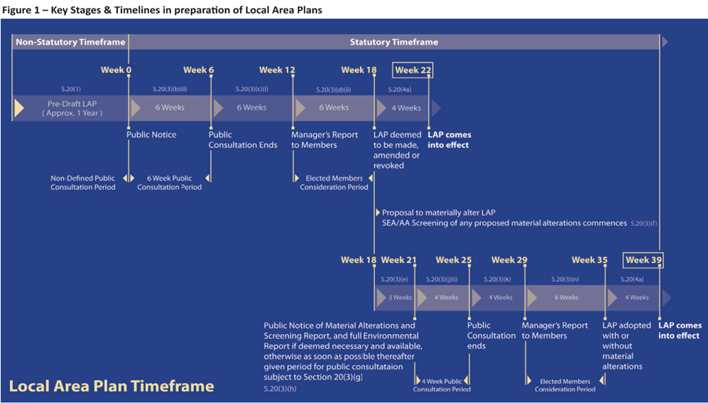
Current Stage

APPENDIX I

Formal submissions received and a summary of the issues raised
Appendix I, Table 1: Summary of formal submissions received between 19th Sept. 2017 and the 24th Oct. 2017
Sub. No. | Name/ Agent/Rep | Summary of Submission
1 | NTA | Movement & Transport  Legislative Background – Section 19(2A) of the Planning & Development Act (as amended) states that each planning authority within the Greater Dublin Area (GDA) shall ensure that its local area plans are consistent with the NTA ‘Transport Strategy for the Greater Dublin Area 2016-2035’ (The “Transport Strategy”).  In order to demonstrate consistency with the Transport Strategy the NTA recommends the following:  - Transport Investment Priorities – chapters 5 and 6 of the Transport Strategy set out the transport investment priorities for the GDA over the next 20 years. The following policies and objectives which facilitate or provide for the following should be included in the Draft LAP  - A review of public transport serving the Town in conjunction with the NTA, in particular focusing on local trips;  - Bus priority measures in Naas Town and Environs, where required;  - Rationalisation and upgrading of bus stops, bus bays and shelters;  - Provision of on-street directional signage to public transport facilities as appropriate;  - Implementation of the GDA Cycle Network Plan, with a specific objective prioritizing the development of the Grand Canal Greenway/Commuter Route from Sallins to Naas;  - Provision of cycle parking on-street and at public transport stops;  - Provision of a safer, more convenient and more comfortable walking environment including signage, junction reconfigurations and improved crossings;  - Road projects which are in accordance with the principles of Road Development as set out in section 5.8.3 of the Transport Strategy; and  - Widening of the M7 between Junction 9 (Naas North) and Junction 11 (M7/M9) to provide an additional lane in each direction;  - Measures which seek to reduce commuter parking and which contribute to greater turnover for parking for non-commuter purposes.  - Integration of Land Use and Transport Planning  - Residential development located proximate to high capacity public transport should be prioritized over development in less accessible locations in the GDA;  - To the extent practicable, residential development should be carried out sequentially – land which are, or will be most accessible to walking, cycling and public transport – including infill and brownfield sites are prioritized;  - Except in limited circumstance, trip intensive developments or significant levels of development should not occur in locations not well served by existing or committed high capacity public transport;  - The receiving environment at trip intensive developments (Including employment, retail, entertainment areas) should be designed in a manner that supports and prioritises sustainable modes;  - Strategic Transport function of national roads including motorways to be protected by the full implementation of “Spatial Planning & National Roads – Guidelines for Planning Authorities”;  - All non-residential development proposals in the GDA should be subject to maximum parking standards and based on public transport accessibility;  - In locations where the highest intensity of development occurs, an approach that caps car parking on an area-wide basis should be applied;  - For all major developments and all schools, travel plans should be conditioned as part of the planning permissions and be carried out in a manner consistent with existing NTA guidance (‘Achieving Effective Workplace Travel Plans: Guidance for Local Authorities’; Workplace Travel Plans: A Guide for Implementers’, and ‘Toolkit for School Travel’);  - Planning at the local level should promote walking, cycling and public transport by maximizing the number of people living within walking and cycling distance of their neighbourhood or district centres, public transport services and other services at the local level such as schools;  - New development areas should be fully permeable for walking and cycling and the retrospective implementation of walking and cycling facilities should be undertaken where practicable in existing neighbourhoods, in order to give a competitive advantage to these models (NTA Permeability Best Practice Guide);  - Where possible, developments should provide for filtered permeability – provision for walking, cycling, public transport and private vehicle access but at the same time restrict or discourage private car through trips; and  - To the extent practicable, proposals for right of way extinguishments should only be considered where these do not result in more circuitous trips for local residents accessing public transport, or local destinations.  In order for the Draft LAP to be considered consistent with the Transport Strategy it must demonstrate that the land-use zonings, and the transportation and planning policies and objectives are aligned with the above principles.  - National Transport Authority Guidance Documents – in addition the NTA recommends that the Draft LAP contains policies and objectives which state that guidance set out in the following documents should be taken into account in development and transport planning in Naas:  - National Cycle Manual;  - Permeability Best Practice Guide;  - Achieving Effective Workplace Travel Plans: Guidance for Local Authorities;  - Workplace Travel Plans: A Guide for Implementers; and  - Toolkit for School Travel  - Transport & Movement Assessment – To ensure the above the NTA recommends that an area-based transport assessment is undertaken to develop a transport plan for Naas that would inform policies, objectives and measures relating to transport and movement in the Draft LAP – this would fulfil Kildare County Council Development Plan 2017-2023 objectives:  - MT02 – prepare a Strategic Land Use & Transportation Study for the central towns including Naas  - MT03 – review and implement integrated Transport Studies for Naas  - TM02 – carry out a review of Traffic Management Plans in Naas in conjunction with the NTA  The NTA can provide guidance on how to progress with an area-based transport assessment and would welcome the opportunity to work with Kildare County Council in this regard.
2 | Department of Education and Skills | Education & Community facilities:  It is important that there is sufficient educational infrastructure to meet the needs of the community. The Department has worked closely with the Council in relation to securing sites for educational infrastructure and will continue to work with the Council in relation to the provision of new schools and the development of existing facilities – the Council’s zoning of lands for this use is critical.  The Department requests that the Council in zoning lands should refer to the Development Plans: Guidelines for Planning Authorities Appendix F (DEHLG, 2007) and the Dept of Education & Skills Technical Guidance Docs for primary schools and post –primary schools.  Any lands being zoned for educational purposes by the Council should be where the provision of services and access will not hinder the development of the schools within the required timeframe. The Council is requested to consider the favourable implementation strategies and phasing in order to ensure ready access to existing infrastructure and avoid disproportionate costs.  The Department requests that any such site reservations are made where possible as close as possible to community facilities such as sports facilities, libraries etc, so these can be shared between school and community. The Department is open to the concept of multi-campus schools where 2 or 3 primary schools are located side by side, or a primary and post primary sharing the same site, as this can reduce the amount of land required.  Where possible land adjacent to existing schools should be zoned appropriately to allow for the potential future expansion of these sites. In addition, the Council is requested to consider a policy of introducing buffer zones around existing school sites – to allow adequate separation from housing whilst also enabling increased school heights in established neighbourhoods for consolidation and intensification of populations.  The Programme of Capital investment – the list of school projects planned to go to construction during 2016 to 2021 was published on 17th November 2015 – Depts. website www.education.ie  Appendix 1 details how the Department calculates educational requirements based on demographic projections from the Council.  Appendix 2 refers to the technical guidance and other documents relating to educational provision  All technical guidance used in the design of new school buildings and extensions are available on Depts. website www.education.ie  Demographic changes in Naas will be monitored and additional educational facilities may be required. Therefore important to zone land for education along with other uses. Dept is available to meet with Council to discuss in more detail as the Draft LAP emerges.  Appendix 1 – Info used to calculate education infrastructure requirements. Based on projected population growth detailed in Draft Plan Dept calculates the following:  - 12% of population is of primary school going age  - 8.5% of population is of post-primary school going age  - Primary school accommodation is calculated on the basis of Pupil Teacher Ratio of 26:1 each class will have 26 pupils.  - New primary schools provided in multiples of 8 classrooms – there are eight class groupings between junior infants and 6th Class.  - New primary school ranging in size from 4-8 classrooms requires 0.77 hectares or 1.9 acres  - New school ranging in size from 8-16 classrooms requires 1.14 hectares or 2.8 acres  - New school ranging in size from 16-24 classrooms requires 1.6 hectares or 4 acres  - New school ranging in size from 24-32 classrooms requires 2.2 hectares or 5.47 acres  - Post primary the Dept refers to the size of a building by the number of pupils it will cater for – no. pupils along with curriculum dictates the range and extent of specialist facilities to be provided.  - Maximum size of new post-primary schools the Dept will build for is 1,000 pupil places  - A new 1,000 pupil post primary school requires 4.57 hectares or 12 acres of land  Appendix 2 – Site Suitability docs for download www.education.ie The Dept published two documents providing guidance for site suitability:  - Technical Guidance Doc 025 – Identification and Suitability Assessment of Sites for Primary Schools  - Technical Guidance Doc 027 – Identification and Suitability Assessment of Sites for Post Primary Schools  Attention drawn to the Dept Environment, Community and Local Govt guidelines “Sustainable Residential Development in Urban Areas” published May 2009 – no significant residential development should take place without an assessment on the impact of school provision (Chapter 4: Page 25). Dept Environment, Community & Local Government Website – www.environ.ie  Dept Education & Skills draws attention to the published (July 2008) Code of Practice for Planning Authorities and the provision of schools – Item 2 and the need for consulting with Dept regarding the assessment of sites
3 | TII – Transport Infrastructure Ireland | Movement & Transport:  The Trans-European Transport Networks (TEN-T) are a planned set of transport networks across Europe. The TEN-T regulations define the objective of increasing the benefits for road users by ensuring safe, secure and high quality standards for road users and freight transport in a coordinated fashion to achieve integrated and intermodal long-distance travel routes across Europe. The N/M7 is identified as part of the TEN-T Core Network and this will have policy repercussions for the Council to consider in local area plan preparation.  National roads play a key role within Ireland’s overall transport system – the NTA’s Transport Strategy for the GDA 2016-2035 identifies the N/M7 corridor as the busiest radial route into and out of Dublin, connecting the Capital with regional cities of Limerick, Cork and Waterford and the economic spine running from Belfast to Cork.  TII’s view N/M7 and associated junctions represent one of the most important national routes in the country.  The NTA Transport Strategy identifies congestion as a significant problem along the N/M7 from south of Naas towards the M50, mainly associated with the large volume of car-based commuting into the Metropolitan Area. While the upgrading of Newlands Cross to a grade-separated interchange has alleviated this to an extent, congestion on the N/M7 and connecting roads in the vicinity of Naas is a growing problem. The NTA identify that this will need to be addressed to mitigate the negative impact of local and commuter traffic on the N/M7’s primary intended function in catering for strategic trips of high economic value.  The Council will be aware of the planned enhancements to the N/M7 Corridor included in the County Development Plan, NTA Transport Strategy and Government’s Capital Investment Plan – requested that these enhancements are reflected in the Draft LAP and that the Plan has cognisance of the issues identified in the NTA Transport Strategy.  Strategic Transport Assessment / Area Based Transport Assessment – The TII is of the opinion that the Draft LAP should be prepared on the basis of an evidence based area transport assessment in accordance with the requirements of the DoECLG Spatial Planning & National Roads Guidelines.  TII stated that a strategic transport and traffic assessment is required for the N/M7 junction at Maudlins – section 1.4 of updated TII Traffic and Transport Assessment Guideline (2014) addresses Area Based Transport Assessment.  Assessment and analysis in support of M7 Naas to Newbridge Upgrade Scheme identified significant congestion issues particularly on the westbound carriageway in the evening at peak times. Issues at Maudlins junction further compounded by both Sallins & Monread roads exceeding their design capacity referenced in Council’s ‘M7 Osberstown Interchange & R407 Sallins Bypass Scheme’ documents.  Development Plan principles promoted in DECLG Spatial Planning and National Roads Guidelines are explicit – where a development plan or local area plan proposes development to take place on zoned lands adjacent to national roads which could affect the operation and capacity of such roads, the planning authority must prepare its plans in such a way that demonstrates that such roads can continue to perform their strategic transport function into the future.  Guidelines require that planning authorities must develop an evidence-based approach to planning policy and undertake detailed transport modelling, as necessary. TII requests that such an assessment is undertaken to inform the preparation of the local area plan.  The Naas Draft LAP should be informed by an evidence based area Transport plan linked to clear phasing and implementation plan included in the LAP to ensure the required infrastructure is provided in a co-ordinated way to support development objectives, safeguard the strategic function of the adjoining national road network and align with the provisions of DoECLG Spatial Planning & National Roads Guidelines (2012).  Any development proposed in proximity to the M7 junctions in Naas is subject to appropriate plan led policies.  TII requests that the new LAP for Naas would co-ordinate land use planning for Naas Town and its environs in a single co-ordinated planning framework.  Specific Policies & Objectives – TII recommends consideration given to including requirements of Chapter 3 of the DECLG Spatial Planning and National Roads Guidelines into the Draft LAP concerning specific objectives relating to:  Traffic and Transport Assessment – Road Safety Audit – Environmental Noise – Signage etc.  Council requested to reference TII Traffic & Transport Assessment Guidelines (2014) in the Draft LAP relating to development proposals with implications for national road network. Thresholds advised in the TII Traffic & Transport Assessment Guidelines (2014) including sub-threshold TTA requirements – relate specifically to development proposals affecting national roads.  TII is available to assist and support the Council in developing sustainable land use and transport based plans for Naas and to discuss observations with the Executive of the Council.
4 | Dept of Culture, Heritage & the Gaeltacht | Natural Heritage and Open Space  Legislation – That the Plan and the SEA take account of the Biodiversity Convention, Ramsar Convention, EC Habitats Directive (Council Dir 92/43/EEC) EC Birds Directive (2009/147EC) Wildlife Acts 1976 to 2012 and the EC (Birds & Natural Habitats) Regs 2011 to 2015.  Designated Sites – That the Plan to include a natural heritage section. Designated sites within or adjoining the Plan Area listed and mapped – candidate Special Areas of Conservation (cSAC), Special Protection Areas (SPA) Natural Heritage Areas (NHA), Proposed Natural Heritage Areas (pNHA), Nature Reserves and Refuges for Fauna – sites detailed on http://www.npws.ie/  Protected Species – That the Plan recognise protected species occur outside designated sites and take note of the National Biodiversity Plan and the need to protect county bio-diversity.  Article 10 Habitats Directive – The Plan to include provisions to encourage the management of features of the landscape of major importance to wild fauna and flora (includes linear landscape features acting as ecological corridors including water courses (rivers and streams, canals, ponds and drainage channels etc.), woodlands, hedgerows, road and railway margins.  Hedgerows, bats and other protected species – Hedgerows should be maintained where possible, where trees or hedgerows have to be removed there should be suitable planting of native species in mitigation. Hedgerows and trees should not be removed during the nesting season (i.e. March 1st to August 31st). Bat roosts can only be destroyed under license under the Wildlife Acts and a derogation under the Birds and Natural Habitats Regs, a license would only be given if mitigation measures implemented.  Rivers & Wetlands – Draft LAP should recognize the importance of wetland habitats and ensure that such sites are protected. Floodplains if present should be identified in Plans and left undeveloped to allow for the protection of valuable habitats and provide areas for flood water retention. Draft LAP should take account of guidelines for Planning Authorities “The Planning System and Flood Risk Management” DoEHLG Nov 2009.  IFI should be consulted with regards to impacts on fish species – Council to consult “Planning for watercourses in the urban environment” download – http://www.fisheriesireland.ie/fisheries-management-1/86-planning-for-watercourses-in-the-urban-environment-1/file  Water – ground and surface water should be protected from pollution. Planning Authority should ensure that adequate sewage treatment facilities are, or will be in place prior to any development proposed in the Plan. The Planning Authority should ensure that adequate water supplies are present prior to development. Care should be taken to ensure any proposed water abstractions or waste water discharges do not negatively impact on Natura 2000 sites.  Roads – where roads listed for improvement and upgrading in the Plan, the opportunity should be taken to address inadequate existing mitigation measures or impeded passage. In making provision (Plan) for transport (reserving lands, integrating or upgrading routes this should be based on information on ecological constraints and allow for impacts to be avoided / mitigated.  Alien Invasive Species – such as Japanese Knotweed and Giant Hogweed. The Plan should have a policy to protect against accidental introduction of such species during development.  Amenity Developments – negative impacts on biodiversity and designated sites can occur as result of development (walking routes, Cycleways, seating, lighting etc.) this can lead to habitat loss, erosion and added disturbance by humans and dogs.  A 10m riparian buffer on both banks of a waterway considered to comprise part of the otter habitat. Any walkways, cycle tracks or greenways marked on the Plan should therefore be a suitable distance from the water’s edge. Pedestrian and cycle routes need ecological assessments in their planning and design and should not target sensitive ecological sites or parts of sites.  Green Infrastructure – it is important to reference and refer to EU Green Infrastructure Strategy. Care should be taken to ensure that green infrastructure involves greening existing infrastructure rather than adding built infrastructure to existing biodiversity corridors.  Pollinators – recommended that the natural heritage section of the Plan should also contain a policy on implementing the All Ireland Pollinator Plan 2015-2020 – In particular uncut road verges where safety allows can provide wild flowers as food for pollinators and should be encouraged.  SEA – Integrated Assessment – in line with EPA publication integrated biodiversity important that SEA process should take place in consultation with teams working on the Draft LAP and the AA – each process can help inform the other. The SEA should examine the effects of policies, objectives and any indicative maps / zonings as well as cumulative impacts with other plans and projects within and outside of the Plan area.  Legislation – The Plan and the SEA take account of the Biodiversity Convention, Ramsar Convention, EC Habitats Directive (Council Dir 92/43/EEC) EC Birds Directive (2009/147EC) Wildlife Acts 1976 to 2012 and the EC (Birds & Natural Habitats) Regs 2011 to 2015. Revised version of the Wildlife Act 1976 is available on the Law Reform Commission website – http://revisedacts.lawreform.ie/revacts/alpha#W  Baseline Data – details of designated sites found at http://www.npws.ie/. For Flora and Fauna in the SEA data of National Parks & Wildlife Service (NPWS) consulted  Water issues and Wetland Habitats – the impact of any water abstraction and wastewater discharge schemes resulting from the Plan should be fully assessed – impacts on surface water or groundwater should be assessed on a catchment or aquifer basis. Where a proposed policy would result in a development in / alongside a river or other waterway the cumulative impact on species and habitats needs to be assessed cumulatively on a catchment basis.  Appropriate Assessment  Conservation objectives - In order to carry out the appropriate assessment screening and/or prepare a NIR, information about the relevant Natura 2000 sites including their conservation objectives will need to be collected.  Integrated assessment - In line with the EPA publication on integrated biodiversity impact assessment it is particularly important that the appropriate assessment procedure, commencing with stage 1 screening, should take place in consultation with the teams working on the draft Plan and SEA as each process can help inform the other to ensure that the objectives and policies in the draft Plan will have no significant effects on any Natura 2000 site. The appropriate assessment should examine the effects of policies, objectives and any indicative maps or zonings, as well as cumulative impacts with other plans and projects both within and outside of the Plan area.  Cumulative and ex-situ impacts - Other relevant Local Authorities should be consulted to determine if there are any projects or plans which, in combination with this proposed Plan, could impact on any Natura 2000 sites.
5 | Irish Water | Infrastructure – Water and Wastewater services  Wastewater Services – current capital schemes to address existing constraints are underway and due for completion in 2021. IW will periodically assess trunk sewer capacity and develop further works to support future upgrades according to development demand.  Naas is served by Osberstown Waste Water Treatment Plant – this has been upgraded from an 80,000 PE capacity to a 130,000 PE capacity.  Water Services – local network reinforcement is required to support specific sites and future development.  IW available to discuss the preparation of the LAP with the Council. IW advises that they are only in a position to confirm water and wastewater availability for site specific new development though the pre-connection enquiry process.  IW enclosed a menu of appropriate objectives / policies for water services in development plans:  General Policies in relation to Water Services:  a) to work closely with Irish Water to identify and facilitate the timely delivery of the water services required to realize the development objectives of this plan;  b) When identifying areas for development, to ensure that full consideration is given to the level of investment that will be required in the provision of water services – particularly in environmentally sensitive areas – to ensure that the provision of water services does not negatively impact on habitat quality, species diversity or other environmental considerations;  c) to facilitate the provision of integrated and sustainable water services through effective consultation with Irish Water on the layout and design of water services in relation to the selection and planning of development areas and the preparation of master plans and SDZ’s;  d) to maximize the use of existing capacity in water services in the planning of new development;  e) to ensure that adequate water services will be available to service development prior to the granting of planning permission for those developments and to require developers to consult Irish Water regarding available capacity, prior to applying for planning permission;  f) to protect existing way leaves and buffer zones around public water services infrastructure through appropriate zoning and to facilitate the provision of appropriate sites for required water services infrastructure as necessary;  g) to ensure that development proposals comply with the standards and requirements of Irish Water in relation to water and wastewater infrastructure to facilitate the proposed developments.  Water Supply:  h) to protect both ground and surface water resources and to work with Irish Water to develop and implement Water Safety Plans to protect sources of public water supply and their contributing catchment;  i) to minimize wastage of water supply by requiring new development to incorporate water conservation measures;  j) to promote water conservation and demand management measures among all water users.  Wastewater Services  k) to ensure that the Local Authority provides adequate storm water infrastructure in order to accommodate the planned levels of growth within the plan area and to ensure that appropriate flood management measures are implemented to protect property and infrastructure;  l) to require all new development to provide a separate foul and surface water drainage system and to incorporate sustainable urban drainage systems;  m) to prohibit the discharge of additional surface water to combined (foul and surface water) sewers in order to maximize the capacity of existing collection systems;  n) to support Irish Water in the promotion of effective management of trade discharges to sewers in order to maximize the capacity of existing sewer networks and minimize detrimental impacts on sewage treatment works;  o) to refuse residential development that requires the provision of private waste water treatment facilities, other than single house systems;  p) to ensure the changeover from septic tanks to collection networks in all cases where this is feasible (subject to connection agreements with Irish Water) and that all new developments utilize and connect to the public wastewater infrastructure. The provision of individual septic tanks and treatment plants in the plan area will be strongly discouraged to minimize the risk of groundwater pollution. Where such facilities are permitted, full compliance with the prevailing regulations and standards, including the EPA’s Code of practice Wastewater Treatment and Disposal Systems Serving Single Houses (EPA 2009), as amended, will be required;  q) to ensure that private wastewater treatment plants, where permitted, are operated in compliance with their wastewater discharge license, in order to protect water quality;  r) to require existing developments that are in close proximity to a public sewer to connect to that sewer, subject to a connection agreement with Irish Water;
6 | Inland Fisheries Ireland | Infrastructure & natural Heritage and watercourses  Naas is traversed by some of the more productive and important salmonid systems in the region. River Liffey and several of its tributaries are great supports of the fish population. The canal in Naas supports significant populations of coarse fish and highlights the sensitivity of the County’s aquatic systems.  The Draft LAP should facilitate the utmost priority for the protection and conservation of salmonid systems in the area – including the River Liffey. IFI’s policy is to maintain watercourses in their open natural state in order to prevent habitat loss preserve and enhance biological diversity and aid in pollution detection. Lands adjacent to surface waters, particularly salmonid systems designated as areas of open preservation allowing protection/ enhancement of biological diversity whist providing open space and recreational amenity.  Natural heritage objectives should include the maintenance of buffer zones along both banks in the LAP area – to protect fisheries and ecological interests.  To ensure that impacts from development / change in land use do not interfere with aquatic environment it is essential that those areas adjacent to waterways are managed in an appropriate manner. River corridors and buffer zones are an ideal and natural way to link areas to attain a high quality Green Infrastructure network for Naas.  Projected growth targets require sufficient treatment capacity within the receiving sewerage systems locally and downstream of waste water treatment plants.  IFI highlight the importance of building a comprehensive and robust assessment of both local infrastructural needs and Local Authority capacity to meet those needs into the plan. Imperative that the LAP works in harmony with Water Services Programme of Irish Water.  The LAP should create the policy framework for sustainable development, be consistent with the River Basin Management Plans and comply with the requirements of EU Water Framework Directive, while promoting the integration and improvement of natural watercourses in urban renewal and development proposals.
7 | E.P.A – Environmental Protection Agency | Infrastructure Natural Heritage Biodiversity and Habitats  Critical Service Infrastructure (drinking water, wastewater, waste) the LAP should include a commitment to support and collaborate with relevant stakeholders including Irish Water. Development proposals and associated population increases should be linked to the ability to provide adequate and appropriate critical service infrastructure.  Water Related Considerations - Draft River Basin Management Plan for Ireland 2018-2021 (DHPCLG) due to be adopted within the lifetime of the Plan. This should be taken into account in preparing the SEA and Plan.  SEA should take into account the need to protect water quality status.  The EPA WFD Catchment Management Portal has useful tools to assess and monitor water and to communicate water quality information.  Flood Risk – the Plan should ensure that development within the Plan area is appropriate to the risk of flooding identified and that vulnerable land uses are avoided in flood zone A/B areas where possible. Flood Risk Management Guidelines (DEHLG 2009). Recommendations of the Eastern CFRAM study (Flood Risk Management Plan(s) for the area should be reflected in the plan.  Biodiversity – SEA should consider describing whether invasive alien species are present within the plan area, and if present, a commitment should be given to implement appropriate management and control measures.  Habitat / Green Infrastructure Mapping – any available habitat/green infrastructure mapping of the Plan area should be considered in the context of environmental protection. If mapping is not available consideration should be given to a commitment to undertake such mapping to enhance baseline environment data information to help inform the Plan.  Non-designated Biodiversity – The Plan should commit to protecting and, where possible, enhancing biodiversity outside of designated areas – including ecological corridors/linkages, hedgerows and wetlands within and adjacent to the Plan area. Existing green / blue infrastructure should be retained and integrated into the Plan to help maintain and conserve ecological corridors and associated species and habitats.  Landscape - Areas of important visual amenity and significant landscape character should be protected in the Plan.  Relationship with other plans and programmes – a number of key influential plans to consider in the SEA and Plan:  - Draft National Planning Framework – Ireland 2040 Our Plan (DHPLG 2017)  - National Mitigation Plan (DCCAE)  - Regional Spatial and Economic Strategies (To commence 2017/2018)  - Draft National River Basin Management Plan (DHPLG 2017)  Additional plans are detailed in Appendix II of the SEA Scoping guidance document.  Climate Adaptation / Climate Mitigation – The Plan should consider how key national level commitments for climate adaptation and climate mitigation can be advanced at a local authority level.  EPA guidance document ‘Research report 164 – Local Authority Adaptation Strategy Development Guideline’ assists local authorities prepare climate adaptation strategies. Preparing a Climate Adaptation Strategy for the County would assist future land use planning in the County and ensure that climate adaptation measures are considered, prioritized and implemented.  Scoping Process Guidance – updated guidance on the SEA Scoping Process, including an SEA Pack, Integration Guidance, SEA Checklist, SEA Spatial Information Sources and guidance on Integrating Climate Change into SEA is available on the EPA website and should be considered in the preparation of the SEA – http://www.epa.ie/pubs/advice/ea/  Guidance on ‘Developing and Assessing Alternatives in SEA (EPA 2015) is available at – http://www.epa.ie/pubs/advice/ea/developingandassessingalternativesinsea.html  EPA State of Environment Report 2016 -= ‘Ireland’s Environment – An Assessment’ (EPA 2016)the recommendations, issues and challenges described in the report should be taken into account as relevant and appropriate to the Plan area in preparing the Draft Plan and associated SEA – http://www.epa.ie/irelansenvironment/stateoftheenvirionmentreport/  SEA WebGIS Search and Reporting Tool – allows users to explore, interrogate and produce indicative reports on key aspects of the environment in specific geographic areas. Reports should be used to inform the SEA screening and scoping stages for Plans and Programmes with particular reference to land use sector – http://www.edenireland.ie  Environmental Authorities – Under SEA Regs notice should also be given to the following:  - Minister for the Environment, Community and Local Government (now the Minister for Housing, Planning, Community and Local Government)  - Minister for Agriculture, Food and the Marine and the Minister for Communications, Energy and Natural Resources (now Minister for Communications, Climate Action and Environment), where it appears to the Planning Authority that the Plan or programme might have significant effects on fisheries or the marine environment.  - Where it appears to the competent authority that the Plan or programme, or amendment to a plan or programme, might have significant effects in relation to the architectural or archaeological heritage or to nature conservation the Minister for Arts, Heritage and the Gaeltacht (now the Minister for Arts, heritage, Regional, Rural and Gaeltacht Affairs) and  - Any adjoining planning authority whose area is contiguous to the area of a planning authority which prepared a draft plan, proposed variation or local area plan
8 | Cllr. Seamie Moore | Number of Issues  General Indicators of a Good Town – Naas:  - The availability of pre-school centres and both primary and second level schools have been a major factor encouraging ‘settlement growth’ in Naas.  - It has a high level of public and well-laid out passive amenities and recreational facilities.  - It has a high level of ‘community interaction’ and ‘supported groups’.  - It is the location for Naas General Hospital, a county-wide medical services centre.  - It has an advantageous proximity to Dublin City and to many national motorway routes.  - Naas is now well-served by Sallins Rail Station and Iarnrod Eireann.  - It has a recognized low-level ‘crime-rate’ and ‘a drugs free’ culture.  - It has a beautiful easy-accessible, walking, cycling and rural type environment.  - It has an extremely long, interesting and proud history as a major Irish Town.  - This has an attached wealth of natural and built heritage in and around Naas.  - It now has infrastructural investment in roads and other services that supports further and continuous development of the area covered by the new LAP.  - It has been designated as the ‘County Town’ to reflect the importance, visionary management and planning of Kildare County Council for the County of Kildare.  - It has an active, positive and helpful Local Authority and Municipal District Committee.  Summary – It should be a priority of the LAP and KCC to protect, promote and grow those vital, obvious and essential strengths in parallel with any future expansion of the Town’s population and economic development.  Retail Naas –Focus only on bulking-up and in-filling of Town Centre space over the duration of the LAP.  The Local Authority should take measures to promote development, penalise land hoarding owners or compulsory acquire idle sites that are not being utilised to the maximum benefit of the town. Promoters of Retail Development should be directed to invest in such idle town centre sites. The eventual development of the unfinished Shopping Centre will contribute to that bulk-up infilling.  Industrial / Commercial Naas - There is a need to promote Industrial/Commercial/Technology investment into Naas and this can only be best achieved by having a number of strategically located land banks readily zoned and available for a promotion. This objective should be twinned with the development of a SMEs Centre to provide incubation units to help develop smaller business investments.  Education - Provide sites for District pre-schools, primary and second level schools and seek support for at least out-reach third level education centres for Naas.  Town Promotion / Heritage / History / Hospitality - Improve Canal linkage with the Town Centre and invest in the promotion of Naas Tidy Towns Committee as a future National Best Kept Town in Ireland, bringing tourism, visitors and future investment.  Canal Harbour Development - KCC should now procure the land opposite Naas Canal Harbour by way of land exchange, CPO or purchase. This would allow the Authority to develop the site in a way to suit a future road infrastructure, people’s park, linear or block, build a canal boating marina and consider a board walk attraction, to link the western side of the canal between The Harbour and Abbey Bridge, as part of a Greenway Development.  De Burgh’s Oldtown Woodland Gardens - As part-owners of Oldtown Woodland Gardens it is imperative that Kildare County Council secures the remainder of The Long Pond and the water featured Alder Grove area, including St Patrick’s Well, as historic and valuable amenity facilities for the people of Naas and Kildare. These gardens also include the termination section of local water streams and access must be must be maintained by Kildare CC /Irish Water to prevent flooding in the town centre.  Naas Moat Hill / North Moat - This ancient and protected feature should be developed as a historical monument, perhaps adding a viewing facility across the flat midlands of Kildare, one of the original reasons for its construction at that location.  Naas Fair Green / South Moat - This area of ground should be added to the Protected Structures List to prevent further development of the site.  Residential Development –  1. New rules/regulations/views should be considered to allow for high rise apartment type developments in Naas, excluding cars and car-parking requirements.  a) At profile town entrances, near main traffic route corridors or public transport routes.  b) Suitable low ground, no/low flood-risk areas.  c) Key undeveloped centre town sites.  2. Provision should now be included in this LAP to allow Commercial/Retail premises to be considered for a return to previously designated ‘Residential’ accommodation in a new Commercial/Retail/Residential zoning designation.  3. The sequential/infilling recommendation on National Planning Guidelines should be used to ensure that lands alongside of existing residential developments within the town area is used for Residential Development and not for Commercial/Industrial development as with the former old GAA grounds. Commercial developments should go to zoned Development Parks outside of Residential Naas.  4. The success of a former planning official in KC, in bringing about the re-arranging of ‘green area’ space in multiple housing developments in the Monread Area to eventually provide a 35 acre District Park, should be studied. This would/could contribute greatly to the need for Municipal Sports Grounds in a developing town.  Community Amenities: There is a need that KCC provide more developed amenity sports lands and accommodation facilities for clubs and teams that are unable to provide such grounds by themselves.  1. Under no circumstances should planning officials propose the zoning designation of ‘Community/Amenities’ or ‘Future Sports Amenities’ in any Draft LAP unless Kildare CC has secured the lands or intends to purchase or compulsory acquire the lands.  2. KCC should change existing regulations that presently prevent the sports clubs from building premises or the positioning of steel containers as Club Facilities on municipal owned sports grounds. Such facilities will be the minimum standard of facility in order that teams can have toilet and changing rooms at future venues.  3. Municipal Sports Grounds of 5 hectares or more should have changing and toilet facilities provided on site by KCC.  Roads Infrastructure In a future increase in the size of Naas Town, the success of the present Inner Relief Road in harnessing the traffic from an old town roads/streets system within that loop, should dictate that a future Outer Ring Road, should be considered to link with the Inner Relief Road and shape the locations and carry the required services for residential, commercial, educational, sporting and amenity facilities in each quadrant district and provide access back to the major motorway routes.
9 | County Kildare Chamber | Economic Development, Education, Infrastructure, Transport, Town Centre  Our Vision for Naas 2018-2024:  - Location of choice for existing and potential business enterprise in the county  - Sustainable, educated, skilled, confident, and entrepreneurial community  - Connected regional, national and international infrastructure enabling growth  - A town excelling in its quality of life and place  Location of choice for existing and potential business enterprise in the county –This LAP must ensure that Naas has sufficient land zoned for enterprise development to meet the demands that the Chamber expect in the forthcoming years. With the M7 Naas to Newbridge Bypass Upgrade, M7 Osberstown Interchange and the R407 Sallins Bypass – Naas will see an increase in foreign direct investment and companies looking to relocate from other counties in Ireland.  Brand Naas – Naas will deliver in employment and enterprise in the period 2018 – 2024. Need to be ready and Brand the town and promote the town locally, nationally and internationally as the location of choice for existing and potential enterprise. Connect Naas – Complete our road projects and ensure that initiatives such as linking commuters from Sallins Train Station to Millennium Park and to Naas become a reality.  Sustainable, educated, skilled, confident, and entrepreneurial community For our economy to thrive, there must be investment in our workforce. The quality of education and research institutions in our region with their capability and track record of adapting to the current and emerging needs of industry is excellent.  Our relationship with Maynooth University must develop further and engagement with business and education providers must also improve. The future educational needs are likely to be significantly different going forward given the pace of changes within technology. This Local Area Plan must deliver on the urgent need to zone land for education use.  A dedicated apprentice and traineeship centre will assist business needs in Naas.  A third level campus linked to Maynooth University will enable our population to study in the town.  Connected regional, national and international infrastructure enabling growth - Naas is well connected by road and rail. The M7 Naas to Newbridge Bypass Upgrade, M7 Osberstown Interchange and R407 Sallins Bypass will be completed by 2021. Our close proximity to Dublin Airport and Port is a competitive advantage when promoting the town.  The wastewater treatment plant in Osberstown has recently been enhanced. Building on the strengths of our existing infrastructure, and aligned with proposals for an increased population and employment density in Naas. The Chamber endorses an integrated town public transport corridor that will link Sallins Train Station, Millennium Park with Naas Town Centre.  The Chamber encourages smarter travel and will work with all key stakeholders to ensure that people both living in the town and working in the town enjoy a smarter way to commute.  Naas needs to be promoted as the most connected town in Ireland. Forward thinking and forward planning will ensure Naas continues to thrive. It must ensure that it seeks to improve the safety, capacity and efficiency of an integrated transportation infrastructure in the town. The plan must address the need to pedestrianise the Main Street of Naas. The town’s services are partially underground and this needs to continue to ensure the town does not lose its appeal.  A town excelling in its quality of life and place - The upgrading of Poplar Square and further upgrades in the main thoroughfare in the town are welcomed and encouraged. The plan should introduce policies that protect the rural landscape and the town landscape whilst helping preserve open space, protecting air and water quality, providing for recreation and creating tourist attractions that bring investments into the local economy.  A town excelling in the quality of life and place lays the foundation for inward investment and for the attraction and retention of talented people.
10 | RGDATA Local Shops – Local Communities | Town Centre, Retail  The LAP should ensure that adequate and suitable provision is made to meet the needs of the growing and changing population, both overall and locally and provide for a vibrant retail mix, healthy competition and consumer choice.  Kildare County Council should acknowledge ‘The Framework for Town Centre Renewal’ published by Retail Consultation Forum and agree to follow the 3 step collaborative approach to Town Centre Renewal.  Step 1 – prepare a database of all key stakeholders in order to engage with them as part of the Health Check  Step 2 – Establish a Town Centre Management Partnership or ‘Town Team’ to oversee the recommendations of the Health Check.  Step 3 – Prepare and implement a Town Centre Plan.  In order to ensure sustainable retail development and promote the vibrancy and vitality of Naas Town Centre in the LAP- no new retail developments should be approved until the Town Centre Health Check is undertaken and the Town Plan is agreed.  The Health Check will help to identify key data about the town and assist the Local Authority in identifying what new development is required, what is in the best interest of promoting a good retail mix, what will best service the population of the town, draw more footfall into the town centre, ensure the vibrancy and vitality and provide sustainable  Retail Planning Guidelines 2012 – Appendix on Town Centre Strategy which includes:  - A profile of the city or town centre identifying the essential qualities of the centre and seek to ensure it continues to meet the needs of the community it serves by consolidating and building on its existing strengths;  - A visioning statement, where a shared vision is drawn up and a strategy / action plan for the centre is then prepared to implement the statement;  - Implementation proposals – from strategic to the specific detailing responsibilities and delivery timetables; and  - Provisions for monitoring and review to ensure that the appropriate actions are being progressed and that changing circumstances are considered.  RGDATA urges that vacant sites in the town are fully investigated for reuse.  Developers with new retail proposals are directed to design plans to fit into the existing retail zones to enhance the town, drive footfall, improve economic performance, retain jobs and facilitate new job creation.  The LAP should state clearly that the Council use its powers to resist proposed developments that do not deliver on the criteria set out in the plan and encourage developers to redesign or relocate developments so that they enhance existing centres.  Town, Village & Rural Renewal and Regeneration: - The LAP should include a commitment that the focal point for retail will be the core of the town and that new retail developments will not be permitted on edge of town, or out of town sites.  RGDATA welcomes the ‘Action Plan for Rural Development’ – The LAP should embrace the objectives of this Plan.  Retail Hierarchy - The Plan should clearly establish the retail hierarchy throughout the town and ensure that there is no over development of local, or neighbourhood centres, edge of town or out of town sites or unsuitable uses in retail parks – effectively drawing business away from the town already experiencing high vacancy rates and loss of footfall.  Neighbourhood Centres – The level of retail provided in villages and neighbourhood centres should relate to the local area. KCC should ensure that neighbourhood centres retain their community status and ensure that they do not create a counter attraction to existing town centres.
11 | Abbey Bridge & Canal Rd Residents Assoc | Transport, Canal Greenway, Amenity & Recreation  Issues of concern arise from traffic that accesses the centre of Naas Town. The increase in pedestrian traffic onto the private road and over Abbey Bridge and along Abbey Road, raise issues of traffic and pedestrian accidents.  Previous submissions have been made to develop and use this area in a safe and community based approach whilst respecting the amenity value of the Grand Canal.  The canal spur area should be used for amenity and recreation uses and need to ensure that this is not developed for commercial activities. Previous submissions are attached as appendices and referenced:  - Designation of Town Centre in place of LAP for the area known as McCormack’s Field – 5.5acres NW of the canal. This area should remain and zoned amenity and develop a Town park.  - Narrow open and amenity space on the northern bank of the Grand Canal – incorporate into the development of Town Park and the proposed Future Park straddling Grand Canal north Tandy’s Bridge.  - That proposed new roads in the NW quadrant area, should not cross the canal, or connect and encourage additional traffic to use the existing bridges. This area should be developed for a Town park accessed through pedestrian and cycle bridges.  - Future Park and Town Park in the Canal Harbour Area developed for non commercial and non residential uses.
12 | Naas Access & Disability Group | Heritage, Amenity, Housing, Transport, Urban design, Canal Area  Lakeside Area – integrate the Famine Graveyard, Wildlife Area and Fairgreen. Include a sensory, disability friendly planting section on Fairgreen and outdoor gym and large chess set facility.  Jigginstown Land and Castle – remove the scaffolding and place roof over the structure. Create an adventure creative activity area inside the space. Develop an area of open space where families can enjoy the area and have a bandstand with links on the open space on other side road linking through to the Harbour area and Mills.  St David’s Castle –purchase the castle and the former business on Corban’s Lane – creating a car park and entrance to the castle. Open up the castle as a tourist attraction for the Town. Create linked green and open space within St. David’s Church  De Burgh Woods – KCC should acquire and create an entrance area so people can access the walks and wooded area safely.  Harbour Area & Canal Walks – To be a special area of development, allow the historic house to be renovated to accommodate senior citizens in a safe environment. Canal area should be only used for local access with some local parking.  Housing – incorporate more 2 bed housing for the elderly in new estates – the numbers of people in this cohort likely to increase dramatically. This will free up properties for families to use. Elderly friendly development – ease of access, age friendly and special needs adaptable.  Streetscape & Urban Design – paths and paving in the town are in poor condition and need adequate and sufficient investment to upgrade and keep maintained – all new housing estates should be accessible and wheelchair standard.  Naas General Hospital – pedestrian crossing is requested at the entrance to this hospital  McAuley Place – request for a zebra or pedestrian crossing in this area  Greenways – all surfaces should be of a high quality, cyclists should be separated from pedestrians  Additional toilet changing area for disabled persons in town, currently there are few locations where disabled persons can use facilities.
13 | Naas GAA | Sports Amenity, Naas GAA  The Submission refers to lands between Naas GAA and Sallins Road (ownership of Springwood Ltd).  Essential that Kildare County Council protects existing open space and amenity land-use zoning in the LAP 2018-2024.  Naas GAA as a locally based community and sporting organization has an urgent requirement for additional amenity land to accommodate for its growing membership.  Naas GAA aspires to acquire an interest in these lands and to form a common arrangement with Scoil Bhride Primary School on Sallins Road in order to maximize the use of amenity land available to both.  Current Land –Use Zoning :Open Space and Amenity to be retained as Open Space and Amenity to facilitate the future expansion of the amenity lands serving the primary school to the north and to ensure that the vista from the Sallins Road to the Canal is maintained free from development. This area of open space shall not form part of the open space required as part of any adjoining residential development.
14 | Naas Tidy Towns Neighbourhood Greenway | Movement & Transport, Town Centre, Retail, Amenity & Open Space, Heritage  Vision – Naas will become the most sustainable town in Ireland – Walking and cycling should be prioritized over cars – Our greenway Plan for the town should be laid down on the LAP and system connected in a seamless way allowing transition from area to area – Main Street pedestrianised.  Use County Town Status – Pilot Town for others to follow – pedestrianisation of the Main Street to improve the public realm and increase economic activity.  Key Challenges Facing Naas – Congestion is big problem within the town and there is a need to encourage people to use other transport modes. Cycling and Walking should be promoted and discourage, or not improve facilities for the car including car parking. There is a need a lorry/truck ban on Main Street.  How can Naas be a great town for older generation, young people and a multi ethnic community? – safe network greenways that are connected then it will enable all users to access the town by many modes of transport. Roads are not safe to cycle on. Need to build segregated cycle tracks that are able to be used by motorized wheelchairs.  Town centre, Retail and Urban Design – parking in the back-lands of the two off main street, pedestrianise Main Street and use Corban’s Lane to loop the Town. Cycle Tracks to link and terminate in the Town Centre.  How reduce vacancy rates and retain / attract new uses in town? – Greenway will bring many visitors to the town. Naas is 20 miles from Dublin.  How make the town more attractive- Pedestrianise Main Street, Improve the public realm at Poplar Square, better seating, help Tidy Town s with their initiatives, remove signage clutter, set standards for shopfronts, reduce congestion and putting in place a lorry/truck ban. Promote and complete Greenway, grow more trees on main Street, increase the utilities available in places – electricity and water to enable the better use of these sites.  Movement & Transport – Congestion is the main issue for residents, workers and visitors. Discourage the use of car for the school run – encourage the use of walking and cycling – lorry/ truck ban should be in place for the town.  How address – Greenway Grid incorporated into the LAP plan map (Oldtown Demense worked but now need a bridge to connect up to the canal)  How reduce over reliance on vehicular transport – build safe routes to schools and clubs. Builders to comply with standards laid down in the cycle manual. New developments should be permeable by cyclists and walkers in a segregated way (no shared space = conflicts), Shared bike scheme.  How make the town a safer place for pedestrians, cyclists and vehicle users? Pedestrianise Main Street, separate cyclists and pedestrians, truck ban in the town centre.  How can cycle and pedestrian movement be encouraged – develop the linked Greenway; replace car spaces with bike spaces. When designing community facilities such as school the design of safe routes and travel plans should be required. Design and develop Park and Walk facilities with safe direct routes to school. KCC should work with Dept to develop pilot bike to school scheme – need to design access points from the Greenway to schools and community facilities and businesses.  Housing & Community – level and range of recreation and community facilities cater for residents? – there are four parks in Naas – Monread, Ballycane, K-Leisure and Lakelands Parks. With proposed Canal Linear Park, De Burgh Woods and Ballymore Rd Park these key green and open need to be better connected through Greenways and encourage walking and cycling.  Land for recreation and sports needs to be purchased by KCC in order to bring forward projects.  Need more all weather full size sports pitches enabling multi-uses and an all weather athletics park.  Heritage – How can the LAP protect heritage of Naas – identify our heritage assets and develop projects for each. The Moat, Walled Gardens at De Burgh, Jigginstown Castle and St. David’s Castle – these sites need to be recorded, investigated and potential CPO.  How can the LAP encourage the re-use and regeneration of protected structures and older vacant buildings – buildings should be identified and located. Market House should be CPO and handed to MacAuley Place, KYS or Tidy Towns to regenerate it.  De Burgh woodlands should be opened with a Trust formed to run it and the Walled Gardens at the same CPO.  Moat – should be protected CPO and the modern property removed.  Fairgreen should be reinstated as a market green.  KDA – there is a lot of additional accommodation space located in vacant spaces over shops and some vacant retail units.  Key opportunity sites for redevelopment in Naas – Millennium Park needs a Master Plan – Cement Factory (Retail) – Donnelly Mirrors (Retail) – New Street built at the Gogarty Site to the rear.
15 | Naas Regeneration Group | Town centre, Retail, Transport & Parking  The Group have made a detailed submission in which they include 14 recommendations each are listed:  Recommendation 1 - The LAP should include a specific policy to seek to limit the growth of the suite of Naas’s Retail Parks in out of town locations and highly restrict any new convenience or comparison retail outside of the Core Retail Area and town centre of Naas.  Recommendation 2 - The LAP should consider extending the area within the town designated Core Retail Area.  Recommendation 3 - The LAP should include a specific policy that there will be no further zonings of retail designation outside of the Core retail Area of Naas and no further retail development will be permitted in out of town locations until substantial convenience and comparison retail floorspace is delivered in the Core retail Area and generally within zones 1 and 2.  Recommendation 4 - A simultaneous footfall count should be undertaken in Naas within the Core Retail Area and at the location of the 5 supermarkets in Naas town in order to understand the current pedestrian flow at these locations.  Recommendation 5 – The LAP land use map should include the designation of zone 1, zone 2 and zone 3 etc so that all parties including the general public can more easily understand the location of planned and future development within the development boundary.  Recommendation 6 – The LAP should include a current and up to date detailed health check of Naas town centre to inform future decision making within the town boundary.  Recommendation 7 – The LAP should include a specific policy reaffirming that there is a presumption against out-of-town retail centres which could impact on the viability and vitality of Naas town centre.  Recommendation 8 – The LAP should allow for the abolition of any development contributions for development activity in zones 1 and 2 which would generate development activity and add to the vitality and viability of Naas town centre.  Recommendation 9 – The LAP should include a policy to restrict new convenience, comparison and retail warehousing development until key sites have been delivered in the Core Retail Area and zones 1 and 2. The most important site for delivery is the proposed shopping centre at Corban’s Lane.  Recommendation 10 – The LAP should include a policy in respect of all new neighbourhood centres that they are appropriately sized in reference to the immediate area and that they are restricted in terms of overall use and size of any units. The Ballycane Neighbourhood Centre is a good example of best practice in terms of the size, scale and range of appropriate uses.  Recommendation 11 – The LAP should include a policy to promote more parking spaces in zones 1 and 2 and limit the restriction or removal of any parking spaces located within the Core Retail Area.  Recommendation 12 – The LAP process should include a Parking Strategy to be carried out to assess the current parking provision within the Naas town boundary area and identify areas for future car parking and where these may be required in light of planned population growth in excess of 7,500 in the next 6 years.  Recommendation 13 – The LAP should consider zoning land within Naas for a future Park & Ride facility.  Recommendation 14 – The LAP should include a specific policy reaffirming the importance of a Post Office in the Core Retail Area and retaining its use in that area.
16 | Naas Rugby Football Club | Sports and Amenity  Naas Rugby Club summary requirements 2017 -2024:  - Additional Playing Pitch facilities in close proximity to the existing club at Forenaughts (Naas Racecourse) to meet the increased demand for additional games and the changing schedule of games to mid-week events.  - Additional Pitch Lighting and Floodlights – to allow for more mid-week games  - Additional Dressing Rooms – to meet the increasing numbers of games in Women and Girls Rugby  - A new Multi Purpose Sports Hall that is adaptable.  - Sli na Slainte – 700m walking path suitable for wheelchair use around the grounds to provide off road walking pathway for parents / visitors in a secure environment  Existing facilities at Forenaught’s:  - 2 x full sized playing pitches one already floodlit to match playing standards  - 1 x youth pitch  - All weather training arena (90m x 50m sand area)  - 4 x dressing room with separate showers for ladies and gents  - 1 x medical room  - Club Pavilion  - Additional lands available for use through separate arrangement at Forenaughts Stud  Club Details The Club has a membership consisting of - Membership of 1,100 members, Senior Players – 150 Adults playing at Senior , Junior 1, 2, 3, 4 levels, Under 20’s – 25 / 35 players, Youths – Youth & Mini section one of the largest in Leinster 530 registered for playing and training. Naas Rugby has 80 girls playing between the ages of 8-18  Future needs  Additional pitches and floodlights – lands at the racecourse could provide an opportunity. Tipper Rd Triangle is free from development.  KCC and the LAP should ensure that land be frozen for the provision of 3 pitches to be located as close to the existing Club.  KCC – the town should have a multi-purpose sports centre as close to existing facilities Naas Rugby, Naas Racecourse, Naas GAA and Sports Centre at Caragh Rd.  Road Safety around the Rugby Club Grounds – Club concerned about road safety and the speed of traffic in the area. The LAP should give priority to introduce and upgrade speed restrictions on the following:  - Johnstown to Beggars End rd (Both directions)  - Naas / Tipper Rd to Forenaught’s Stud Junction (Both ways)  - Naas / Tipper rd to junction at Tipper House (Both ways)  - Naas / Fishery Lane (Both Ways)  - Kill / Fishery Lane to Beggars End with exits to both Tipper / Naas Rd (Both ways)  Naas Area Sports Partnership – Rugby Club is a full and active partner and suggests that a Naas Local area group is established  - Cited at the Town Hall to maximize footfall and to be accessible  - Develop a web-site and database listing all sports and recreation clubs and associations linking contacts and websites  - Promote and encourage sporting links to schools  - Promote Naas as an ideal venue for staging sports events  - Encourage the co-operation between various clubs in order to maximize the use of facilities and assets  - Assist in the applications for Sports Capital Grants  - Promote the development of sports facilities and infrastructures  - Provide information, and advice on management, finances, marketing, insurance and promotion issues.
17 | Naas Sports & Tourism | Town centre, Tourism, Heritage, Evening and Night Time Economy, Purple Flag  Tourism Vision - Naas needs to be seen as an Historic, Contemporary and Premium Market Town. A special place to live and visit  Short term issues – many of these relate to cleanliness and maintenance and the better use of the local assets and resources.  Proposals –  - screen off run down and derelict sites  - Power wash and clean up of public and private buildings, footpaths and street furniture  - Establish Main Street for boutique retail, premium restaurants and pubs  - Bring the Farmers Market back to the centre of the Town  - Re-open a central cinema in town  - Appoint a Town Clerk and Town Manager to work for the town and the area  - Bring more life back to the town, quality accommodation use flats and space above shops  Longer term issues – the Town has no central heart, no functioning entertainment facility. The Town has many historical buildings but no thought on how to market and promote these. The Town lacks vibrant and thriving Evening and Night Time Economy. Traffic congestion and movement through the town is a big issue. The town lacks places for people to be entertained and a place for people to congregate.  Longer-term proposals  - Develop a Central Park area from Church Lane/ Corbans Lane/ John’s Lane, North Main Street and Market Sq to include St. John’s Castle and St. David’s Church.  - Develop and build a significant assembly /concert hall in the heart of the Town.  - Develop our many historic sites and link these together  - Develop and bring to life our canal, canal harbour  - Develop a Naas Museum and library to enlighten all about the history of the town in the Town Hall  - Develop a Central Park - Develop Oldtown - Develop the Canal Harbour area - Develop Canal and Corbally Line  - Develop the Greenway and waterways in the town including the  - Take Traffic out of the Main Street and Central Park – make the area pedestrian friendly  - Make Naas the Place to Stay in the County and develop more hotel accommodation  - The Town needs to develop a Purple Flag programme in order to better promote the Town at the moment it is not being marketed or promoted effectively in a coordinated way.  - More Garda and community Gardai needed along with a more comprehensive CCTV scheme to improve the sense of safety.  - Naas town centre should position itself as a provider of high quality retail/food/drink and hospitality.  - The town centre needs to regain its self-confidence, energy and enthusiasm.  - Naas should present itself as an historic and contemporary market town with a strong emphasis on community values. Nas na Riogh means the meeting place of Kings – a potential tag line for Naas should reflect the theme of ‘meeting place’.  Define success for Naas:  A Centre, a place that defines the town – a traffic system catering for all traffic types – active and visible town centre management (cleaning, signage, planning and maintenance) – action on vacant and derelict sites – build a reputation for quality go upmarket.  Implementation Plan for the LAP with actions and timescales, and regular updates and communications.  Implement the Colliers Report.
17a | Naas Sports & Tourism | Sports Recreation and Amenity Space  Sports Vision - A key overall and strategic objective of the new LAP for Naas has to include consideration for the future Amenity and Recreational needs of the current and proposed future citizens of Naas – especially considering the proposed population growth to 30,000 by 2024 and on to 50,000 by 2040  There are currently 6,311 pupils attending schools in Naas, 3,198 primary and 3,113 Secondary. If the above population projections are correct this will mean pupil numbers of almost 10,000 by 2024 & almost 16,000 before 2040.  Sports Issues - Within Naas there is an acute shortage and lack of adequate sports pitches and facilities to cater for existing demand within the Town Centre  - GAA within the greater Naas area there are 325 teams with only 14 full size pitches available. Naas GAA has 85 teams with only 2 full size pitches – the recommended pitch usage is 8/10teams per pitch.  - Rugby large adult membership and 600 underage member – there are only 3 full size pitches.  - Soccer (See attached appendix 1) there are 6 clubs, 55 teams (42 under age, 2 ladies and 11 men’s) and 1,120 members; all facing increasing demands. Cannot progress due to a lack of facilities – changing rooms  - Other Sports – within Naas there 40+ additional sports and recreational clubs  Longer Term Proposals 3-10 years  - Develop an appropriate hierarchy of Parks and Open Spaces suitable for the needs of the Town now and into the future  - Develop and extend our existing Public facilities in Naas, allocate and develop lands:  - Extend the Sports Centre – K-Leisure facility at Caragh Road  - Develop facilities at Pipers Hill, Craddockstown, and proposed new Millennium College and Kerdiffstown Park facility.  - Develop a new multipurpose sports hall at an appropriate location  - Consider the development of Private Facilities at a number of identified locations.  - Develop the Greenway and Canal Corridor and link this with new Parklands  - Allocate appropriate and sufficient public and private resources.
18 | URBACT | Town centre, Public Realm, Movement & Transport, Heritage  Naas has a small town centre for the population of 21, 000, therefore it is critical that the town centre consolidates and expands.  - The periphery must be drawn into a positive and dynamic relationship with the centre.  - Naas needs a public realm strategy with strong network and interconnection.  - Naas needs to seriously modify its car dependency culture, and encourage cycling and walking, supported by the right infrastructure.  - Citizens are a primary resource. A collaborative culture can harness this energy. Naas must nurture innovation, find ways to involve citizens in the making of the LAP and in coproducing a successful Naas of the future.  Key Projects for Naas include:  - Overall Strategy for Public Realm in Naas  - The Sallins – Naas interchange corridor .  - Naas Harbour Development.  - The Car parks/ Backlands Masterplan.  - Poplar Square.  - Pedestrian Streets / One -way Traffic Circulation.  - The Naas Greenway – Walking & Cycling Loops.  - The Canal Linear Park – Naas to Sallins.  - Corbally Line Canal Development / Newbridge Road Bridge Lift.  - The Fairgreen Outdoor Amenity Area.  - The Town Well Amenity Area – Newbridge Road.  - De Burgh Gardens.  - Jigginstown Castle.  - St David’s Castle.  - Leinster Mills Redevelopment.
19 | Woodlands Residents Association | Movement & Transport - Naas Inner Relief Rd – Section Dublin Rd to Blessington Rd.  The Residents Association consider that the current proposed route for the Inner Relief Rd is redundant and needs to be rethought to facilitate the growing needs of Naas the proposed positioning raises concerns for owners and residents:  - Noise Pollution – the construction of the road will inconvenience residents and create noise and air pollution. When complete and in use this will also cause additional issues  - Air Pollution – the increase in traffic will create an increase in pollution from vehicle exhaust  - Structural – impact on houses and property in the area during construction and when in use  - Security – several of the houses will be exposed to the rear and cause potential security issues  - Privacy – the road will decrease the privacy afforded to the properties in the area  - Street Lighting – issues of sky glow, glare and light trespass  - Leisure Access – area is used for exercise, walking and the walking of dogs. If the road is built in this location this facility will be removed  - Traffic – the road will cause an increase in traffic in the area and create an impact at the junction with Tipper Rd  The residents association recognise the need for an Inner relief road to help with the movement and transport issues. Suggest that the positioning of the Road needs to be further out on the North Eastern Boundary of the racecourse – this would better serve the longer term needs of the town and ensure and retain the well-being and quality of life of the residents of Woodlands.
20 | Anne & Larry Breen | Economic Development, Town centre, Amenity Space, Movement & Transport, Housing, Heritage  Vision – Make Naas a better place to live for its residents, make it more attractive for visitors to come and see and spend time in and improve the business retail economy in the town centre.  Economic Development – There needs to be a plan to improve significantly the footfall in the town. Re-energise the retail business in the town; attract leading brand outlets and the redevelopment / completion of the dormant shopping centre.  Town Centre, Retail and Urban Design – Emphasis on brown-field regeneration. All vacant premises made good, upgrade, renew and re-open  Canal Harbour – Designated open space/ amenity developed as a park / recreation amenity for all. No detrimental commercial, residential or industrial development in this natural amenity area.  Movement & Transport – Careful consideration given to prevent planning decisions that damage the natural or built environment (obtrusive bridges over the canal)  Infrastructure – Relief roads around periphery of the town should be outer roads and not inner relief roads.  Housing & Community – Need for responsible and sensible planning of residential development to maintain the integrity of living space and quality of life for residents. More social and affordable housing is required to tackle homelessness.  Heritage – The rich history of Naas has not been harnessed, promoted and or exploited. Naas has a large number of attractions North Moat, Town Hall, Canal and Harbour, St. David’s Castle, Market House, Jigginstown House, Courthouse, Old Garda Barracks, St David’s Church, Presbyterian Church, Church of Our Lady & St. David’s Church of Irish Martyrs etc…  Naas needs a consolidated plan assessing the assets and working with Kildare Failte to develop and promote these, renew them, upgrade them and put life back into them – Town needs a museum and info centre.  KDA plans need to encourage people to visit the town, set up business, provide facilities, keep residents in the town increase footfall and improve economic development locally.
21 | Aoife Egan | Housing – No more additional housing on the Kilcullen Rd. With current and additional housing underway road at capacity leading to delays mornings and evenings.
22 | Applegreen Service Areas | Economic Development Former Cemex Site – Applegreen Service Areas – previous planning history (planning register reference 15/500) on the site (Granted by KCC but withdrawn by applicant on appeal to ABP). Application sought to demolish existing structure and construct 3 no. buildings – Global Training Hub (Office) – Global logistics & Food Research / Production Building (warehouse/logistics) – Motorway services amenity building and fuel area. Application withdrawn due to concerns that the development plan didn’t include site specific objectives supporting the same.  Previous zoning in the Naas Town Development Plan 2011-17 NE10 (Enterprise & Employment)  This submission seeks to include a specific map based objective in the new LAP 2018-2024 for an off-line motorway service station on the site with following objective in the written statement.  “It is an objective of the Council to facilitate the provision of an off-line service area on the former Cemex lands on the Dublin Road, Naas”.  The wording objective of the NE10 zoning be amended as follows:  “To facilitate opportunities for employment and enterprise uses, including manufacturing, research and development, off-line service area and light industry within a high-quality campus type development.  It is intended these lands will be used for enterprise and employment uses, therefore it is intended to re-direct other uses that are considered to be more appropriate on other land zoning categories away from this land zoning to other suitable land use zonings.  Heavy industrial proposals more suitable to Industrial and Warehousing zoned land and retail proposals more suitable to Town Centre zoned land will not normally be permitted”  Applegreen Services Areas Ltd remain fully committed to the development of the former Cemex site on the Dublin Road in Naas. The previous decision by Kildare County Council to grant permission for a mixed use development including an off-line service area demonstrates that the Council supported the principle of the development and considered it to be acceptable from a technical perspective in terms of traffic, visual impact, landscaping, etc.  It is submitted to the Council that the planning benefits of on off-line service area at this location are as follows:  - The regeneration of a key gateway site at the main entry point into the town.  - A high quality service for long-distance, inter-urban motorists using the M7  - Significant economic stimulus to the area with the provision of up to 400 jobs (based on previous scheme)
23 | Ballymore, Tetrarch Capital & Midwest Holding | Economic development, Housing, Education – Development area Killashee  Vision for Naas - The Naas/Newbridge Core Economic Area also benefits from being located beside the Curragh and established premier bloodstock industry. In order to support Naas as a self-sustaining growth town and the Core Economic Area as a viable employment centre, sectoral opportunities in high tech manufacturing, ICT, food production, tourism and bloodstock should be promoted and developed.  Naas as a County Town - Naas, as the county town of Kildare, must develop facilities and attractions of regional importance.  County has unique identity ‘The Thoroughbred County’ of Ireland – Naas should develop ancillary facilities and services to support the equine industry. Specifically in Naas vocational training and apprenticeship courses to serve the sports horse industry.  Naas Development Boundary – New boundary should at least include lands included in the Environs areas. Killashee Hotel is identified as tourism centre and the proximity of Pipers Hill Education Campus.  Making Naas Great for Older, Young and Multi-Ethnic Community – traditional approach of housing elderly people is no longer adequate to cater for changing and diverse needs. Broader range options required including retirement villages and dedicated facilities. The LAP should endorse new models of provision and identifies retirement villages as a distinct land-use category. For younger people Naas can offer a wider range of sporting, recreation and vocational training opportunities. Policy in the LAP promoting the Town as centre of sporting excellence with objective attracting sports training facilities of regional and national importance.  Proposed Development lands Killashee – Tetrarch Capital owns the Killashee Hotel and Spa. 120ha of lands in the area owned by Ballymore, Tetrarch Capital & Midwest Holding; all lands were previously zoned. Planning permission for a 18 hole golf course, golf villas, apartments and clubhouse and 4,000sq.m office park was granted on lands in 2007 (Plan App – 05/437) – scheme not built out. New vision being created as an ‘Integrated Tourism and Recreational Development’ as envisaged in previous 2011 Kildare CDP. The proposed development will consist of equestrian based residential community which will contribute to the growth of Naas and enhance its profile as the county town of the “Thoroughbred County” to include:  - An Equestrian Centre including indoor and outdoor arenas, American Barn stables, paddocks and trails,  - A training centre for apprentices in equine trades,  - Equestrian based housing,  - A Regional Centre of Excellence for Soccer,  - A potential home for local rugby interests and visiting teams  - A retirement community.
24 | Barry, Catherine, Eoghan & Padraig Redmond | Movement & Transport Naas Inner Relief Road - Section from Dublin Road to Blessington Road  Road Construction - construction of this road so close to Woodlands and The Paddocks will create noise and air pollution in the immediate area  Noise Pollution – the construction of the road will inconvenience residents and create noise and air pollution. When complete and in use this will also cause additional issues  Air Pollution – the increase in traffic will create an increase in pollution from vehicle exhaust  Structural – impact on houses and property in the area during construction and when in use  Security – several of the houses will be exposed to the rear and cause potential security issues  Privacy – the road will decrease the privacy afforded to the properties in the area  Street Lighting – issues of sky glow, glare and light trespass  Leisure Access – area is used for exercise, walking and the walking of dogs. If the road is built in this location this facility will be removed  Traffic – the road will cause an increase in traffic in the area and create an impact at the junction with Tipper Rd. Peak times there are queues at Tipper Rd / Blessington Rd junction. Lower section of Tipper Rd will become a rat run for vehicles wanting to avoid the proposed major Blessington Rd junction.  Suggest that the Inner Relief Rd is needed to help with the revival of the town. The proposed location of the road is redundant and the routing needs to be re-thought. Access from Fishery Lane with line along the Northern Boundary of the Racecourse
25 | BKM Tapes Ltd – Brendan & Lynette Mulhern | Residential – request the addition of Residential zoning to Retail / Commercial of premises at 1 Highland View Naas.
26 | Brian O’Riordan | Movement & Transport, Housing, Town centre  Housing Site between Canal and Caragh Court - There is too much social housing development in the area (next to K-Leisure)  Transport – There is a need for a link road to run down Rathasker Rd onto the motorway by Ray O’Brien’s Garage.  Town Centre – Town Council need to review and assess the impact of 2017 rate hikes on retail businesses in the area.
27 | Burke Family | Economic development, Housing, Amenity Open Space  Naas Vision – This should highlight the role and potential of Naas as the economic and social gateway to the County on the principal road and rail lines from the Capital to the South and South West. The LAP offers a new opportunity to extend the development boundary and incorporate the outer environs.  Naas LAP should provide a sequential approach to the zoning whereby lands spatially closest to the town core and public transport are prioritized.  Economic Development – Naas should capitalize on its strategic location by identifying sites for development. Promote and build upon the strengths of Millennium Park and Kerry Group HQ for investment in employment.  Housing & Residential - Naas has fallen behind some of the smaller urban centres such as Maynooth, Celbridge, Leixlip in terms of population growth and the latest census confirms Newbridge and Kildare have exceeded Naas’s population growth figure.  Naas has in place infrastructure projects required to facilitate and enable growth – roads, water, waste water and broadband.  40% of the employment profile of Kildare is employed outside of the County mostly in the GDA.  There is a major area of undeveloped land at Caragh Rd, Grand Canal and Town Centre – NW Quadrant.  CSO Data 64% of all journeys to work are by private car, less than 20% commuters use community and or public transport, less than 20% use bicycles or walk to work. The LAP should identify optimum routes for cycling and walking between residential, employment and town centre. The LAP should seek to identify for interchange facility between rail station at Sallins and town centre Naas.  The Naas branch of Grand Canal should be developed as major Recreation and Tourism Amenity – Linear Park. Priority afforded to pedestrians and cyclists over vehicular traffic and upgraded access to town centre from the Linear Park.  The Burke family would consider ceding lands to KCC to enhance public facilities and amenity use of Naas Canal Linear Park – in return for residential development zoning of the balance of their lands as per the plan at The Knocks.  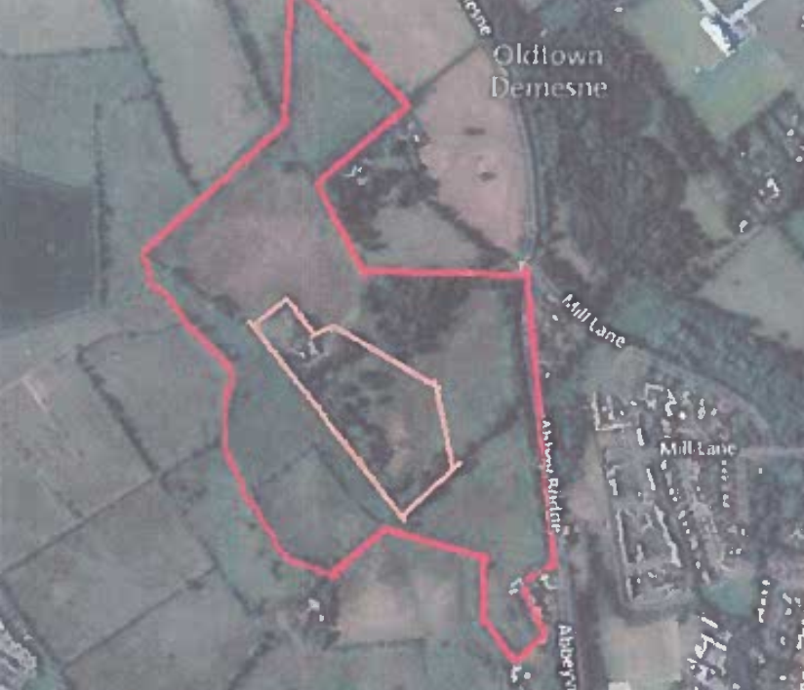
28 | Cairn Homes Properties Ltd | Housing & Residential  Lands at Jigginstown, Naas – Cairn Owns lands identified as zoned I – Agriculture and objective to retain and protect agricultural uses and C- Residential lands zoned to the north of the ring road (circa 16ha) which link to the town centre, as identified in the Naas Plan 2011 – 2017. Request to change the land zoning of the land from Agriculture to Residential to enable the land to be brought forward (12.5ha) which can deliver 437 new residential units if a density of 35units/ha is applied.  Cairns land is suitable for residential development and can make a positive contribution to the need for additional residential zoned land in Naas 56-80 hectares. Cairn is constructing and delivering new homes and have capacity to deliver large quantum’s on an annual basis.  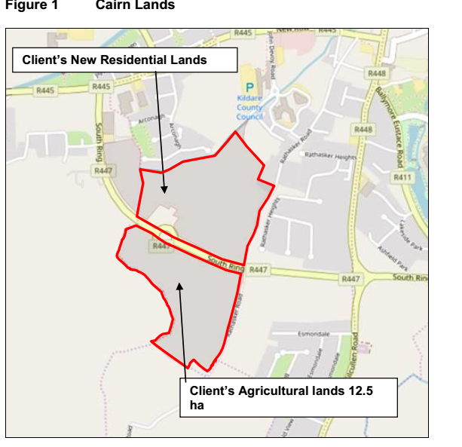  Undeveloped residential lands in Naas – 136ha of land 88.4ha (65%) had extant permissions. Density of the extant permissions 21.8 units per ha (1,930 units on 88.4ha). Remaining lands could accommodate between 1,038 and 1,666 dwellings on a density range 21.8 units per ha and 35 units per ha.  Housing allocation 5,533 for Naas – sufficient new residential zoned land to deliver between 3,430 and 4,058 units and therefore shortfall of 1,475 – 2,103 units depending on density. Future requirement 42-60 ha and 15% land for roads and open space = 61-87 hectares  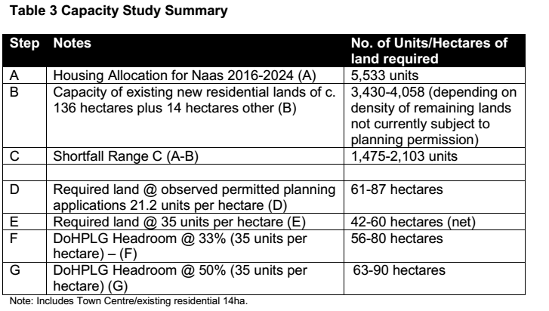  If 21.2 units per ha used the quantum of land increases to 91-130 ha.  Lands at Jigginstown are strategically located in terms of road access and infrastructure and proximity to the town centre and directly adjoin lands which are currently zoned for New Residential to the north and east.
29 | Castlekeel Ltd | Housing & Residential - Proposed residential and housing development – Dublin Rd  Site A – just over 1 ha adjacent to the racecourse with the Dublin Rd forming the north-western boundary. Site was previously zoned L, Leisure & Amenity.  Site B – is 4.3ha with road frontage onto Fishery Lane and bounded by the Racecourse on western and southern boundaries. Site was zoned Q: Enterprise & Employment.  Request that both site A and B are zoned for residential purposes, company can deliver housing on the sites immediately:  • Both sites are within walking distance of good regional and local public transport;  • Site A forms an infill site as it is adjoined on all sides by existing development;  • A proposed residential development on site A does not require new vehicular access or any additional services infrastructure;  • Site A is at a visually prominent location vis-à-vis the entrance to the town and the adjoining racecourse, which would provide a high quality design landmark type development. The site has good road frontage and good vehicular access can be provided;  • Site B can accommodate a good mix of apartment and housing development where the apartments can form an attractive northern edge to the development site.  • The development of housing within Site B is the most compatible form of development in close proximity to Naas Racecourse.  • The road frontage along the northern site boundary provides good vehicular access to develop the entire site.  • Both sites have existing connections to the public water services from previous applications.  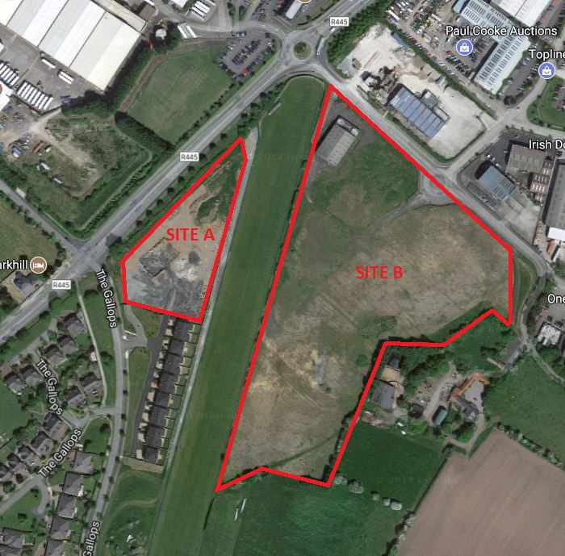
30 | Chris McLoughlin | Movement & Transport – Cycleways  - Request the proposed plan for the Kilcullen Rd Cycleway be re-visited.  - Impact upon businesses reliant upon parking – 10 impacted  - Need for cycle lanes  - Cycle lanes tend to be ignored  - Proposal is flawed  - Alternative and safer routes not considered  - Town needs regeneration and not a project likely to negatively impact existing businesses and employment opportunities in the area.
31 | Chris O’Neill | Movement & Transport – Cycleways  Naas needs more cycle lanes and less on street parking areas
32 | Christopher McDonald | Housing & Community, Heritage  Housing - The Council should build more council housing, with the rent being recycled back into the community and local area – rather than to private landlords  Heritage – Jigginstown House is an eyesore and a dangerous structure and should be demolished. The restoration project will costs millions and the money could be better used for more worthwhile local projects.
33 | Clonmel Enterprises | Economic Development – The Company would welcome the opportunity to extend the storage yard at the rear of the premises. Request that surrounding lands are re-zoned and the current extent of NE 1 Industry / Warehousing zoned land is extended.  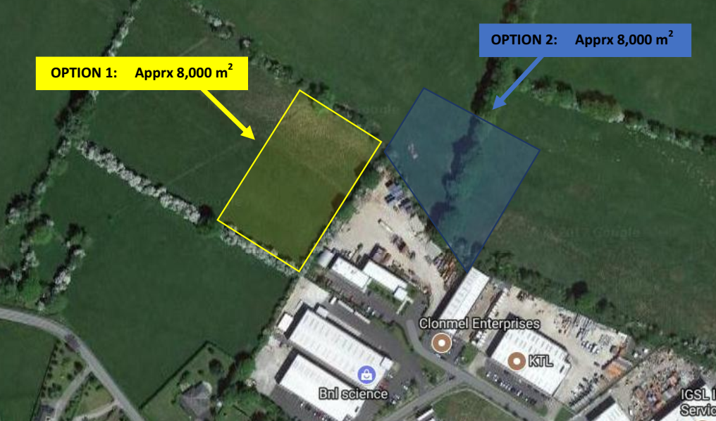  Company could extend in two directions but would prefer option 1.
34 | Colivet Family | Housing & Residential  Issues – Housing Supply, Isolation of Pipers Hill and Lack of Neighbourhood Centre in South Naas  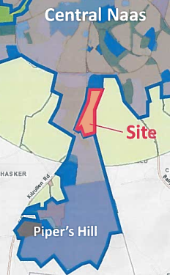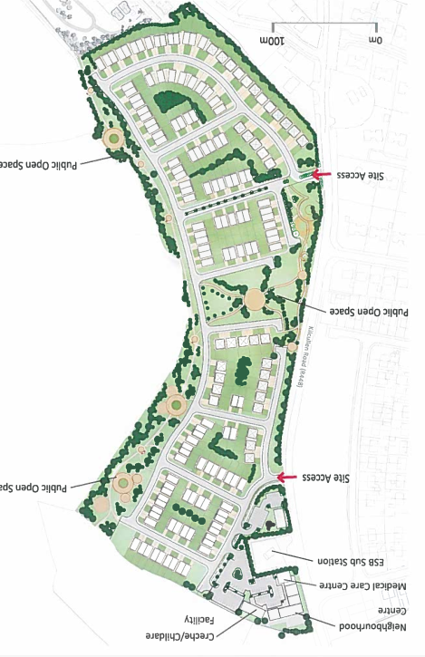  The submission proposes a framework plan to demonstrate how a 10.5ha piece of land can help address part of the housing supply issue, tie Piper’s Hill back into the town and deliver a neighbourhood centre for the wider area.  Lands are situated 1.5 km south of Naas town centre and in close proximity to Garda Station, Hospital and Piper’s Hill College and education campus.  Adjoining lands zoned to north are zoned education and community use and lands to the south new residential – this represents a vacant gap connecting the areas where densities of between 30-50 dwellings per ha could be anticipated but a more realistic density range of between 20-35 dwellings is suggested.  In the area the Kilcullen Road Part 8 – Greenway project delivered and the Osberstown WTTP plant increasing capacity to 130,000 PE capacity.  Key Challenges – tie development within Killashee back into Naas.  Where should development take place – development located between southern ring road and Killashee.  The site does not have any material constraints.  - Naas is identified as the premier county town where residential and employment growth is to be focused  - 2015 Govt Action Plan seeks to address housing crisis by encouraging development private houses  - Govt circular advised LPA to examine all ready to go lands for housing – emphasis is on delivery of housing  - Previous foul infrastructure constraints in Naas resolved with increased capacity at Osberstown WTTP to 130,000PE  - Housing target stated in the LAP Issues Paper will result in deficit of 907 dwellings relative to capacity existing residential zoned lands  - Bulk of new residential lands in Naas located in south of the town  - Piper’s Hill zoning has resulted in large scale development ion south of the town with separation from Naas  - Absence of a neighbourhood centre to serve growing population in the area  - Planning guidelines, local policy and established precedent 30 dwellings per ha is appropriate residential density  - Subject lands could help tie Piper’s Hill back into town  - Lands are in single ownership and have frontage onto Kilcullen Rd which has been improved  - Lands are serviced with water and wastewater connections
35 | Con Horan | Housing & Community  Naas has achieved Age Friendly Town – Naas should provide guidance and assistance to other towns in Kildare
36 | Conor Furey | Housing & Community, Town Centre – There is a need for higher density residential development in the town centre. Additional lands shown on the plan should be zoned town centre.  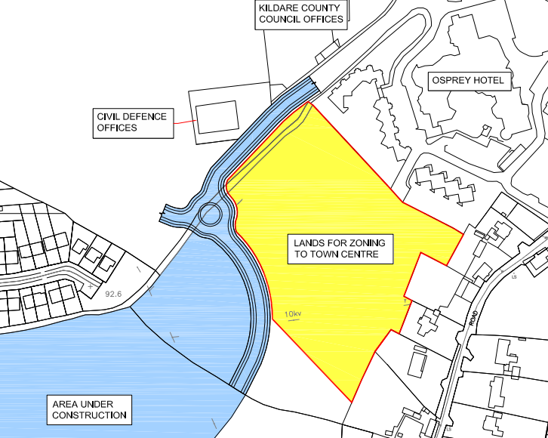
37 | Craddockstown Golf Club | Housing & Residential, Sports – community  Would like to develop a walk way and trim trail around the golf course, they would like to develop an academy of golf within the golf complex and extend the use of the clubhouse for additional community uses.  Housing & Open Space Amenity lands – Objective of the submission to zone part of the golf course as zoned land C – New Residential and propose additional lands would be more suitable for golf course and should be re-zoned F – Open Space & Amenity.  Reason – To safeguard the viability of the golf course and retain this asset within the community. Golf Club has seen a decrease in members and a severe fall in income. The upkeep and running of club is becoming more expensive and the Club is looking to diversify.  The site is 55ha located 2km on the southern side of Naas Town. Site bounded to the east by R410 Blessington Rd, to the north by residential zoned land and to the south and west by agricultural land. Proposal relates to c.7ha of Golf Course lands to the north east along Blessington Rd to residential use and could complement the Golf Course and rezone lands to the south west to open space.  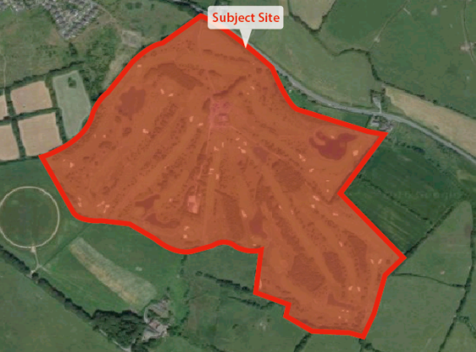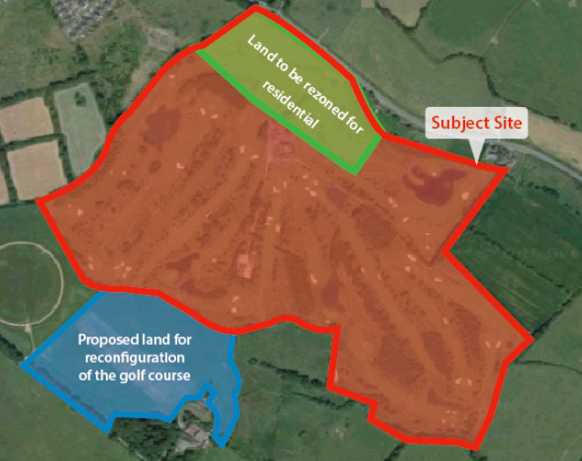  Blue lands are in the ownership of a third party and are indicative only.  - The land is a natural extension of the urban area of Naas  - Provide opportunity for the diversification of uses on the subject site  - The lands are serviced and a proposal could be developed promptly  - Additional golf course and amenity lands could be accommodated within adjacent lands to reconfigure the course.
38 | Crylock Developments Ltd | Economic Development - Industrial / Warehousing land zoning at Ladytown  - Lands zoned are located 2km west of the town centre and adjacent to Newhall Junction of the M7.  - Lands are highly suited for zoning Industry / Warehousing as lands close to national motorway network, other services infrastructure and the County Town. A small portion of adjacent lands were zoned NE1 in the Kildare CDP 2011-17.  - Lands are circa 110ha  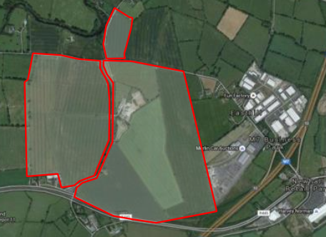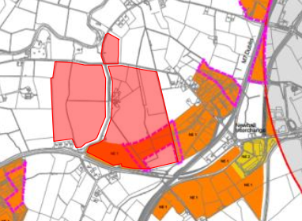  - Lands are currently zoned agricultural and substantially flat.  - Lands were omitted from zonings in the Naas Environs in the new Kildare CDP 2017-23  - The site is ideally located for Industrial/Warehousing use due to its accessible location on the edge of the built-up area of Naas and to address the negative trend of long distance commuting from Naas to Dublin City.  - The emerging and existing planning policy context is supportive of the location of space extensive, less intensive employment uses on Greenfield sites outside of the built up area of Dublin.  - The zoning of subject lands would capitalize on the comparative locational advantage of Naas for industrial / warehousing / general employment uses.  - Development of subject lands in future would provide significant employment and support business and economic development, help to balance population and employment in Naas and reduce long-distance commuting.  - The zoning will foster investment and benefit the economy of Naas.  - Subject lands should be recognized within the LAP as a strategic location for the provision of space extensive employment uses.  - Development of subject lands subject to appropriate zoning would deliver road and access improvements benefiting the surrounding area and constitute a logical extension of the contiguous built up area of the town.  - Subject land and the environs of Naas must be included within the new development boundary in the new LAP to provide for their proper planning and sustainable development – and to safeguard the ability of the town to accommodate employment growth.
39 | David Lindopp | Movement and Transport  - The Grand Canal cycle / pedestrian track runs from Dublin City to Peamount. Proposes that the track be extended all the way from Naas to Kildare. Request that the additional area be completed and finalized.  - Greenways are popping up in various parts of the country and this could be a great asset and opportunity for the Naas local economy and commuters providing an alternative sustainable option.
40 | David O’ Rourke | It is requested that land comprising 3.3 acres, located within the grounds of Oldtown House, Sallins Road is rezoned from M: Future Park/Greenbelt in the Naas Town Plan 2011-2017 to C: New Residential in the new Naas LAP. The rezoning requested from M to C is based on a number of interrelated planning factors as follows:  Sustainable Development - The site directly abuts existing urban and suburban development and is proximate to the town centre and an extensive array of services and amenities. The principles of sustainability dictate that the best use of this land would be to zone the land for residential purposes in order to avoid encroachment into the un-spoilt countryside. The current zoning of the site as ‘M’ does not allow the best use of this use in terms of proper planning and sustainable development.  Sequence of Development - The zoning of the lands for residential purposes would accord with the Sequential Approach as set out in the Development Plans-Guidelines for Planning Authorities, 2007 and would also accord with adjacent uses which include Scoil Bhride, Naas GAA, a petrol station and a number of existing residential estates.  Services and Infrastructure - The subject site is located within an existing built up area and would not place a strain on service provision and every effort should be made to promote new urban and suburban proposals in locations that are already serviced.  Historical Considerations - Although the land occupies a sensitive position, given its location relative to Oldtown House, the site is physically and visually separate from this Protected Structure (NS 19-072) by dense mature landscaping. It is envisaged that the subject site could accommodate low profile dwellings. Previous policy decisions have recognised that these Demesne lands can accommodate new housing.  Impact on Parkland Objective - The subject site comprises 3.3 acres which is a miniscule proportion of the planned 87ha (215 acres) of parkland proposed in the Naas Town Development Plan 2011-2017. The provision of this small tract for housing would not jeopardise the delivery of this open space objective. Furthermore the subject site is in private ownership, is not accessible to the public and is not the subject of legal agreements relating to the creation of a public park..  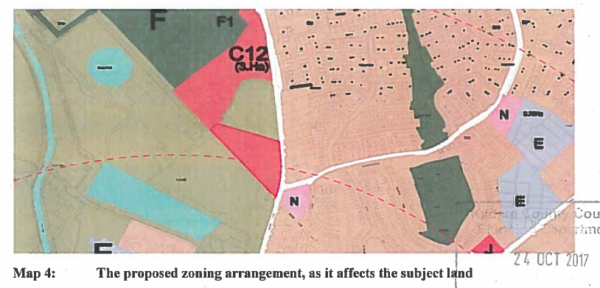
41 | Dermot O’ Rourke | This submission relates to land known as Keredern House comprising approximately 50 acres located to the immediate west of the Grand Canal. The site is zoned M: Future Park/ Green Belt in the Naas Town Development Plan 2011-2017. It is requested that the controls which apply to M zoned land are amended in order to allow for a single dwelling to be built on the extensive O’ Rourke landholding for the daughter of the landowner who will take over the running of the existing stud farm.  - The M zoning in question only applies to lands in Naas and therefore any change would not have implications countywide and would only affect the lands of Keredern House and Oldtown House.  - Legal and Historical Events  A part of arrangements entered into between Oldtown House and Kildare County Council, lands on the eastern side of the Canal have been dedicated as being for future public use. The landholding at Keredern House operates as stud farm and is privately owned and the lands are not the subject by any legal agreements relating to the development of a public park and remain in private ownership. Refer to Mahon v An Bord Pleanála regarding the distinction between public and private property in the context of a similar recreational zoning objective. It is submitted that the M zoning is unduly restrictive and the land use zoning matrix does not reflect the existing equestrian business of this landholding.  - Future Equine Plans  The running of the stud farm will soon be transferred to the landowners daughter. In order to enable her to undertake this role, she requires on farm accommodation. Currently the M zoning does not permit the construction of a dwelling on the landholding. Should this continue to apply to the landholding, it is likely to result in the cessation of the stud farm operation. It is noted that new dwellings in the rural area of Kildare are generally acceptable for individuals working in the equestrian industry. Refer to Reg. Ref. 05/560 (PL 09.212556). Therefore the erection of a single dwelling on the landholding to accommodate a family member working in the business would be consistent with the adopted policy of the Council.  - The Planned Park  It is submitted that the proposed change to zoning objective to accommodate the erection of a house on this 50 acre active stud farm would not prejudice the achievement of the planning parkland. Furthermore the normal classes of exempted development apply to this landholding. It should be noted that in the case of Howth SAAO, new residential development is permitted at a density of one dwelling per 2.5ha, therefore there is scope for the planning authority to consider the relaxation of zoning objective M.  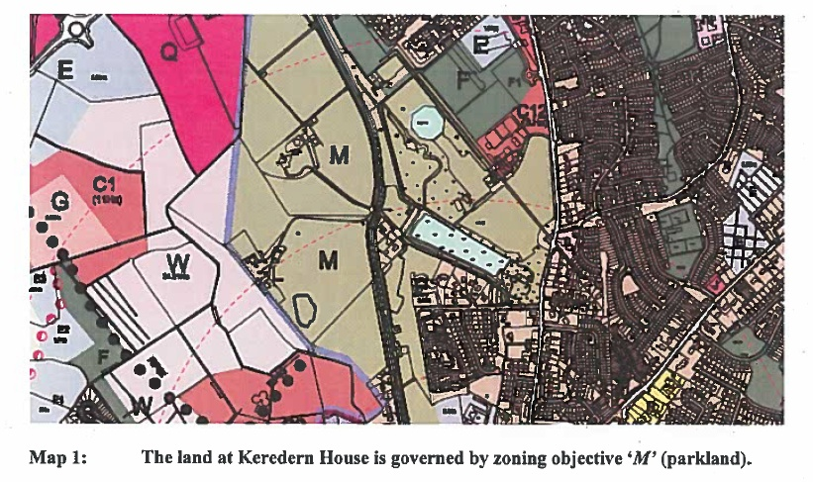
42 | Dorothy Kinirons | It is requested that land comprising 6.69ha, located at Jigginstown, Naas is rezoned from I: Agriculture in the Naas Town Plan 2011-2017 to Q: Enterprise and Employment in the new Naas LAP 2018-2024. The following reasons have been set out to justify the rezoning of the subject site to Q: Employment and Enterprise:  - To ensure that the future Naas Local Area Plan 2018-2024 will be achieved.  - To accommodate sufficient growth of jobs in Naas  - The land is in close proximity to the road network and will comply with the principles of the sequential approach.  - To allow for adequate enterprise and employment zoned land in the future Naas Local Area Plan in compliance with National policy.  - All infrastructural services are readily available in the area to accommodate future development.  - The need to develop Naas in an orderly manner  - It is a sustainable proposal.  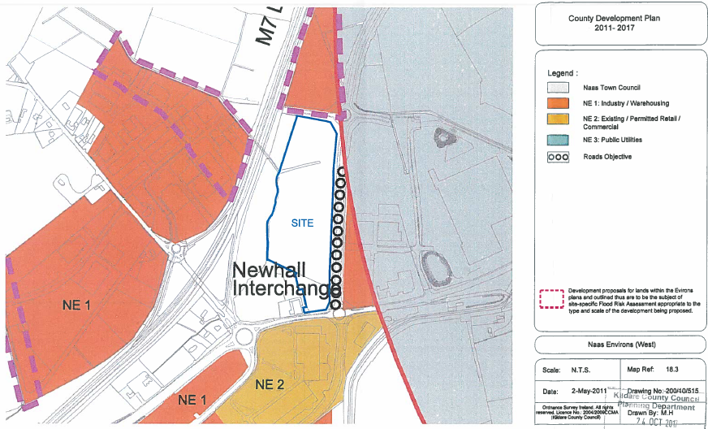
43 | Eamonn Gilgunn | It is noted that further social housing is proposed in the Newbridge Road Area. It is supported that there is a need for social housing in the Naas area; however it considered that the needs of the town both socially and economically would be better served if these social housing development were situated in alternative areas as the vast majority of social housing is already located in the Newbridge Road area.  Mixed housing and dispersal of social housing throughout urban areas is the accepted best practice. Therefore it is requested that the Council revisit the plan to centralise all new social housing developments in the Newbridge Road area. There are a number of areas in Naas which have little or no social housing which where new developments of same would be better placed.
44 | Eileen Kiely | - Irish Language  The Irish speaking community of Naas is a growing area and this should be reflected in the Local Area Plan by proposed that Irish becomes more visible in the community. This could be achieved through public signage and by the use of Irish at public events and festivals.  - Community Facilities  The southern quarter of Naas is lacking in indoor and outdoor community space. It would greatly benefit from a community/cultural centre and playing pitches. Other areas of the town seem to be better serviced in this regard.
45 | Fergus Phelan | It is requested that 2.19 ha of land at Craddockstown is rezoned from I: Agriculture in the Naas Town Development Plan 2011-2017 to C: New Residential (Low Density) in the new Naas LAP. The proposed entrance to these lands is from the R411. The following reasons have been set out to justify the rezoning of the subject site to C: New Residential:  - Site is in close proximity to Naas, within 2000m from the town centre.  - Site is in close proximity to all infrastructural services on residential site C9 to the north.  - Pattern of development in the immediate landholding is of a low density nature.  - Small scale of the proposals comprising 2.19 ha.  - Necessity to provide varied types of residential units for people with their own landholding.  - Allowance must be made for adequate residential zoned land in line with Government Policy.  - The need to develop Naas in an orderly manner.  - Site is close to community, recreational and social services.  - It is a sustainable proposal.  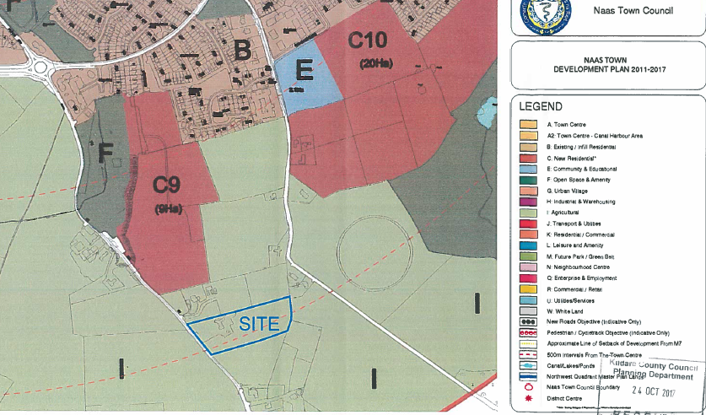
46 | Fiona Gilgunn | Car Parking and Town Centre  The recent changes to car parking in Naas Town Centre are negatively impacting upon work and leisure time. It is submitted that as a psychotherapist operating on the Main Street, clients have difficulty in finding parking in the evening particularly. If The Moat Theatre is hosting an event, parking is at capacity for the evening.  The increase in rates at SuperValu is extortionate and unaffordable. The loss of the car park at the Moat is shocking and the reduction from 1.5 hours to 1 hour maximum stay is too little time for anyone to go about their business in Naas. It appears that the Council want all business to move to Newbridge, or to Tesco at Monread.
47 | Fiona Lennon | Cycling  The cycling infrastructure in Naas is very poor. Cycle lanes in the town should perform the following functions:  - Join up to form a network that allows travel main destinations in the town;  - Lanes should be separate cyclists from traffic;  - Allow children to safely use them to travel to and from school;  Currently cycling on the footpath is the only safe way to cycle as a way of everyday transport with children in Naas. While it is noted that some new cycle lanes are planned on the Kilcullen road, it is submitted that a critical mass forming a separate cycle network is needed for these routes to be useful for everyday transport.  Transport planners should attempt to cycle around Naas to see how frustrating and dangerous the lack of a joined up cycle network is.
48 | Ger Dunne | Social, Community and Recreation  The Canal should receive special attention in the new Naas Local Area Plan with a focus on social, community and recreation. It is suggested that an access point i.e. a specific slipway be provided to enable boating enthusiasts to gain access to the water. If access to the canal was provided it would allow boaters to begin or end their canal journey at a specific point and it would encourage more visitors to Naas.  The Canal must be utilised as a positive feature within the community.  Waste Water Treatment Site (The Sewage Farm) - This land should be rezoned to allow for community and amenity uses and passive open space.  Car Parking - A plan for parking is required to allow for mourners and attendees of funerals and the cemetery etc at St Corban’s Cemetery on the Dublin Road. The proposed cycle land on this stretch of road will seriously restrict and disrupt parking at this location.  LAP Process - All future plans that include issues paper should be delivered/posted to all residents and businesses in the area of the proposed local area plan.  Security - Security cameras should be installed at St. Corban’s Cemetery as a deterrent to criminals targeting parking vehicles.  Corban’s Lane Shopping Centre - In the event that the shopping centre does not proceed as a shopping facility, the zoning of this site should be amended to facilitate alternative uses such as Educational campus.  Broadband - Consideration should be given to the installation of free wireless broadband in Naas Town.  Zoning - Lands located on the Kilcullen Road should be zoned NE 8: Hotel and Leisure as it is behind the existing hotel and is inaccessible to the public. The site zoned L: Leisure and Amenity located between Ploopluck and Millennium Park should be rezoned to ‘W’ to allow access to the public.
49 | Glengolden Builders Ltd. | It is requested that 4.06ha of land at Tipper South, Blessington Road is rezoned from I: Agriculture in the Naas Town Development Plan 2011-2017 to C: New Residential in the new Naas LAP. The proposed entrance to these lands is from the R411. The following reasons have been set:  - Additional residential land should be zoned to ensure that the future Naas Local Area Plan 2018-2024 will be achieved.  - The rezoning of these lands to residential will enable accommodate the growing population of Naas.  - Location of land will enable the sequential development of Naas.  - Small scale of the proposals comprising 4.06 ha.  - Allowance must be made for adequate residential zoned land in the compliance with Government Policy.  - Proximity of the site to town centre on the R 410.  - All infrastructural services are readily available in the area.  - The need to develop Naas in an orderly manner.  - Site is close to public transport, community, recreational and social services.  - Site is within 2000m walking distance of town centre.  - It is a sustainable proposal.  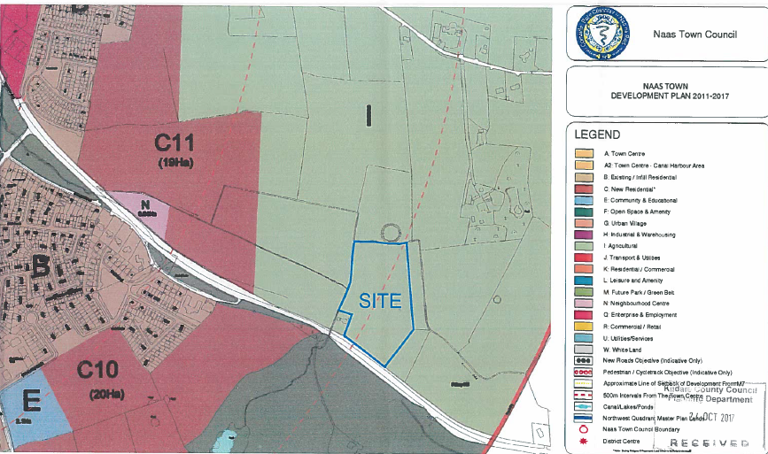
50 | Headfort Properties Ltd | It is requested land located on Corban’s Lane comprising 0.099ha is zoned B: Existing/Permitted Residential in the Naas Town Development Plan 2011-2017 is changed to A: Town Centre in the new Naas Local Area Plan. The following reasons have been set out to justify the rezoning of the subject site to A: Town Centre:  - The site is located directly opposite the Town Centre zone  - There is a proposal to develop a new Town Retail Centre opposite this site  - Naas has been identified as a Primary Dynamic Cluster  - There is insufficient land at appropriate locations for this type of land use.  - The site of the site is relatively small (0.099ha)  - The site is serviced with no physical or infrastructural constraints  - The policies and objectives of the Naas Town Development Plan would be achieved.  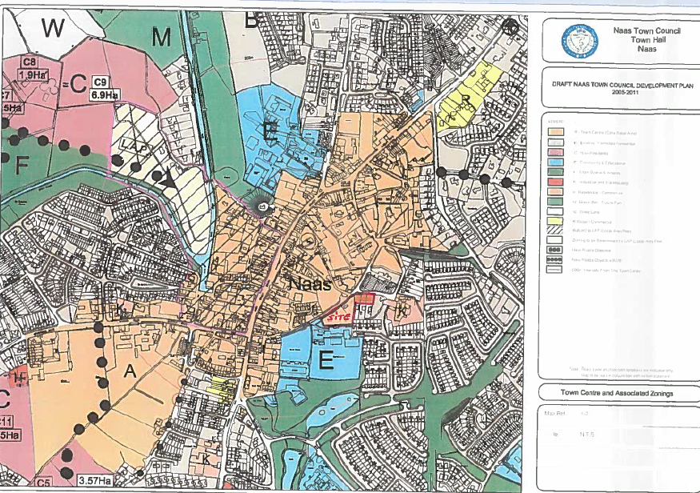
51 | Jim O’ Sullivan | - Encourage the use of ‘over the shop’ residential units throughout the town centre.  - Make the exit from Basin Street to South Main Street safe for pedestrians. Current signage allows motor traffic to drive directly onto the pedestrian area without halting.  - Designate land between Abbey Bridge and the Harbour for development as a Town Park that will enhance the attractiveness of the town centre in to the future  - Advance the ring road system to allow for the pedestrianisation of the town centre.  - Preserve the integrity of the canal vista on the Corbally Branch for the Harbour to the Newbridge Road and the main line from the Harbour to the 1st Lock.  - Identify new burial grounds as it is likely that St. Corban’s Cemetery will be exhausted within the period of the plan.  - Maintain a green zone of 100 metres along the canal. Currently insurers are reluctant to provide normal cover for properties within 100m of any waterway i.e. the canal.
52 | Jimmy Kelly | It is requested that land located in Tipper West comprising 26.9 ha is rezoned from I: Agriculture in the Naas Town Development Plan 2011-2023 to C: New Residential in the new Naas LAP. The following reasons are set out to justify the proposed rezoning:  - The development of the land would represent the sequential extension of residential development within Naas in accordance with the Sustainable Residential Development in Urban Areas Guidelines (2009) and section 3.4.6 of the Kildare CDP. The site is contiguous to existing zoned land with the benefit of planning permissions 15/176 and 15/1060.  - Access to the proposed site is available from both the Tipper Road and the Blessington Road with considerable road frontage and could potentially facilitate an Outer Relief Road.  - The lands are located within 1.5km of the town centre and in close proximity to the proposed new Neighbourhood Centre.  - Water supply, waste water and storm water services are located in close proximity to the subject lands.  - Potential flood risk can be eliminated by the adoption of measures already approved by the Planning Authority and An Bord Pleanála for similar development in this area.  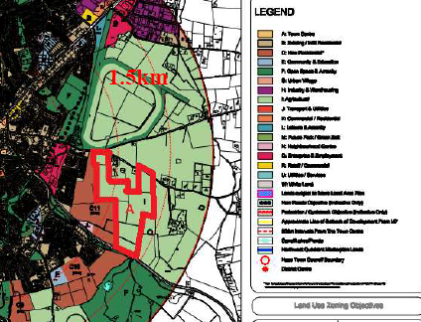
53 | Joe, David and Robert Osborne | It is requested that land location in Craddockstown Demesne comprising 9.5ha is rezoned from I: Agriculture in the Naas Town Development Plan 2011-2017 to C: New Residential in the new Naas LAP. Concept design drawing submitted. The following reasons are set out to justify the proposed rezoning:  - The development of the land would represent the sequential extension of residential development.  - Access to the land is available from Craddockstown Road. The development of the land would facilitate the improvement and realignment of this road which has been and objective of the Naas Town Plan for several years.  - The land is located within 2km of the town centre and is in close proximity to school, church and retail outlets.  - Water supply, waste water and storm water services are located in close proximity to the land.  - CFRAM and PFRA studies indicate that there is no flood risk associated with the land.  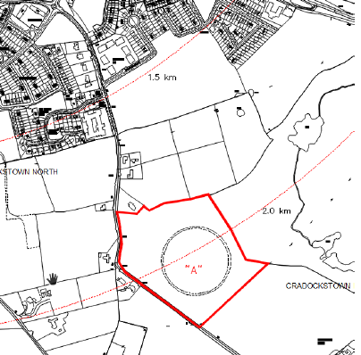
54 | John Kinchella | It is requested that land located at Kilashee comprising 2.5 acres are rezoned from I: Kilashee in the Naas Town Development Plan 2011-2017 to Commercial/Industrial use. This site is located directly opposite KWETB and the hotel. The site has significant road frontage. (No map attached to submission)
55 | John O’ Reilly | - Given that the town is to grown to a population of 40,000 to 50,000, all facilities and services that are required e.g. playing pitches, community parks etc should be put in place.  - The new LAP should allow for up to 5 storey buildings in the Poplar Square area.
56 | Joy Donohoe | The provision of a retirement home would be a fantastic idea. There are no amenities for additional private or social housing.
57 | Kevin Maher | Town Park, Caragh Road  It is requested that the land opposite located on the Caragh Road currently zoned B: Existing Residential/Infill in the Naas Town Development Plan 2011-2017 should be rezoned M: Greenbelt/ Future Park to facilitate a public park for the surrounding residential areas. County Kildare is one of the fastest growing counties in Ireland with a strong growth cluster in Naas. Key to ensuring that the County and Naas remain an attractive place to live and work is to build strong and inclusive communities that have a sense of place and belonging. In order to achieve this objective the following suggestions and examples should be implemented to benefit the local area:  - Comparing outdoor and healthy lifestyle choices in Naas and Australia, the Millennium Ring Road is full of walker, runners, roller bladers and cyclists each morning and evening. Pop-Up Races and running groups use this road as part of their routes. It would be great if a park for recreation at the west end of Naas (near Caragh Court) was provided to contribute to this healthy lifestyle.  - The new park would be part of a larger network that would provide the town’s population with the opportunity for recreational and sporting activities. This park would be essential to the development of a balanced, sustainable and attractive community and living environment.  - Naas is relatively well served by sports facilities however the town does not have adequate provision of parks and playground areas. The demand for such facilities is likely to increase as the population grows. It would be appropriate to facilitate the provision of publicly owned and accessible open space areas.  - If rezoned to provide for a public park, the site is located opposite Caragh Court would create a network to contribute to the Waterways Ireland Greenway Project and would serve the residential areas of Caragh Court, Jigginstown, Ardconagh, Finlay Park, Castle Park and Elmore. The park could include stone chess boards, outdoor gym area and cycle track.  - The site is located close to K Leisure and is the starting/finishing point for many sporting events. To develop this site would be a once in a lifetime opportunity to invest in the environment and the community.  - Kildare has a rapidly increasing ’65 and over’ age cohort (whom feel a sense of exclusion, an amenity like a park can help bring people together), representing 7.9% of residents in the county. The county also has a high level of population in the 0-4 and 5-12 age cohorts, whom if they have to travel to a park at the other side of town will feel that they don’t belong to an area. With all the welcome developments going on in the area, a field that was once on the edge of a busy town will now be closer to its centre, with very little identity to its natural past.  - To respond in a coherent sustainable, spatial fashion to the challenges facing the county, while building on its strengths and providing a more focused approach to planning for future growth. The Core Strategy will help facilitate a more consolidated compact urban form, helping build stronger integrated communities (major key element in achieving sustainable development objectives), together with the balancing of our natural and built environment that is sustainable and has an appropriate development approach. If this approach is adopted by the Local Authority, then the delivery of social, community and cultural infrastructure to meet the needs of the existing and future population will/should be achieved. The provision of community infrastructure and services is central to fostering sustainable communities and delivering successful places to live and have a sense of belonging. Access to education, health and community support services, leisure and a good quality built environment is a prerequisite for the creation of sustainable communities. Social inclusion is a key objective at national and local level. In order to combat social exclusion, actions must be taken at both national and local level to focus on the most disadvantaged areas, ensuring that those at risk of social exclusion have the opportunities and resources necessary to participate fully in economic, social, cultural life and enjoy a standard of living and wellbeing that is considered normal in today’s society.  - This is an ideal location in Naas for the provision of a small park (c. 3.67ha) as it would serve all sectors of the community and all ages.  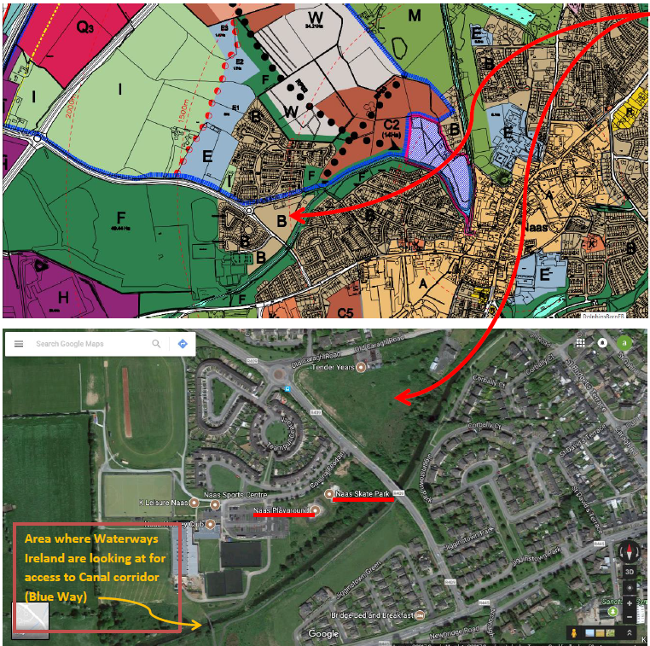
58 | Liam, Seamus, Paul O’ Brien | It is requested that land zoned I: Agriculture in the Naas Town Development Plan 2011-2017 is rezoned to B: Existing Residential/Infill (Low Density)  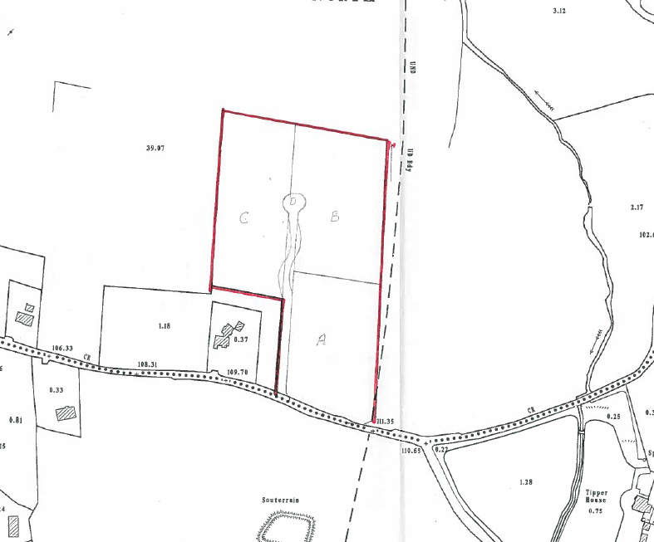
59 | Mark Rogers | There should be a larger emphasis on cultural, historical and heritage issues and encourage tourism.
60 | Michael Dunphy | - Vision - The LAP should consider the recreational benefits of the canal located so close to the town and should promote its safe use by all members of the community, contributing to a healthier population e.g. similar to greenways being developed around the country.  - Development Design - Walking around Naas it is obvious to see how the Council/Councillors have sucked the life out of the town due to 10 years of a disused shopping centre, shops closing weekly, the development of orbital retail parks etc. The LAP needs to promote family life and entice people back into the town centre with retail and leisure activities for young and old.  - Movement/ Transport/ Infrastructure - The development of Finlay Park along with future plans in the surrounding area, will contribute to an already serious problem of traffic congestion on the new Caragh Rd. The design of the junction with the Newbridge Rd was never fit for purpose and the planned new M7 interchange for the Kerry Group site will further add to congestion with people using the route towards Kilcullen etc. This infrastructural issue needs to be addressed in the LAP, otherwise people in Jigginstown Park will feel trapped.  - Housing/ Community - Adding more social housing to the new Caragh Rd adjacent to an existing estate goes against best practice of mixed development. If housing is required, it is considered that it should cater for the elderly in an environment close to the town centre and amenities. Ideally given the proximity of the site to K Leisure, the site on the Caragh Road should be used for recreational purposes. There are no informal parks in this area of town as K Leisure is for team activities etc.
61 | Millennium Properties | It is requested that land located adjacent to Millennium Park comprising c. 4ha that is zoned Q: Employment & Enterprise in the Naas Town Development Plan 2011-2017 is rezoned to C: New Residential in the new Naas LAP. The following reasons are set out to justify the proposed rezoning of the subject site:  - Facilitates contiguous extension of existing residential development in Naas;  - Promotes sustainable transport modes with Sallins Train Station located c. 800m to the north of the site.  - Retail and community facilities are accessible on foot in Monread Shopping Centre located c. 400m to the north of the subject site.  - Site is located c. 800m east of permitted Secondary School (Reg. Ref. 16/434)  - Site is located c. 800m south of Scoil Bhride National School  - Site is close to employment opportunities within Millennium Park  - There is sufficient capacity in water, foul, drainage, power and gas networks and the availability of high speed broadband and telecommunications.  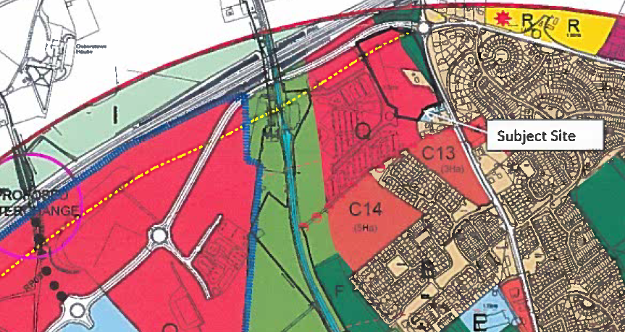
61a | Millennium Properties | This submission is submitted in the context of a Naas Northwest Quadrant Masterplan comprising approximately 234 ha located in the north west area of Naas. It is submitted that the masterplan area is identified in the Naas Town Development Plan 2011-2017 as the main area for the future planned expansion of Naas.  The masterplan has been prepared by Millennium Properties and is intended to inform the preparation of the Naas Local Area Plan 2018-2024. ‘The vision of the masterplan is to create a vibrant and bustling town expansion wholly integrated with the fabric of Naas, offering a diverse mix of activities and providing the ideal work- life balance without the onus of long commuting. It will develop a strong employment zone and new residential neighbourhoods drawing on its natural setting to help create a community that is an extension of the town.’ The development of the North West Quadrant is proposed within the context of the following themes set out in the masterplan:  - A profile of Naas  - Policy Context  - Site Context  - Transportation  - Urban Design Framework identifying Character Areas  - Phasing and Infrastructure Delivery  Land pattern and land ownership is defined in the masterplan with 20 seperate landowners being identified either within or adjacent to the Northwest Quadrant. In summary, the masterplan sets out the following proposals:  - The rezoning of lands for the provision new residential development in the North West Quadrant comprising c. 63 ha in total. Approximately 19ha of these lands were previously zoned for residential development in the Naas Town Development Plan 2011-2017, of which 1.7ha relates to Finlay Park which is currently under construction. The masterplan envisages that residential development will be provision at a density of between 30-50 units per hectare. This has the potential to deliver up to 1,900 housing units to accommodate a population of approximately 5,500 people.  - The provision of a Neighbourhood Centre instead of the Urban Village proposed in the Naas Town Development Plan 2011-2017. It is proposed to locate this retail element on lands previously zoned for Community and Educational uses on 0.5ha of previously zoned White Land. It is envisaged that this neighbourhood centre will serve Naas Community College, Millennium Park and the general neighbourhood.  - The zoning of 4.88 ha of land to facilitate the provision of a primary school.  - The provision of a connected and permeable new residential neighbourhoods and employment areas with ancillary community facilities along with a network of green spaces recreation and amenity facilities.  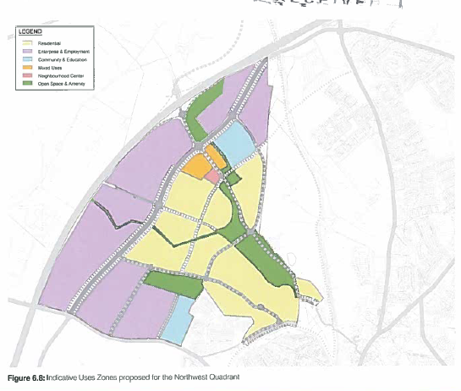
62 | Naas Racecourse PLC | It is requested that land located at Naas Racecourse, Kingsfurze comprising c. 3.4ha is rezoned from F: Open Space and Amenity in the Naas Town Development Plan 2011-2017 to C: New Residential in the new Naas LAP. A concept layout plan is submitted. The following reasons are set out to justify the proposed rezoning of the subject site:  - The development of the land would represent the sequential extension of existing residential development in accordance with Sustainable Residential Development in Urban Areas Guidelines (2009).  - Access to lands is available from the existing and proposed section of the planned Inner Relief Road which will be completed within the lifetime of the new LAP.  - The site is located within 1.5km of the town centre, 1.5km of the M7/N7 and less than 3km from Sallins Train Station.  - Water supply, waste water and storm water services are located in close proximity to the subject site.  - CFRAM and PFRA studies indicate that there is no flood risk associated with these lands.  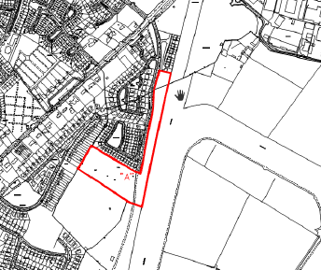
63 | Neil Austin | - Town Centre - Naas is a great place to live and raise a family, however concern is expressed that while the town centre should be supported through this new LAP, it should not be at the expense of the character of the town. Business in Naas has suffered as there is a focus on developing the nightlife of the town and promoting shopping centres outside the town centre. This trend has lead to the deterioration of the town centre.  - Transportation - Concern is expressed regarding the future transport infrastructure of Naas. The proposed M7 widening will help traffic flow between M9 and M7 and the new interchange at Osberstown will help people to access the motorway. However living in Jigginstown Park, it is evident that there is pressure on the Caragh Road. Additional traffic from the new estates around Devoy Park, Finlay Park, Primrose Lane and Arconagh accessing the M7/N7 via 9a will have a significant impact on Jigginstown Park.  - Site at Caragh Road - The proposed additional social housing on the Caragh Road would fail to achieve a balanced mix of housing as set out in good planning policy. Failing to provide a mix of housing types would lead to this area developing as a majority disadvantaged area of Naas in contrast to other areas around the town.  - The Grand Canal - The Canal is a great asset and an important heritage asset in the town. The towpaths are well used by joggers, cyclists, walkers and families; however the locks or the towpaths are not well maintained with roots growing through the tarmac, litter and reed making the canal un-navigable.
64 | Niall Collins | There should not be any additional housing planned for the Killashee/Pipers Hill area. This road has been narrowed in recent years and is very busy in the mornings and evenings. The Kilcullen Road cannot cope with further traffic as it is at capacity with the existing houses and 5 schools on this road.
65 | Niall Sargent | This submission promotes the use of The Tiny House as an innovative solution for Ireland’s housing crisis. Most Tiny Houses are built to high energy efficiency standards and cost below €40,000. Having regard to CSO figures, house prices, cost of construction, mortgage rates it is concluded that Kildare is one of five counties where a buyer need 20-26 % of their disposable include to fund a mortgage. Referring to American and Canadian examples where Tiny Houses have been developed, it is submitted that the Tiny House would quickly address affordable housing issues in Ireland as well as providing housing for students, retirees and young adults who wish to buy their first home but cannot afford it. The Tiny House would also address the issue of homelessness.  It is submitted that the Irish Government can take the following steps to make Tiny House communities a reality across Ireland:  - Preparing national guidelines for a minimum dwelling size to allow for tiny houses to provide affordable and sustainable housing choices;  - Streamline permitting process for Tiny Houses by offering pre-approved plans for purchase;  - Identify older neighbourhoods as good locations for Tiny House communities;  - In new development areas, identify pockets of neighbourhoods for Tiny Houses;
66 | Norman Farragher | The County Council should purchase empty buildings and convert them to domestic dwellings and apartments to revitalise the town centre. This submission is pro Naas Community Men’s Shed.
67 | Origin Enterprises | It is requested that land located at Newhall that were zoned NE 1 in the Naas Environs of the Kildare County Development Plan 2011-2017 are zoned for Industrial/ Warehousing purposes in the new Naas LAP. In relation to the economic development of Naas the questions posed in the Naas LAP Issues Paper are addressed as follows:  - Should a new development boundary be drawn for the planned growth?  It is submitted that the new development boundary must incorporate the Naas Environs including the subject lands.  - What are the economic strengths and competitive advantage of Naas? - The subject lands are ideally suited to capitalise on the competitive advantage of Naas as an ideal location for industrial, warehousing, distribution and logistics uses having regard to the proximity of the site to the M7.  - What type of industry/employment opportunities should be encouraged in Naas and where should it be located? - While the built-up area of Naas is suited to the provision of higher intensity employment uses, the environs of Naas provide the opportunity to advance significant industrial and employment uses. Lands such as the subject site are well suited to bring forward new opportunities for employment having regard to their access to the national road network, and the need to balance employment and population in Naas.  - How can the LAP support and facilitate new business and employment? - The zoning of the subject lands at Newhall for industrial / warehousing use will facilitate the creation of new business and employment in the area.  - What can Naas do to attract further investment and foster local economic development and entrepreneurship? - It is respectfully submitted that the zoning of the subject lands as suggested for industrial / warehousing use will serve to attract further investment in the area.  - Should opportunity sites be identified and specific objectives formulated for underutilised areas of the town? - It is considered that the subject site should be identified as an opportunity site within the forthcoming Naas Local Area Plan 2018 in order to highlight its potential for industrial / warehouse type development.  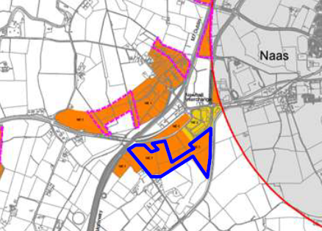
68 | Paul Reid | Naas should investigate the possibility of creating the position of an ‘Urban Planner’. This office should be given the necessary resources and support to bring the physical environment up to and beyond expectations for a large prosperous urban centre in 2017. The position should be given a strong brief and a healthy budget to achieve quality results.  The individual appointed as Urban Planner should have a proven background in quality, innovative design and urban planning and should be appointed by a small team to achieve tangible results within a set time frame. If Naas’s many crucial assets were harnessed under on visionary office it could create a vibrant centre for the town and its people.
69 | Pierce Malony | It is requested that land located at Oldtown Demesne, Sallins Road comprising 1.34ha zoned M: Future Park/Greenbelt in the Naas Town Development Plan 2011-2017 is rezoned to C: New Residential in the new Naas LAP. The following reasons are set out to justify the proposed rezoning of the subject site:  - Proximity of the site to town centre (less than 650m)  - Proximity of site to Sallins Train Station (2000m)  - Site directly adjoins existing on-going residential development to the north (The Orchard)  - Site is on the bus route to Sallins Train Station  - The small scale of the proposal (1.34ha)  - All infrastructural services in place and minimum costs to service the site  - It is an infill site  - Site is in close proximity to GAA and schools and other social facilities  - Site has no protected structures within its boundaries  - Site entrance could be achieved through the adjoining housing estate ‘The Orchard’ currently under construction.  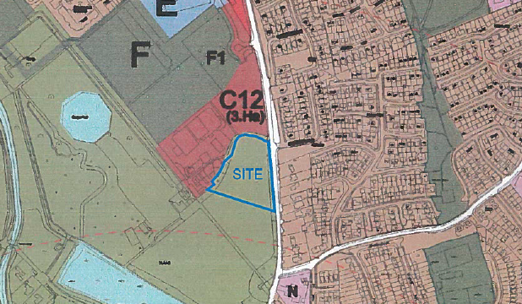
70 | Queally Group | Economic Development, Housing & Residential  - During the lifetime of the Plan the Company is expected to grow and develop.  - CityWest to Naas Corridor is now a key hub in the development of agri-food  - Essential that the new LAP creates and provides the right conditions for enterprise and innovation to flourish.  - Sufficient lands to be zoned, supportive policies and flexible development standards for employment generating and supporting uses.  - Sufficient lands zoned for residential development at sustainable locations that can be released over the life-time of the plan  - Providing affordable homes at locations proximate and accessible to employment opportunities is essential to the continued growth and success of Naas.  - Strategically located landbanks in infrastructure rich areas can make a significant and positive contribution to the future growth and development of Naas as a designated Large Growth Town.  - Plan represents an opportunity to spatially rebalance the town on the south of the town centre – leveraging existing investment in public infrastructure, supporting and capitalizing on community, schools and other infrastructure at Piper’s Hill and sequentially expanding the urban area in a sustainable manner on infill urban consolidation sites.  - This area has the capacity, existing services and established residential community infrastructure to support continued development of Naas.  - Queally Group is working on high quality residential development on 3.5ha Bluebell Farm on the Kilcullen Rd. An additional 13ha of suitable land adjacent to this site should be considered for further development.
71 | Quinby Holdings Ltd | Housing & Residential, Movement & Transport – Jigginstown lands 88ha  - Landownership of 88ha located to the south-west of the town  - Site is approximately 1.5km south west of the town adjacent and accessible to the Naas Southern Ring Road  - Site is serviced by water mains, sewage, telecoms, electricity and gas  - Lands are located within the development envelope, contiguous to existing zoned development, provide an opportunity to balance the urban form focusing future growth south of the southern ring road  - Population growth of Naas hasn’t performed and is lagging behind other towns- previous constraints of Osberstown WTTP have been removed, economy recovered and there is a housing need.  - Estimated deficit of 907 units up to 2024  - Subject lands meet requirements for a KDA in that lands are greater than 10ha and will extend the urban area of Naas at an appropriate location having regard to existing patterns of development and potential connectivity. The SW quadrant provides an opportunity to maximize investment in existing infrastructure, support a balanced urban form and consolidate the urban footprint.  - Request that lands are zoned for New Residential Devt – 71ha Priority 1(NPF category), Open Space and Recreational 15ha and Neighbourhood Centre 2ha and developed through a phased Masterplan.  - Submission accompanied by a Transport Assessment Report – details the benefits of the new road links, and assess impact of proposed traffic generated from future development on subject lands.  - Submission accompanied by a study of Naas Harbour to Corbally Harbour towpath.  Recommendation 1 – The lands at Jigginstown to be identified as KDA as they are of sufficient scale to extend the urban area of Naas at an appropriate location having regard to existing patterns of development and potential for connectivity. The area should be the focus for new residential development during the plan period.  The LAP should include an indicative design brief KDA1 (Jigginstown) setting out the broad parameters for their future development. The LAP should also require more detailed urban analysis as part of a Masterplan which will be required to be prepared as part of any development proposal.  Recommendation II – the lands at Jigginstown be zoned for development as follows. New Residential (c71ha total) – Neighbourhood Centre provide for new/existing neighbourhood centre and associated facilities (c.2ha) – Open Space & Amenity – to protect and provide for open space, recreation and amenity space (c.15ha)  Recommendation III – Movement & Transport seeking support for a new road network in the Jigginstown area, extending the existing distributor road system on the southern side of Naas and providing a high capacity local traffic network connecting regional and national roads.  Policy Objective – To construct a road through zoned land t Jigginstown (Jigginstown Link Rd) linking the Naas Southern Ring Road, Newhall Retail Park Spur and the Kilcullen Road.  Recommendation IV – Recreation and Amenity upgrading of the Corbally Canal  Policy Objective – to upgrade the towpath of the Grand Canal (Corbally Line) linking Corbally Harbour with Naas Harbour to provide for pedestrian and cyclists  Recommendation V – Extend the LAP Boundary out to the boundary of previously zoned land in the Naas Environs Plan. To the west of the town this would include all intervening land between the Naas Town 2011 LAP administrative boundary and the boundary of previously zoned land in the Naas Environs Plan around the M7 Motorway at Newhall Interchange and including the lands at Jigginstown and Grand Canal (Corbally Line) west of the lands at Jigginstown.
72 | Quinby Holdings Ltd | Housing & Residential – Tipper Road Site  For the brownfield lands located south of Tipper Rd the proposal includes – a change from the previous land use zoning ‘Q 0 Enterprise and Employment’ to ‘C – New Residential’ to provide new residential development.  The site is located south of Tipper Rd and to the north of Blessington Rd, approximately 1km east of Naas town centre. The lands are brownfield land and extending to an approximate site area of 3.16ha. The subject site is bound to the north by Tipper Rd, to the south by commercial and industrial units including An Post and AIB and by residential development to the east and west.  Provision of residential development on this site is sustainable development give its:  - Location in close proximity to Naas town centre;  - Links to high quality transport infrastructure and public transport services;  - Proximity to existing services and community facilities, such as schools; and  - The residential character of the surrounding area.  The NPF sets out a 3 tiered approach to land zoning and it is proposed that the site would be classified as a Tier 1 site – as land is available for development  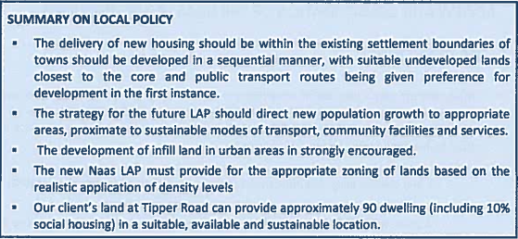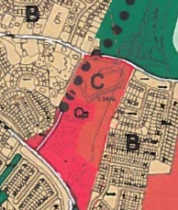
73 | Richard Godsil & Ward Frisby | Heritage, Economic Development  The former Leinster mills site is located 2km to the north of Naas Town centre and located on the western bank of the Grand Canal (Naas Line). The site area is c.1ha and comprises the former mills (protected structure) and adjoining lands to the north and south and west.  The site was designated M1- Leinster Mills in the previous Naas LAP 2011-17: “The sensitive re-use or re-development of Leinster Mills for cultural tourists based uses such as a museum or restaurant, with the possibility of a limited number of apartments ancillary to the main cultural/tourist use of the building will be encouraged where the use is compatible with the character of the protected structure.”  Proposal in the Draft LAP to further acknowledge the Leinster Mills complex and site but provide for greater flexibility in terms of the range of uses and development form in order to create a vibrant and viable canal side hub and destination.  Additional objective / policy in relation to Protected Structures in the LAP:  “Kildare county Council actively encourages uses that are compatible with the character of protected Structures. In certain cases, the Planning Authority may relax site zoning restrictions and be responsive to appropriate alternative uses for a structure in order to secure the protection and restoration of the structure.”  The Issues Paper acknowledges the important role that the Grand Canal plays in relation to the built heritage of Naas. Submission is supportive of the protection of this important amenity and heritage resource.  Submitted that sensitive development including the adaptive reuse of Protected Structures along the canal should be specifically promoted within the LAP.  The submission requests that in the case of Leinster Mills that the LAP retains a specific zoning and policy objective for the Leinster Mills complex which will encourage and promote the reuse of the protected Structure and development of its adjoining lands with a well-considered range of uses to promote and support a vibrant and viable canal side hub / destination.  Zoning and or policy objective should provide for:  - The established office use at Leinster Mills;  - Additional office uses;  - An Avoca-styled destination (café/bar/restaurant use)  - Cultural tourism and/or the integration of the Mill’s industrial heritage features into redevelopment proposals;  - Boutique/craft/niche retailing  - Hotel use; and  - Residential development  The suggested wording for the zoning and policy objective is:”To support and promote Leinster Mills Complex and site as an integrated tourism, cultural and amenity destination with complementary commercial and residential uses.”  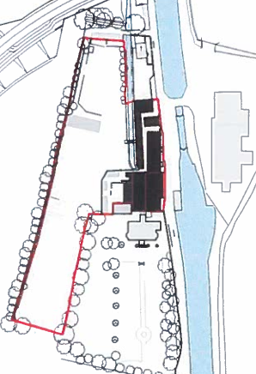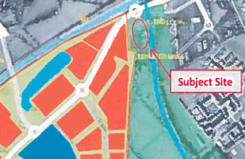  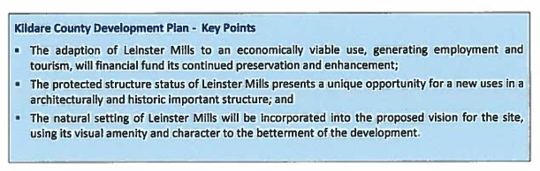  Proposed Development Vision for the Site:  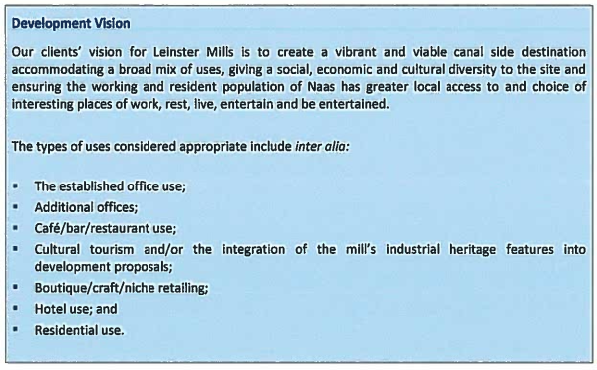
74 | Robin Skelton | It is requested that land located at Jigginstown comprising 4.44ha zoned I: Agriculture in the Naas Town Development Plan 2011-2017 is rezoned to C: New Residential (Low Density) in the new Naas LAP. The following reasons are set out to justify the proposed rezoning of the subject site:  - Proximity of the site to Naas  - The existing pattern of development in the immediate vicinity of the site.  - The small scale of the proposal (4.44ha)  - Necessity to provide different type of residential units for people with their own landholding.  - Allowance must be made for adequate residential zoned land in order to comply with Government Policy.  - The need to develop Naas in an orderly manner.  - Site is close to community, recreational and social services.  - It is a sustainable proposal.  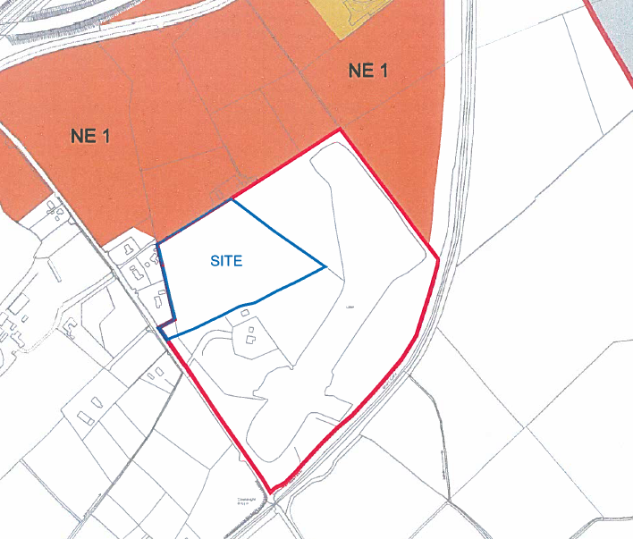
75 | Sandra Nelson | The submission refers to the disabled car parking provisions within the town and the varying types of ramps for vehicles and access ramps. Most disabled parking spots in the town require a ramp to be lowered into oncoming traffic. The only safe disabled spot is located outside Meadows and Byrne; however people keep parking in the yellow box and the path there is deep the ramp is still out on the roadway. It is not enough to provide disabled parking spots in the town; they need to be safe and accessible.
76 | Siobhán O’ Carroll | - There is a serious lack of mid-high level employment opportunities in Naas. There is a need to attract more companies such as Kerry Group in the IT, Pharmaceuticals, and Financial HQ’s etc sectors. There are too many people commuting to Dublin and once the younger generation is seeking employment they too will have to move to Dublin.  - Naas Town Centre and retail in general needs to be re-developed or more orbital shopping parks developed urgently as there is nowhere to shop in the town centre.
77 | Springwood Ltd | It is requested that land located at The Orchard, Oldtown Demesne - Plot A 0.89ha zoned F1: Open Space and Amenity in the Naas Town Development Plan is rezoned to C: New Residential in the new Naas LAP and Plot B Plot B 0.43ha zoned C: New Residential is rezoned to F: Open Space and Amenity in the new Naas LAP.  In addition the removal of the objective relating to Views and Prospects of the Canal corridor identified on Map Ref 11.4 in the Naas Town Development Plan is sought.  The following reasons are set out to justify the proposed rezoning of the subject site:  - Proximity of the site to Naas (less than 800m)  - Proximity to site to Sallins Train Station (1800m)  - Site F1 directly adjoins The Orchard Housing Estate to the south and the Plot B forms part of the Orchard Housing Scheme.  - Site located on bus route to Sallins Train Station.  - The small scale and infill nature of the proposal.  - All infrastructural, community, social services are in place.  - Site entrance to the Sallins Road is existing  - It will provide amenities for the GAA, school and the residents of The Orchard Housing Scheme.  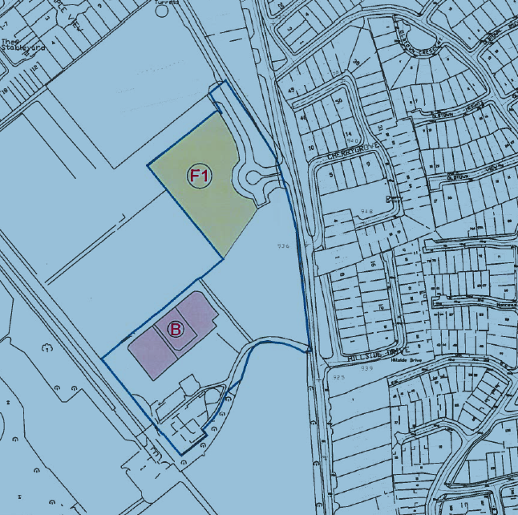
78 | Susanne Quinn | Variety of Issues – Town centre Retail, Car Parking, Environment, Amenity Space, Education , Housing Residential, Movement & Transport  - Improve Retail Offer – the town centre is in decline with a number of shops having closed down. Naas has a vibrant evening and night time economy but a declining retail offer. Naas is lacking a large full service supermarket shopping centre.  - Town centre needs additional car parks within the town centre, the limited spaces in the town is pushing visitors away.  - Create an initiative that all new developments must plant lots of trees at the front of their developments where they face on to public areas –Additional Specific Policy - that all developers undertake a large planting programme particularly at the public face of each development – there should be a high level of tree planting on the road networks through any housing development – Any new developments facing onto the ring road include a designated large strip exclusively for tree planting (10-15m wide allowing for planting 3x trees). This will improve the environment and make the area more attractive.  - Public Park along the canal and the De Burgh Estate Park should be a key priority of the LAP – the public realm in Naas is very poor. The park needs to be located within the town and connect into the centre.  - All overhead power lines in the town centre to be relocated underground.  - Zoning lands for Education – projected population growth in Naas will add pressure on the resources of the town. A detailed analysis and survey needs to be carried out on whether the existing school network has the capacity to absorb the projected population – including school numbers and the availability / opportunity to extend and expand school sites. 842 school children (11.3o% of 7445) – 32 classes = 2 new primary schools. 632 post primary students (8.5% of 7445) – 24 classes. For new residential and housing schemes additional lands to be zoned and considered as part of the whole development.  - New Housing and Residential Development – additional lands will be required to be zoned to meet the identified new dwelling numbers stated. Naas is very top heavy with large concentration of housing stock in the northern sectors of the town. New housing should be focused in the southern area to re-balance the town.  - Housing Policy new housing with more than 200 housing units should be required to develop a Masterplan. Infill development of sites within the town should be prioritised first before zoning and developing out of town sites. All new housing developments should have 15% green space allocation with an increase to 20% for out of town developments. Increase density by building 3 instead of 2 storey homes and by allowing scaled apartment blocks in mixed use type developments.  - Housing Policy – any new residential developments in Naas with more than 100-200 dwellings should have a children’s play area incorporated into the public space as a part of the landscaped public environment. Cairn Homes on Ballymore / Eustace Rd incorporates playground and an open gym area.  - Housing Policy – evaluate whether there is a need for new childcare facilities within new housing developments.  - Northwest quadrant should be developed for employment and business uses, with some residential developments.  - Movement & Transport – consider a new Park & Ride scheme for the town in order to reduce travel and volumes and commuting by car (Sallins Train station)
79 | Swans on the Green | Submission to re-zone the adjacent domestic property to commercial in order to allow the business to grow and develop. Original shop known as Fox’s in 1985 was a corner shop, the business has evolved and developed over time. The business now stocks and sells niche market and local artisan products and takeout foods. The business employs 20 full-time and 22 part-time staff.  The business has acquired an adjoining property in order to upgrade the existing facilities and expand the sit down area and to a private parking area for customers.
80 | Thomas Maguire | Town Centre and Retail  Proposals to make the town centre a more pleasant place to shop with an improved public realm for people, children, pedestrians and cyclists.  - Number of poor planning decisions and zoning decisions that have impacted upon the town centre.  - The town now has many vacant and derelict commercial units, with a poor public realm.  - Piecemeal planning continued with the building of a new bus shelter in Market Square  - Review of the map of Naas – Monread Centre has become the town centre of Naas MD.  - Provide one way traffic system Murtagh’s Corner to Wolfe Tone Street along Main Street  - One way traffic system Blessington Road to Murtagh’s Corner along Corban’s Lane  - Widen Blessington Road from its junction with the Dublin Rd to the proposed Corban’s Lane Rd junction with Blessington Rd.  - Close off the road between Blessington Rd and Corban’s Lane and remove the old railway bridge to provide new Town centre Park.  - Partially close off Friary Rd along the front of Lawlor’s Hotel.  - Consider removing the bus stops from Poplar Square  - Provide “cycle paths” through the town centre area with on street bicycle parking. Consider option of limited public bicycle scheme at Sallins train station, new tourist office and Naas town centre.  - Pedestrianise Poplar Square  - Pedestrianise Market Square, save for vehicular entrance to partially completed shopping centre.  - Enhance public realm through hard and soft landscaping with tree and all cables to be routed underground Free Wi-Fi to be provided in the town and CBD area.  - Construction of a new road through Naas – single carriageway 5m wide with parallel car parking on each side.  - Consider the change of zoning of the partially completed Naas Town Shopping Centre to a University use – food science campus linked to Kerry Group.  - Set up a separate agency to deal with the town centre of Naas and an established CBD area.  - Provide automatic barriers and exit payment systems to all car parks in the town centre.  - Provide “commercial rates” levy on all out of town centre car parks.  - “Commercial Rates holiday for all new commercial tenants in Naas for up to 5 years on sliding scale.  - Relocate the main access route from the new interchange at Millennium Park to provide a direct vehicular route through Millennium Park and into the town centre.  - Provide a new public transport corridor from Sallins train station through Millennium Park along new access route and into the town centre.  - Provide a one way public transport route with a new bridge over the Grand Canal through Naas town car park at the rear of the old Town Hall to Main Street. Return route along Naas Credit Union side to Town Hall and back over the Abbey Bridge and into Millennium Park.  - Provide a new car park for town centre, tourist office, interpretative centre, restaurant, museum and hotel to allow for development of the Canal Harbour in Naas.  - Remove the Urban Village zoning at Millennium Park.  - Provide a “public transportation corridor” through Lakelands Estate and Sunday’s Well from Blessington Road to Naas Hospital = direct access.  - Provide a new Eastern By-Pass from Johnstown roundabout at N7 to Blessington Rd.  - Consider the future use of small buses (15-20 seat) for public transport around the town.
81 | Westar Homes Ld | This submission requests the Council to consider the economic and social benefits of facilitating high density and high quality residential development on zoned lands at Finlay Park, recognising the strategic importance of these lands in the context of the NPF, the Regional Planning Guidelines and the Kildare County Settlement Strategy. This submission is made following strategic level consultation with Kildare County Council in addition to discussions with owners of adjacent zoned land. The land comprises undeveloped zoned land and land on which development is currently under construction (Reg. Ref. 13/500055/PL. 73.242895).  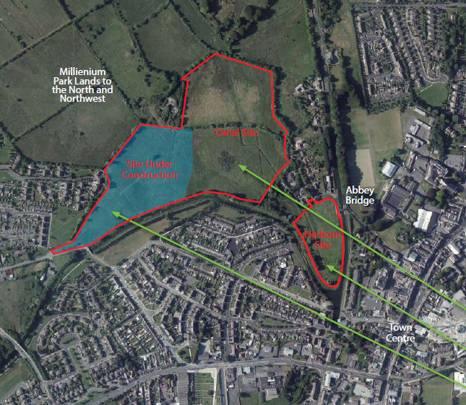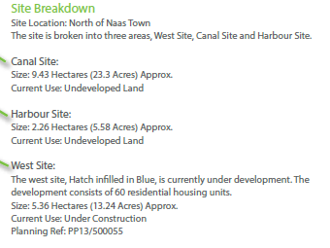  This submission was made in the context of a detailed Masterplan and is accompanied by proposed schemes for each site and 3D images of how the sites could potentially be developed.  A summary of the submission is as follows:  - That lands identified as ‘Lands Subject or Future Local Area Plan’ in the Naas Town Development Plan 2011-2017 are recognised as an ‘Opportunity Site’ for the delivery of a hotel and other commercial/ public amenities on the canal interface.  - That lands zoned F: Open Space and Amenity’ located to the west of ‘C2’ lands in the Naas Town Development Plan 2011-2017 are rezoned C: New Residential.  - That lands zoned C: New Residential (west of the LAP lands) in the Naas Town Development Plan 2011-2017 are extended to the canal front while retaining an appropriately sized amenity strip immediately adjacent to the canal edge.  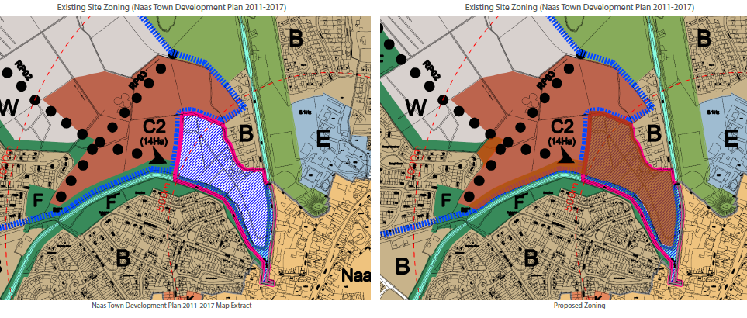  The submission is accompanied by a site specific flood risk assessment, which concludes the following:  Fluvial Flood Risk  Initial assessment of existing flood risk indicators suggested the Site might be at risk from fluvial flooding and thus further assessment was carried out. Liaison with Waterways Ireland confirmed there is no discharge, direct or overtopping, from the canal to the Site. Given the minimal run-off from the natural catchment and the topography of the Site, it is considered that risk of fluvial flooding at the Site is very low.  Groundwater Flood Risk  Initial assessment of existing flood risk indicators suggest the Site is not at risk from Groundwater flooding.  Pluvial Flood Risk  Pluvial Flood Risk Initial assessment of existing flood risk indicators suggest the Site is not at risk from pluvial flooding. Notwithstanding this, development close to the canal could block existing flow-paths that would discharge pluvial discharge in the unlikely event of the canal overtopping.
82 | Aldi Stores (Ireland) Ltd. | It is submitted that it is Aldi’s intention to further expand the Regional Office and Distribution Centre in the future and to expand the employment base in Naas.  - This submission requests that the subject site zoned H: Industry & Warehousing in the Naas Town Development Plan 2011-2017 remains zoned as H in the new Naas LAP.  - It is requested that the undeveloped section of Aldi owned lands are zoned Q: Enterprise & Employment in the new Naas LAP to allow for future expansion of the Aldi Regional Office.  - The zoning of the lands as requested will facilitate the expansion of Aldi operations in Naas and will strengthen the town’s position as a key employment base for County Kildare.  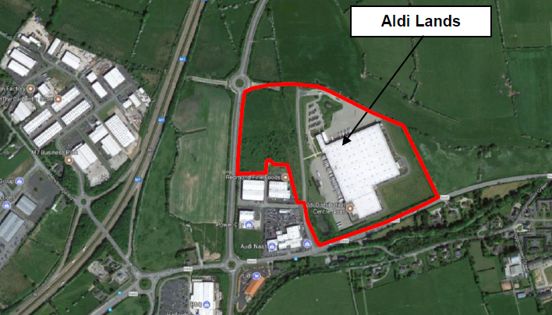
83 - 93 | Antoinnette & Eugene Forde  C&L Higgins Elsie Lloyd Frank O’Leary Helen O’Leary Helena Cahill Juanita Meany Liz & Frank Butler Maria & Bobby Lloyd Maura Fidgeon Thomas J Higgins | This submission relates to the area in the vicinity of Abbey Bridge and the private road running north west towards the Old Sewerage Farm. Recent developments and potential issues that may arise from the new Naas LAP are highlighted:  - Currently there is an increased volume of pedestrian traffic from Caragh Road Housing estates through fields to access the private cul de sac and onto the town centre via Abbey Bridge and Road. As this is a private roadway, there are concerns regarding liability from the use of the road by non- residents.  - Concern regarding the safety of pedestrians walking to the town centre and vehicles using Abbey Bridge and Canal Road.  - Finlay Park (Westar Group) has advertised access to the town centre via Abbey Bridge as a selling feature for this development. This is false and misleading.  - Abbey Bridge is on the RPS and needs to be preserved and maintained to the highest safety standards. It has been the subject to anti social behaviour and vandalism in recent years.  - The volume of traffic on the East Canal bank is cause for concern. It has become a rat run at school time and has become a significant health and safety issue. To further increase this traffic issue, the road running to the town centre, via Abbey Bridge has a choke point close to the Moat. This in turn poses risk regarding access for emergency vehicles to the area.  - Previous submissions by the Abbey Bridge and Canal Road residents Association to previous LAPs have raised some of these issues, however recent developments on the Caragh Road has added to these concerns further.  - It is requested that KCC take on board the concerns raised and propose mitigation measures in the new Naas LAP against the risk to health and safety and road safety of the area for both pedestrians and vehicles.  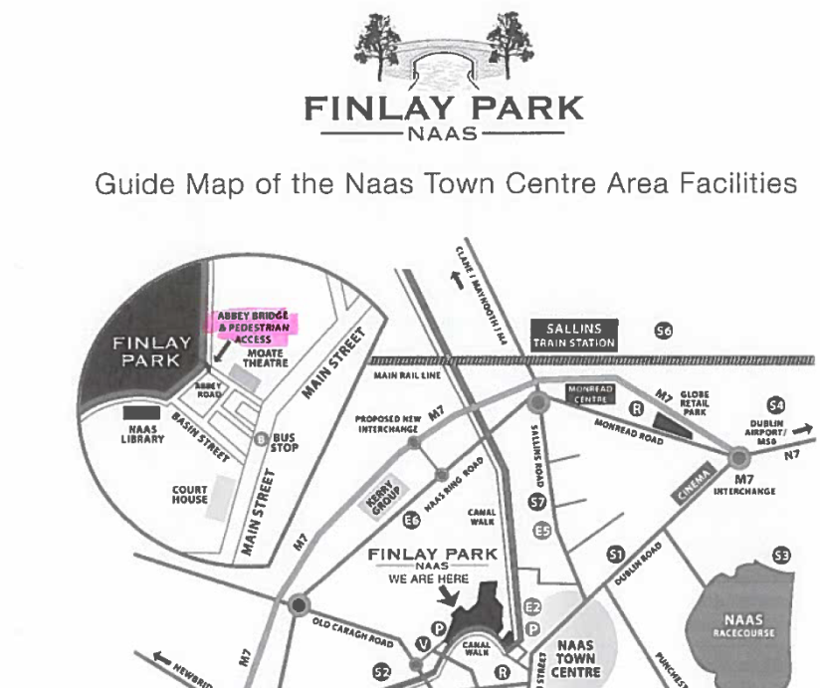
94 - 118 | Anthony Boland Aoife Ni Ruairc Ciara Shortall Colm Gordon Donal O’Riagain Eoin O’Mordha Jackie Blake Joseph Bergin Liam Grogan Mac Dara O’Maithiu Maebh Ni Chleirigh Mairead Finn Mick Moriarty Niamh Whittaker Padraic Grogan Paul Whittaker Roberta Keaney Ruth Leathlobhair Sarah Stewart Siobhan Evans Siobhan Grogan Sorcha Mulryan Susan Herbert Tom Davis Willette Conroy | - It is submitted that almost 1,000 students are currently in full time education through the medium of Irish in the Gaelscoileanna. Several thousand households value our Constitutional first language, therefore Kildare County Council should ensure that all official forms for completion, all public signage, road signage should have Irish at least as prominently as English and all public and media notices etc are as freely available in Irish as in English.  - Community groups who support or promote the use of Irish should be incentivised to continue to do so.  - KCC in conjunction with the Naas LAP should organised events that promote the use of Gaeilge at key events such as Easter or Seachtain na Gaeilge.  - Local politicians should be encouraged to use Gaeilge equally in their election campaigns.  - Use of Irish should be encouraged within KCC workplace as it is in many private sector offices through such initiatives as Irish Language Lunch Day and other themed events.  - If public funds are being spent, the Irish language should be visible e.g. at local festivals etc. KCC should make it part of the conditions of funding groups or events.  - There should be grants available from KCC to local community groups to promote the Irish language e.g. GAA, Comhaltas, Scouts etc.  - Prior to granting planning permission to businesses or groups, it should be required that they include how they will include the use of the Irish language on signs and within the business etc.  - There is an opportunity to build a culture centre in the area with Irish being central to such a project.
119-124  132  133  134  135  136  137  139  141  142  145  148 | Ailis Robinson Alan Duncan B. Egan Barry Brophy Barry Ward Bernadette O’Connor David O’Halloran Derek O’Connor Dorota Gebura Eileen Nelson Emily Ward Finbar Ward Gail Coughlan Geraldine Ward Jacqueline Howley John Aherne Laurence Hogan | Caragh Rd site Naas:  - The Newbridge/Caragh Road (R409) area is currently providing a high level of social housing. If this area is selected by the Council for additional social housing, the mix of private and public housing will be disproportionate to the rest of the town and is contrary to best practice to disperse social housing throughout an area rather than concentrate it on one area. It is unbalanced that this area has the highest concentration of social housing.  - There are so many young professionals moving to Naas, this level of social housing may discourage them moving to the area.  - The site on Caragh Rd may be better used for a retirement village/nursing home which is much needed in Naas.  - The Newbridge/ Caragh Road is congested enough without adding further traffic to the area. The planned exit on the Millennium Road onto the M7 will exacerbate this problem.  - Additional social housing in the Caragh Rd area would create massive social problems similar to Moyross in Limerick.  - There is enough social housing to the south of the town. Put social housing to the north of the town.
125 | Cairan Gormley | - Corban’s Lane shopping centre must be considered in the new Naas LAP. The LAP must include a traffic management strategy to be put in place and decisions need to be made as to the future use of Corban’s Lane.  - The exit from the new leisure facility onto the new Caragh Rd is congested at peak flow, traffic calming measures should be considered at K Leisure .  - The site zoned B: Existing Residential/Infill on the Caragh Road should be rezoned to F: Open Space and Amenity to provide a balanced approach and further use both sides of the Canal.  - Traffic signage at the exit from Finlay Park should be provided as it appears that this is not treated as a main road by traffic.
126 | Cathal Mc Lysaght | - Replace the bridge over the canal on the old Limerick Road to allow access to walkers and boat users to navigate the canal from Naas Harbour to the end of the Corbally Canal.  - Create a community park on lands opposite the entrance to Caragh Court.  - Proceed with work to allow access to the Oldtown Demesne Gardens.
127 | Catherine Mc Grath | The traffic congestion on the Caragh Rd is already unbearable and the planning exit onto Millennium Rd will exacerbate the problem.
128 | Ciaran & Ruth O’ Loughlin | - The site suggested for social housing in already at capacity. The site is small and trying to fit additional housing into it will be visual unpleasant, will detract from the scenic walk, will create further traffic congestion, will devalue property, will cause anti-social behaviour  - There is a lot of social housing already provided on the Caragh Rd. It should be dispersed throughout the town such as on Sallins Rd and Tipper Road where there is no social housing.  - This site could be better used to develop this area in a positive way.
129 | Ciaran O’ Loughlin | Social Housing should be distributed more evenly throughout the town and not concentrate in the Jigginstown, Old Caragh Rd area.
130 | D. Mellon | (i) Traffic is already congested enough on the new Caragh Rd causing major bottle neck into town.  (ii) As the population ages w need to be proactive in ensuring that there is suitable retirement housing available.
131 | Darina Dunphy | - The housing plan for Finlay Park and the surrounding area is going to add serious pressure to an already congested ring road. The planned exit from M7 to Millennium will exacerbate this problem.  - There is already social housing adjacent to this site and additional social housing will ghettoize this area.  - The site should be used to provide a retirement complex to allow older people to ‘downsize’ or a day care centre/ nursing home for people in our community.
138 | Frank Lawler | - Is Finlay Park not on a flood plain and at risk of flooding?  - There are already bottlenecks on the Caragh Rd, more housing will create more traffic.  - More thought must be given to the older population and provide facilities to keep them active on the site being considered for additional social housing on the Caragh Rd.
140 | Gary Stafford | - Traffic at peak times from Jigginstown Park is currently a significant issue.  - Concern that the ‘Mini Homes’ in the media would be substandard form of development  - Concern about the proximity to the children’s crèche.
143 | James Foley | Housing & Community - The land access to the Caragh Road from the playground is proposed to be zoned for social housing. This is against the principle of diversification and mixed housing type. Concern is raised that another block of social housing is proposed to the rear of the Council offices. Therefore all the social housing developments will be located in one area in the town. No other lands are proposed for the provision of social housing in Naas.  The site on the Caragh Rd offers an opportunity to include older members of the community to develop a retirement/nursing home to cater for Naas’s ageing population.  Economic Development - Corban’s Lane Shopping Centre would bring more business, revenue, rates and people into the town centre and would give residents a greater choice.  Movement & Transport - The housing planned for Finlay Park and the surrounding area will add serious pressure to an already congested traffic system on the new Caragh Rd. The planned exit on the Millennium Rd onto the M7 and the construction of the Community School will further exacerbate this issue and will prevent residents in this area from accessing the town centre.
144 | John & Fiona Lennon | - The new Caragh Rd is very congested at peak times with the junction of R409 and R445 experiencing tailbacks regularly. Existing Jigginstown Green can be very difficult especially turning right.  - Create a full pedestrian crossing at the bottom of new Caragh Bridge rather than just a zebra crossing.  - Limit the R409 between the R445 and the Ring Road to local access or make it one way as it is very difficult to turn right out of the estate. The volume of traffic is likely to increase further with new housing at Finlay Park and the new M7 interchange at Kerry Group. The junction between the R409 and R445 is not fit for purpose and will not cope with additional traffic.  - It is understood that social housing is planning for Craddockstown, Devoy Barracks & Jigginstown which is in addition to social housing already in Ballycane, Craddockstown, Cois na Feadáin & Primrose Gardens. There is no social housing planned for other areas e.g. Sallins Rd, Blessington Rd, Tipper Rd. If the planning social housing on the Caragh Road goes ahead it will lead to a disproportionate concentration of social housing in one area of Naas which is contrary to Government Policy and KCC policy which promote diversity and integration.  - Some of the planned site for social housing should be used for housing for older people or people with disabilities rather than just social housing.
146 | John Coyne | Housing - Proposal to build new dedicated social housing units between Caragh Court and the Canal should be withdrawn. This area should be an amenity for all residents. The area needs more crèches spaces, the traffic from Finlay Park is already putting an extra strain on the Caragh Rd Junction. A new relief road should be built out from the back of Finlay Park onto the Ring Road in Millennium Park.  Town Centre - - Parking spaces in Naas town centre are very limited, this is killing the town. Recent decision to remove free parking on weekends is wrong and it just serves to drive people to Tesco, Monread.  - Walkway from Jigginstown Park to Naas town should be resurfaced. Trees breaking up the path could cause cycling falls. The wasteland at the canal near the library should be developed into a park and bring new business opportunities new the old canal terminal.  - Parking at Sallins Trains Station is inadequate and needs investment to increase spaces on both sides of the track. The feeder bus to commuter trains is very limited and irregular. It should have a higher frequency.
147 | Julie Ann & Andy Black | Leaving for work/schools runs from Jigginstown Park in the morning is difficult with the level of traffic backed up sometimes back the first roundabout heading out the Caragh Road. The traffic is so bad already, please don’t make it worse.
149 | Letitia Foley | Locating a large park near residents close to Caragh Court, Jigginstown, Ardconagh and all developments planned in the area.  Housing & Community - Providing additional social housing on Caragh Road is contrary to the policy to disperse social housing throughout the whole of Naas, otherwise areas of stereotypes will be created as low class, cheap or inferior such as Tallaght, Crumlin, Ballyfermot. The site on Caragh Road could accommodate housing/apartments for older members of the community.  Movement & Transport - Traffic from all the housing already built and planned will have to use the new Caragh Rd as the main route to access Naas Town Centre. The Sallins by pass and new community school will also bring more traffic along the new Caragh Rd. The new LAP must identify other alternative roads to cope with a major increase in traffic on Caragh Rd which already has major tail backs with residents in this area at a significant disadvantage in accessing the town centre.
150-159  161  163-165  166  168 - 178  179  182  184  194  196-  198 | Liz Matthews Margaret Duncan Marianne Lawler Martin & Geraldine Hogan Mary Brophy Mary O’Halloran Michael & Ciara Wogerbauer Michael O’Halloran Michelle McElroy Michelle Williams Nicola Harney Pat & Carol McCabe Paul Dunne Paula Dunphy (Moran) Ray O’Halloran Roger & Petra Lahtinen Roger Parrow Ruth O’Loughlin Ruth Teskey Sandra McIntyre Sean Brophy Sian Williams Siobhan Melia & Martin Cooney Stephen Ryan Tricia Kelly William Quilter Aled Williams Ann Crowley Ben Doyle Deidre Hogan Doreen Ryan Fiona Gilgunn Geraldine Fitzpatrick | Residential Development on Caragh Rd  - The housing planned for Finlay Park and the surrounding area is going to add serious pressure to an already congested traffic system on Caragh Rd.  - Adding another set of social housing in the Caragh Rd area goes against the idea of diversifying social housing throughout the town  - The site outside Caragh Court could offer the opportunity to include our older members of the community in a retirement or nursing home.  - The site could alternatively be developed for open space / recreation.
160 | Neil Austin | Town centre and retail - Concerned about the town’s prosperity. Local businesses in the town have suffered as the nightlife and night-time economy have grown. Out of town shopping centres have impacted on the town centre.  Movement & Transport - Concerns about the transport infrastructure. Motorway widening will need to additional pressures and pinch points in the Caragh Rd area.  Housing & Residential - Caragh Road proposed housing development will have an impact with an over concentration of social housing in one area.  Heritage and Canal -Naas had a great asset in its canal. The towpaths are well used but the canal locks, the towpath and the canal itself are not maintained at all and are making this route un-navigable.
162 | Ollie Collins | - Vision – Naas to be a busy centre, safe to live and work in for all  - Town Centre – Redevelop Main St back to being a busy shopping area and remove the cranes  - Movement & Transport – Too much traffic entering the Town Centre  - Infrastructure – Build larger schemes with easy access  - Housing – Build housing for older people and improve services  - KDA – Demolish the derelict factories on Maudlin Rd and redevelop  - Other issues – Stop camp sites on sites and roads around the town  - Social Housing – there is enough social housing on the Caragh Rd at present. Any further development in this area should be for elderly people
167 | Richard Lyons | Residential Development on Caragh Rd  - The housing planned for Finley Park and the surrounding area is going to add serious pressure to an already congested traffic system on Caragh Rd.  - The Town centre needs to be finished off or something built in its place. Town needs a new cinema and shops aimed at youth and young people which will bring them back into the town.  - The Canal should be developed as an amenity, including re-opening for boats. Develop the canal towpath into a greenway route for walkers and cyclists.  - Housing – develop mixed areas rather than clustering social housing in one area.
180  183  185-  189  190- 193  195  199  200- 218 | Aleksandra Kazmierczak Ann Marie Thompson Bernie O’Connor Brian Dempsey Brian Kavanagh Brian king Catherine Domican Celine Maguire Clare Linehan David Burke Dee Hulse Delphine Lelievre Helen Cully Joseph Bergin Joy Donohe Karen Cahill Karen McTague Keith Cully Kieran Rogers Leona Martin Mags Conroy Marie Daly Martin Murray Niall O’Reilly Orla Allen Owen McClave Paul Domican Robert Burke Ross Allen Ruth Brennan Shelagh Pentony William Gilligan | Triangular site location at the entrance to Caragh Court should be developed as a community park
219 | Adrian Geissel | Objection against the planned location of the Naas Inner Relief Road. Concerns raised regarding:  Population increase is welcome but is likely to place great pressure on traffic especially at school and commuter times. Recent planning permissions granted and the commencement of developments demonstrates additional pressures. With the anticipated completion of the shopping centre, daytime traffic will also increase.  The proposed new inner relief rd will not alleviate the problems especially in light of the current and proposed housing development in the south of the town.  Existing Dublin Rd operates at capacity at peak times  Urge the Council to review the pending infrastructure plans in the context of current and future population demands and suggest that the inner relief road be located to the east of the Racecourse. This would facilitate a circular traffic flow from the N7 exit 9 clockwise around Naas Industrial Estate along Fishery Lane.  Blessington Rd could then also be re-prioritised to and from Ballycane with an emphasis on free-flow, reducing congestion in the area through to Kilcullen Rd
220 | Brendan Moran | Objection against the planned location of the Naas Inner Relief Road. Concerns raised regarding:  Connection of the proposed road at the roundabout at Fishery Lane and along the north and eastern boundary of the Racecourse and onto Blessington Rd would cut down on significant traffic congestion.  The existing location for the road is in the wrong location and will cause additional congestion.
221 | Catherine Corrigan | Objection against the planned location of the Naas Inner Relief Road. Concerns raised regarding:  Noise and Air Pollution – Security and privacy issues – Increased traffic congestion – Impact on the environment and loss of wildlife habitats.  The New Rd should be located further out on the eastern side of the Racecourse.
222 | Claire Prasad | Objection against the planned location of the Naas Inner Relief Road. Concerns raised regarding:  Concerned about the negative environmental impact that the proposed road will have on the area. The old plan is about 30 yrs old and is now not relevant considering how the area has changed and developed.  It is not appropriate to progress with something just because the money is available – an efficient route / access should be found to get traffic out of Naas and onto the N7 – this road and route will not provide this.  Alternative route to the east of the Racecourse is a better longer –term solution  Issues raised and identified include:  - The noise levels, dust etc during construction.  - The worst problem the continuous traffic noise both day and night – the bedrooms are in the back of the bungalows  - Strong lighting at night  - Compromised security to the rear of the homes  - Traffic pollution and particle emissions  - Property devaluation  - Negative impact on the Racecourse  The money and resources should be used to construct a good road in the best place. Do not use the money to build a road in the wrong place and that will destroy a local environment.
223 | Claudia Stone | Objection against the planned location of the Naas Inner Relief Road. Concerns raised regarding:  Strongly oppose the construction of the Relief Rd in its proposed location as it will cause more congestion – moving it to the other location east of the Racecourse would be a better option. Connecting at Fishery Lane would avoid congestion on Tipper Rd
224 | Colette Cooney | Objection against the planned location of the Naas Inner Relief Road. Concerns raised regarding:  Understand the need for a road but concerned about the close proximity of the route to properties in Woodlands.  Road will increase the volume of traffic, noise, lighting.  Tipper Rd has long been used as a walking route – are there plans to widen the road for footpaths on both sides of the road.  How is the road proposed to be separated from the boundary wall of Woodlands
225 | Deirdre Curtin | Objection against the planned location of the Naas Inner Relief Road. Concerns raised regarding:  - NO assurances given regarding the impact of noise and air pollution on the residents of Woodlands.  - The proposed road will add to traffic congestion on Tipper Rd. During school drop-off period it is very difficult to exit Woodlands – congestion in this area will increase considerably.  - Woodlands residents have previously submitted an alternative plan and proposal
226 | Don Higgins | Objection against the planned location of the Naas Inner Relief Road. Concerns raised regarding:  The volume of traffic utilising the Tipper & Blessington roads in the morning and evening is very heavy  To facilitate existing and future developments I would suggest that the proposed ring road should be built much further out from the current proposal.  A significant volume of traffic travelling from Dublin use the Tipper / Blessington Rd as a rat run and this will be exacerbated with extra housing in the area
227 | Fiona Duigan | Objection against the planned location of the Naas Inner Relief Road. Concerns raised regarding:  Currently proposed location of the Rd is not only ill-conceived and anachronistic but is also in contravention of the objectives in the draft LAP 2018-24 (Issues Paper). The population growth of 7,445 persons and a dwelling target of 5,533additional units. Within the local area there is a large new housing estate already planned for construction between Tipper Rd and the Blessington Rd – the big picture encompasses an expanding image of Naas.  The most appropriate and far-sighted alternative to the Inner Relief Road is an Outer Relief Road to be constructed on the East side of the Racecourse
228 | Gail Collins | Objection against the planned location of the Naas Inner Relief Road. Concerns raised regarding:  Concerned about the security and privacy issues that the proposed road will bring to the area.  Concerned about what will happen to the strip of land lying between the resident back garden boundaries and the edge of the proposed road?  The proposed road will bring a large amount of road and traffic congestion to Tipper Road – the safety of pedestrians, cyclists and the growing number of school children travelling on and using Tipper Rd will be hugely compromised with additional traffic from the new housing estate.  An alternative route along Fishery Lane and the northern boundary of the racecourse has not been given more consideration.  The proposed new road will be busy and noisy and will impact houses 1 to 24 – this would be unconscionable and unwarranted.  Pollution - noise pollution day and night Pollution - from vibration during construction and afterwards – vehicular traffic - Pollution - exhaust fumes - Pollution – Light - Pollution – Dust - Loss of Privacy Danger to safety  Loss of sleep – Impact on Trees and Wildlife - Impact on the Health & Well-being Residents - Pedestrian footpaths and cycle paths leading to other uses such as caravan parking - Location of Bus Stops and associated Noise -  Potential anti-social behaviour - increased security risk to the rear of properties – burden on infrastructure and additional traffic congestion. – Devaluation of houses and property – Degradation of the Racecourse – Reduction of Racecourse Car Parking – Restriction of Access to the Racecourse.  Building a new road so close to the residential estates would require attention and expenditure on the following matters:  - Electricity cables underground – Services (water, sewage, storm water drainage, telephone, broadband and gas etc.  - Noise mitigation measures Including the building of walls, additional tree planting and buffer zones  - Sound proofing and insulation of homes  - Interference with reception – radio, TV, broadband and mobile signal.  Scrap the current proposal and build and Outer Relief Rd instead.
229 | Jim & Shirley King | Objection against the planned location of the Naas Inner Relief Road. Concerns raised regarding:  - The emerging plan for Naas is based on Plans some 30 years old  - The proposed road development is out of date and it doesn’t take account of the medium and longer term needs of traffic management of Naas and the surrounding areas.  - Inner Relief Rd will as proposed pass directly behind a number of bungalows in Woodlands, impacting all in the area and most importantly those closest to the Racecourse.  Short –term –  - Excessive noise from the construction work which will impact on the peaceful enjoyment of the gardens which back onto the Racecourse;  - Dust pollution meaning that windows at the back of the bungalows will have to remain closed and clothes lines cannot be used;  - Other health concerns related to the above.  Long Term  - Excessive noise from a high volume of traffic which will directly impact on the peaceful enjoyment of the gardens and bungalows;  - Light and air pollution adversely affect the quality of life;  - Direct access to the rear of the properties will be an increased security risk.  Other matters  - Reduce the parking spaces available to racecourse attendees, which will lead to car being parked in Woodlands causing traffic and parking congestion and dangers to children and pedestrians.  - Racecourse is home to lots of wildlife and is an amenity space for walking. The asset is invaluable to the town  - In favour of the development of Naas including a ring road, but the current and proposed route is not suitable  - The proposed route will cause additional traffic congestion where it joins the Dublin Rd.  - Just because the money is available is no justification to spend it on the wrong project in the wrong location
230 | John Collins | Objection against the planned location of the Naas Inner Relief Road. Concerns raised regarding:  - Concerns about the potential noise pollution if the road goes ahead  - What remediation is proposed to counteract this  - What will be done with the land between the proposed road and Woodlands – this is used and accessed as amenity for walking.  - Could the road be relocated through the far side of the racecourse to exist out at Fishery Lane.
231 | John Ward | Objection against the planned location of the Naas Inner Relief Road. Concerns raised regarding:  - The road will be better suited to the eastern side of the Naas Racecourse, away from residential housing  - The road will cause health issues due to the high levels of emissions and breaches of privacy
232 | Justin Mac Antsaoi | Objection against the planned location of the Naas Inner Relief Road. Concerns raised regarding:  The Inner relief road will border the back gardens of the residents houses in the Woodlands Estate – Questions:  - What is the closest the new road will come to any houses in the Woodlands Estate?  - What provisions have been made for soundproofing, privacy and prevention of access to properties at Woodlands from this new road?  - Where can a copy of the road plan be inspected?
233 | Kathleen Ward | Objection against the planned location of the Naas Inner Relief Road. Concerns raised regarding:  - Tipper Road is a narrow winding country road with heavy traffic already using it  - Health grounds because of noise, light and air pollution due to the close proximity of the road to houses.  - Could the road be pushed out to the far side of the racecourse connecting the roundabout at Fishery Lane where there are fewer residential homes  - This would avoid impacting on an already busy and congested area of Tipper Road.
234 | Kay Cregan | Objection against the planned location of the Naas Inner Relief Road. Concerns raised regarding:  - Destroy a beautiful green wildlife area home to foxes, rabbits, hedgehogs, buzzards and pheasants  - It will create a problem with noise and air pollution  - Security, the backs of the properties will be more exposed
235 | Kieron Curtin | Object to the proposed Naas Inner Relief Rd as believe it is not necessary.  Prefer devoting time to Main Street in Naas with so many buildings and shops boarded up.  The Relief Rd was considered before and it was concluded that the Council could not afford it.
236 | Mae Leonard | Objection against the planned location of the Naas Inner Relief Road. Concerns raised regarding:  Concerned about the destruction of the Woodlands environment for the building of the inner ring road through the racecourse in Naas. I have been tending the hedgerows and looking after the wildlife in the area. Area been kept litter free to allow foxes and hedgehogs to thrive in the area
237 | Maria Grogan | Objection against the planned location of the Naas Inner Relief Road. Concerns raised regarding:  Proposed new road Tipper Rd to Dublin rd will have impact on the Woodlands estate and properties 1-24. Road should be moved to the eastern side of the Naas Racecourse. If built in proposed location then boundary fences should be moved 4m and a wall constructed to reduce and screen noise. Houses to be fitted with treble glazing to reduce noise levels.
238 | Marian Ward | Objection against the planned location of the Naas Inner Relief Road. Concerns raised regarding:  - Security and Privacy issues  - Noise pollution  - Traffic congestion on the Tipper Road
239 | Patrick J Grogan | Objection to the location of the proposed Naas Inner Relief Road. Concerns raised regarding:  - Ruining the serene countryside view for the adjacent houses  - Noise pollution  - Emission levels  - Road lighting  - Traffic congestion  It is suggested to move it to the far side of the racecourse connecting at the roundabout at Fishery Lane, along the northern boundary of the racecourse and on to the Blessington Road.
240 | Paul Murphy | Objection against the planned location of the Naas Inner Relief Road. Concerns raised regarding:  - Noise and Light pollution  - Privacy and Security issues  - Traffic congestion coming down Tipper road via Tesco, impacting residents leaving the Woodlands Estate.
241 | Paula Ward | Objection to the Inner Relief Road through Naas racecourse due to:  - Noise pollution  - Emission levels  - Lighting pollution  - Traffic congestion to Tipper Road  - The destruction of the living environment, being close to town but in a quiet and peaceful area.
242 | Rhonda Willoughby | Objection against the planned location of the Naas Inner Relief Road. Concerns raised regarding:  - Noise pollution  - Security issues  - Traffic congestion  - Safety for walking
243 | Róisín & Alan Stewart | Objection against the planned location of the Naas Inner Relief Road. Concerns raised regarding:  Objection to the location of the Inner Relief Road through Naas racecourse at the back of their property. Concerns of air and noise pollution created by passing traffic both day and night, for the health of their children with the air and the speeding traffic., their quality of life, lighting issues, restricted access to the racecourse and the compromise of their security and privacy.
244 | Steven Fadian | Objection against the planned location of the Naas Inner Relief Road. Concerns raised regarding:  Opposes the Inner Relief Road that planned to start at ‘The Gallops’ Estate, this ring road should link directly into the ‘Big Ball’. If the construction goes ahead it will cause major traffic problems. A small estate road cannot be considered for a major ring road to assist a population of 29,000 by 2024. It is suggested to have a road from the ‘Big Ball’ somewhere.
245 | Ted Murphy | Objection against the planned location of the Naas Inner Relief Road. Concerns raised regarding:  Concerns raised regarding the location of the Inner Relief road at the rear of the Woodlands property as follows:  - Noise and Air pollution  - Privacy and security issues  - The overall impact of tipper Road  - Suggested to instead construct an outer ring road instead, avoiding impacts on housing developments in the town.
246 | T.R. Smith | Objection against the planned location of the Naas Inner Relief Road. Concerns raised regarding:  Issues concerning Noise and Air Pollution  The new road should be pushed out the eastern / far side of the Racecourse and not through the Racecourse as proposed and suggested.

Appendix II

Informal submissions received and summary of issues raised

During the informal public consultation day on the 3rd October 2017, 100 people attended and made comments. A summary of each comment/submission made is set out below.
Appendix I, Table 1: Summary of Comments from the public at Public Consultation Day 3rd Oct. 2017
CATEGORY | SUMMARY OF ISSUES RAISED
VISION | - Plan now for 45,000 people  - Get ready, Be ready for population increase  - Create a Living Town  - Health and Well Being  - Improve Youth and Teenage facilities  - Purple Flag for Naas  - LAP should include an Evening and night time Economy Strategy
EMPLOYMENT, ENTERPRISE/ ECONOMIC DEVELOPMENT | - Increase in Utility Capacity to encourage development in Millennium Park  - More new jobs and employment opportunities  - More Jobs and encourage multi-nationals  Market the town overseas via the IDA & Enterprise Ireland
TOWN CENTRE/  VACANCY/  DERELICTION/  TOURISM | - Public Realm Strategy  - De-clutter town centre  - Open up the closed and vacant shops  - Re-use vacant town buildings  - Millbrook Laundry and the Pepe Factory should be acquired and brought back into use  - Number of derelict and wasted spaces in the Town Centre  - Provide Pop-Up shops options for enterprising people  - Residential use in the Town Centre needs to be increased  - Use of empty rooms over shops needs to be encouraged  - Increasing residential use = life, vibrancy and an increase in footfall  - Improved residential use in the town centre, flats and accommodation above retail units  - Incentives and Grants to refurbish derelict and rundown buildings  - Improve the publicity on grant schemes available for refurbishment of buildings in Town  - Bite the bullet on Poplar Square once and for all  - Go high with building developments in the town  - Need more emphasis on tourism  - Naas has never exploited the huge potential of its heritage assets  - Heritage and history of the town needs to be developed to help attract more people to Naas  - Naas needs a Tourist Office in the town  - Naas needs a dedicated Tourist Office in town  - Make John Devoy Barracks into a Tourist and Heritage attraction
STRATEGIC OPEN SPACE/  RECREATION/  AMENITY | - Create an Urban Greenway - Sallins to Dublin – safer routes to walk and cycle  - Walking Town for Community focus points  - Create a Town Park  - Improve the canal towpath and encourage more use  - Pedestrianise the length of the canal  - Better and safer cycle routes and facilities  - Town park at the Canal Basin  - Create a new Park in the Harbour area for families and teenagers  - Naas needs to provide more parks and open spaces  - Link up the areas of Green and Open Space  - Integrate Green Spaces into the Town
MOVEMENT & TRANSPORT | - Improve the Town centre with a dedicated one way system – Johns Lane & Basin Street  - Create a one way traffic system  - One way Traffic system for Naas Town Centre  - No cars on Main Street  - More Car Parking facilities in Naas  - Provide free parking in the Town – consistent approach across all towns in Kildare  - Greater provision for Public Transport in Naas
RETAIL | - Improve retail offer – Penneys / Dunnes Stores  - Finish and Open the Shopping Centre  - Shopping Centre in the Heart of Town  - Naas does not need a Penneys or a Dunnes Stores  - Move or CPO the Telephone Exchange to out of town location  - Move the An Post Sorting Office out of town
COMMUNITY FACILITIES | - Create a multi-use community centre to accommodate a variety of community groups  - Create new and modern community facilities and buildings  - Community Theatre helps with Mental Health Issues  - More sports pitches in Naas  - Develop a walking and trim trail on the east side of the Town  - Develop more interesting and fun things to do in Naas  - Make Naas more colourful  - Develop and set aside more graveyard and burial plots  - Improve Crèche and Childcare facilities in Naas  - Develop more play areas
HERITAGE | - Need more emphasis on Tourism  - Town has never exploited the huge potential of its Heritage Assets  - Heritage and History of the Town needs to be developed to help attract more people to Naas  - Heritage and History can link the Town together  - Naas needs a Tourist Office in the Town  - Make better use of the large amounts of built and natural heritage assets  - Protect and enhance our Built Heritage – Irreplaceable  - Develop a Heritage Trail around Naas linking the prominent and recorded Protected Structures  - Save St. David’s Castle  - Critically review and analyse the RPS list and the Towns ACA
IRISH LANGUAGE | - Greater recognition and support for Irish Language speaking population  - Grants for shops and businesses that use and promote Irish Language  - Dual language signage Irish and English  - Use Irish language throughout Naas Town Centre including signage, advertising, shop fronts and place names.

